

“A Joint Multilingual Framework for Hope Speech Detection in Bengali and English”

By
Fatema Khatun
230122001
Md. Abu Sayed
230122004
Sarmin Akter Eti
230122015
Foysal Ahamed
230122035
Md. Rajaul Islam
230122039

A thesis submitted to the Department of Computer Science and Engineering in partial fulfillment of the requirements for the degree of
Bachelor of Science (B.Sc)

Department of Computer Science and Engineering
European University of Bangladesh
20 June, 2026

© 2026. European University of Bangladesh
All rights reserved.

Declaration
It is hereby declared that

- The thesis submitted is our own original work while completing a degree at European University of Bangladesh.
- The thesis does not contain material previously published or written by a third party, except where this is appropriately cited through full and accurate referencing.
- The thesis does not contain material which has been accepted, or submitted, for any other degree or diploma at a university or other institution.
- We have acknowledged all main sources of help.

Student’s Full Name & Signature:
Fatema Khatun  230122001 |  | Md. Abu Sayed  230122004
Sarmin Akter Eti  230122015 |  | Foysal Ahamed  230122035
Md. Rajaul Islam
230122039

Approval
The thesis titled “A Joint Multilingual Framework for Hope Speech Detection in Bengali and English” submitted by
- Fatema Khatun (230122001)
- Md. Abu Sayed (230122004)
- Sarmin Akter Eti (230122015)
- Foysal Ahamed (230122035)
- Md. Rajaul Islam (230122039)
of Spring, 2026 has been accepted as satisfactory in partial fulfillment of the requirement for the degree of B.Sc on 20 June, 2026.

Examining Committee:
Supervisor: | _______________________________  Dr. Chowdhury Sajadul Islam  Associate Professor & Chairman, Computer Science and Engineering (CSE)  European University of Bangladesh
Co-Supervisor: | _______________________________  Mohammad Mehadi Hasan  Assistant Professor, Computer Science and Engineering (CSE)  European University of Bangladesh
Thesis Coordinator: | _______________________________  Dr. Mohammad Shaharia Bhuyan  Assistant Professor, Computer Science and Engineering (CSE)  European University of Bangladesh

Departmental Head:  (Chair) | _______________________________  Dr. Chowdhury Sajadul Islam  Associate Professor & Chairman, Computer Science and Engineering (CSE)  European University of Bangladesh
Ethics Statement (Optional)

This research has been conducted in both Bengali and English: monolingual, cross-lingual (zero-short) and finally multilingual. It is based on the identification and analysis of Hope Speech(1) and Non-Hope Speech(0) in the text. The data used in the study were collected and processed in accordance with ethical research guidelines. No personal identifying information of any individual (such as name, address, telephone number, e-mail address or other sensitive data) was intentionally collected, stored or disclosed. Where necessary, the data were anonymised to protect participants' confidentiality.

The labelling or annotation of the dataset has been carried out in accordance with specific guidelines to ensure that personal, religious, political or social biases do not influence the research findings. Annotators have been instructed to evaluate the text using the predefined Hope Speech(1) and Non-Hope Speech(0) criteria.

The models and methods developed in this research have been created solely for use in academic research and to encourage positive and constructive online communication. They are not intended to restrict any individual's or group's freedom of expression, suppress legitimate opinions, or make decisions automatically.

This research has been conducted in accordance with the established ethical guidelines for artificial intelligence (AI) and natural language processing (NLP), emphasising transparency, fairness, confidentiality protection and the responsible use of technology.

Abstract

This research presents a robust joint multilingual framework for hope speech detection in Bengali and English, addressing the critical scarcity of computational resources for Bengali—the world’s fifth most spoken native language. The study aims to mitigate the extreme class imbalance prevalent in online discourse, where hope speech often accounts for as little as 1% of content. Utilizing BongHope, the first curated and balanced Bengali dataset (2,626 samples), and the large-scale HopeEDI English dataset (28,451 comments), performance was evaluated across monolingual, cross-lingual (zero-shot), and joint multilingual setups. State-of-the-art transformer models, including MuRIL, XLM-RoBERTa (XLM-R), and mBERT, were employed to identify subtle positive features in text. Experimental results demonstrate that while MuRIL achieves the highest performance in monolingual Bengali tasks (F1 ≈ 0.83), XLM-R reaches the highest Macro F1-score of approximately 0.81 within the proposed joint multilingual framework. This joint approach effectively leverages the linguistic diversity of high-resource English alongside the balanced characteristics of low-resource Bengali to significantly enhance model recall for rare positive messages. Ultimately, this framework provides a technical foundation for promoting Equality, Diversity, and Inclusion (EDI) by fostering a more positive and supportive online environment.

Keywords: Hope Speech Detection; Multilingual; Bengali NLP; Transformer Models; MuRIL; XLM-RoBERTa; Equality, Diversity, and Inclusion (EDI); Class Imbalance.

Dedication (Optional)

To our dear parents, whose selfless love, sacrifice, inspiration and unwavering support form the foundation of every achievement in our life. Their tireless efforts, guidance and unfailing belief in me have continually given us the strength to press on.

We also dedicate this research work with deep respect and gratitude to all our teachers, advisers and well-wishers, whose knowledge, inspiration and support have enriched our academic journey.

Finally, this research is dedicated to all those who work tirelessly to foster positivity, hope, empathy and constructive communication in society. This study on the Hope Speech is a humble tribute to their efforts.

Acknowledgement

First and foremost, We offer our boundless gratitude to Almighty Allah, without whose infinite mercy, grace and compassion this research would not have been possible.

We express our deep gratitude to my esteemed supervisor, Dr Chowdhury Sajadul Islam, and our co-supervisor, Mohammad Mehadi Hasan. Their invaluable guidance, constructive advice, ongoing support and sincere encouragement have guided me at every stage of this research. Their wisdom and assistance have played a crucial role in the successful completion of this work.

We extend our heartfelt gratitude to all the faculty of the Department of Computer Science and Engineering, whose knowledge, teaching and inspiration have enriched my academic life.

Finally, We would like to express my sincere gratitude to our friends, classmates and well-wishers, whose support, advice and encouragement have inspired me throughout the entire research process.

This research has been successfully completed thanks to the collective cooperation, guidance and goodwill of everyone. We are sincerely grateful to them.

Table of Contents
Declaration ii
Approval iii
Ethics Statement iv
Abstract v
Dedication (Optional) vi
Acknowledgement vii
Table of Contents viii
List of Tables ix
List of Figures x
List of Acronyms xi
Glossary xii
Chapter 1 Introduction 1
  - Background and Motivation 1
  - Research Problem 3
  - Research Objectives 5
  - Research Questions 6
  - Significance of the Study 7
  - Scope of the Study 8
  - Limitations of the Study 9

Chapter 2 Literature Review 11
- Foundation of Hope Speech 11
- Hope Speech vs Non Hope Speech 13
- Existing Hope Speech Datasets 14
- Hope Speech Dataset Annotation 16
- Traditional ML Baseline Models 18
- Transformer-Based Language Models 20
- Research Limitation 22
- Chapter Summary 24
Chapter 3 Research Methodology 26
- Research Framework 26
- Dataset Description 27
- Datasets Overview 27
- Bangla Dataset 29
- English Dataset 30
- Bangla + English Dataset 31
- Data Annotation and Labeling 32
- Hope Speech (1) 32
- Non Hope Speech (0) 32
- Data Preprocessing 33
- Cleaning 33
- Filtering 34
- Data Split 35
- Test & Val Data 35
- Train Data 35
- Model Selection 36
- mBERT (Multilingual BERT) 36
- XLM-R (XLM-RoBERTa) 36
- MuRIL (Multilingual Representations for Indian Languages) 36
- Experimental Setup 37
- Monolingual (Bangla → Bangla / English → English) 38
- Cross-lingual (English → Bangla) 39
- Multilingual (Bangla + English → Bangla) 39
- Baseline Configuration 40
- TF-IDF + Logistic Regression 40
- TF-IDF + Linear SVM 40
- TF-IDF + Naive Bayes 40
- TF-IDF + Random Forest 40
- TF-IDF + XGBoost 40
- Evaluation Metrics 41
- Accuracy 41
- Precision 41
- Recall 41
- F1-Score 41

Chapter 4 Experimental Results and Discussion 42
- Experimental Environment 42
- Experimental Data Overview 44
- Monolingual (Bangla → Bangla / English → English) 44
- Cross-lingual (English → Bangla) 47
- Multilingual (Bangla + English → Bangla) 49
- Training & Validation Analysis 52
- Monolingual (Bangla → Bangla / English → English) 52
- Cross-lingual (English → Bangla) 55
- Multilingual (Bangla + English → Bangla) 56
- Confusion Matrix & Roc Analysis 58
- Monolingual (Bangla → Bangla / English → English) 58
- Cross-lingual (English → Bangla) 64
- Multilingual (Bangla + English → Bangla) 67
- Error Analysis 70
- Monolingual (Bangla → Bangla / English → English) 70
- Cross-lingual (English → Bangla) 73
- Multilingual (Bangla + English → Bangla) 74
- Models with Baseline Comparison 76
- Monolingual (Bangla → Bangla / English → English) 76
- Cross-lingual (English → Bangla) 78
- Multilingual (Bangla + English → Bangla) 79
- ROC Curve Comparison 80
- Monolingual (Bangla → Bangla / English → English) 80
- Cross-lingual (English → Bangla) 83
- Multilingual (Bangla + English → Bangla) 84
- Experimental Comparison 86
- Monolingual (Bangla → Bangla / English → English) 86
- Cross-lingual (English → Bangla) 86
- Multilingual (Bangla + English → Bangla) 87
- Performance Comparison 87
- Performance Analysis 90
Chapter 5 Conclusion and Future Work 92
- Conclusion 92
- Contributions of the Research 93
- Limitations 95
- Future Work 96
- Final Remarks 98
References 99
Appendix A. 102

List of Tables

Name of the Table | Page No
Table I: Hope Speech Vs Non Hope Speech Comparison | 13
Table II: Bonghope Vs Non Hopeedi Comparison | 16
Table III: Monolingual (Bangla → Bangla / English → English) Comparison | 86
Table IV: Cross-Lingual (Bangla → English) Comparison | 86
Table V: Multilingual (Bangla + English → English) Comparison | 87
Table VI: A Joint Multilingual Framework Comparison | 89
Table VII: Performance Summary Of Top-Performing Models | 89
Table VIII: Summary Of Top Results | 91

List of Figures
Figure Name | Page No
Figure 3.1: Research Framework | 26
Figure 3.2.1: Existing Dataset Overview | 27
Figure 3.2.1: Dataset Information | 27
Figure 3.2.1: Datasets Overview | 28
Figure 3.2.2: BongHope Dataset Overview | 29
Figure 3.2.3: HopeEDI Dataset Overview | 30
Figure 3.2.4: Bangla + English Combain Dataset | 31
Figure 3.7: Experiment Setup | 37
Figure 3.7: Experiment Flowchart | 38
Figure 4.2.1: mBERT BAN → BAN Data Overview | 44
Figure 4.2.1: mBERT ENG → ENG Data Overview | 44
Figure 4.2.1: XLM-R BAN → BAN Data Overview | 45
Figure 4.2.1: XLM-R ENG → ENG Data Overview | 45
Figure 4.2.1: MuRIL BAN → BAN Data Overview | 46
Figure 4.2.1: MuRIL ENG → ENG Data Overview | 46
Figure 4.2.2: mBERT ENG → BAN Data Overview | 47
Figure 4.2.2: XLM-R ENG → BAN Data Overview | 47
Figure 4.2.2: MuRIL ENG → BAN Data Overview | 48
Figure 4.2.3: mBERT BAN + ENG → BAN Data Overview | 49
Figure 4.2.3: XLM-R BAN + ENG → BAN Data Overview | 50
Figure 4.2.3: MuRIL BAN + ENG → BAN Data Overview | 51
Figure 4.3.1: mBERT BAN → BAN Training Curves | 52
Figure 4.3.1: mBERT ENG → ENG Training Curves | 52
Figure 4.3.1: XLM-R BAN → BAN Training Curves | 53
Figure 4.3.1: XLM-R ENG → ENG Training Curves | 53
Figure 4.3.1: MuRIL BAN → BAN Training Curves | 54
Figure 4.3.1: MuRIL ENG → ENG Training Curves | 54
Figure 4.3.2: mBERT ENG → BAN Training Curves | 55
Figure 4.3.2: XLM-R ENG → BAN Training Curves | 55
Figure 4.3.2: MuRIL ENG → BAN Training Curves | 56
Figure 4.3.3: mBERT BAN + ENG → BAN Training Curves | 56
Figure 4.3.3: XLM-R BAN + ENG → BAN Training Curves | 57
Figure 4.3.3: MuRIL BAN + ENG → BAN , Training Curves | 57
Figure 4.4.1: mBERT BAN → BAN Confusion Matrix | 58
Figure 4.4.1: mBERT BAN → BAN ROC Curve | 58
Figure 4.4.1: mBERT ENG → ENG Confusion Matrix | 59
Figure 4.4.1: mBERT ENG → ENG ROC Curve | 59
Figure 4.4.1: XLM-R BAN → BAN Confusion Matrix | 60
Figure 4.4.1: XLM-R BAN → BAN ROC Curve | 60
Figure 4.4.1: XLM-R ENG → ENG Confusion Matrix | 61
Figure 4.4.1: XLM-R ENG → ENG ROC Curve | 61
Figure 4.4.1: MuRIL BAN → BAN Confusion Matrix | 62
Figure 4.4.1: MuRIL BAN → BAN ROC Curve | 62
Figure 4.4.1: MuRIL ENG → ENG Confusion Matrix | 63
Figure 4.4.1: MuRIL ENG → ENG ROC Curve | 63
Figure 4.4.2: mBERT ENG → BAN Confusion Matrix | 64
Figure 4.4.2: mBERT ENG → BAN ROC Curve | 64
Figure 4.4.2: XLM-R ENG → BAN Confusion Matrix | 65
Figure 4.4.2: XLM-R ENG → BAN ROC Curve | 65
Figure 4.4.2: MuRIL ENG → BAN Confusion Matrix | 66
Figure 4.4.2: MuRIL ENG → BAN ROC Curve | 66
Figure 4.4.3: mBERT BAN + ENG → BAN Confusion Matrix | 67
Figure 4.4.3: mBERT BAN + ENG → BAN ROC Curve | 67
Figure 4.4.3: XLM-R BAN + ENG → BAN Confusion Matrix | 68
Figure 4.4.3: XLM-R BAN + ENG → BAN ROC Curve | 68
Figure 4.4.3: MuRIL BAN + ENG → BAN Confusion Matrix | 69
Figure 4.4.3: MuRIL BAN + ENG → BAN ROC Curve | 69
Figure 4.5.1: mBERT BAN → BAN Error Analysis | 70
Figure 4.5.1: mBERT ENG → ENG Error Analysis | 70
Figure 4.5.1: XLM-R BAN → BAN Error Analysis | 71
Figure 4.5.1: XLM-R ENG → ENG Error Analysis | 71
Figure 4.5.1: MuRIL BAN → BAN Error Analysis | 72
Figure 4.5.1: MuRIL ENG → ENG Error Analysis | 72
Figure 4.5.2: mBERT ENG → BAN Error Analysis | 73
Figure 4.5.2: XLM-R ENG → BAN Error Analysis | 73
Figure 4.5.2: MuRIL ENG → BAN Error Analysis | 74
Figure 4.5.3: mBERT BAN + ENG → BAN Error Analysis | 74
Figure 4.5.3: XLM-R BAN + ENG → BAN Error Analysis | 75
Figure 4.5.3: MuRIL BAN + ENG → BAN Error Analysis | 75
Figure 4.6.1: mBERT BAN → BAN Model Comparison | 76
Figure 4.6.1: mBERT ENG → ENG Model Comparison | 76
Figure 4.6.1: XLM-R BAN → BAN Model Comparison | 76
Figure 4.6.1: XLM-R ENG → ENG Model Comparison | 76
Figure 4.6.1: MuRIL BAN → BAN Model Comparison | 77
Figure 4.6.1: MuRIL ENG → ENG Model Comparison | 77
Figure 4.6.2: mBERT ENG → BAN Model Comparison | 78
Figure 4.6.2: XLM-R ENG → BAN Model Comparison | 78
Figure 4.6.2: MuRIL ENG → BAN Model Comparison | 78
Figure 4.6.3: mBERT BAN + ENG → BAN Model Comparison | 79
Figure 4.6.3: XLM-R BAN + ENG → BAN Model Comparison | 79
Figure 4.6.3: MuRIL BAN + ENG → BAN Model Comparison | 79
Figure 4.7.1: mBERT BAN → BAN ROC Curve Comparison | 80
Figure 4.7.1: mBERT ENG → ENG ROC Curve Comparison | 80
Figure 4.7.1: XLM-R BAN → BAN ROC Curve Comparison | 81
Figure 4.7.1: XLM-R ENG → ENG Curve Comparison | 81
Figure 4.7.1: MuRIL BAN → BAN ROC Curve Comparison | 82
Figure 4.7.1: MuRIL ENG → ENG ROC Curve Comparison | 82
Figure 4.7.2: mBERT ENG → BAN ROC Curve Comparison | 83
Figure 4.7.2: XLM-R ENG → BAN ROC Curve Comparison | 83
Figure 4.7.2: MuRIL ENG → BAN ROC Curve Comparison | 84
Figure 4.7.3: mBERT BAN + ENG → BAN ROC Curve Comparison | 84
Figure 4.7.3: XLM-R BAN + ENG → BAN ROC Curve Comparison | 85
Figure 4.7.3: MuRIL BAN + ENG → BAN ROC Curve Comparison | 85

List of Acronyms

AI | Artificial Intelligence
ML | Machine Learning
LR | Logistic Regression
NB | Naive Bayes
RF | Random Forest
TF | Term Frequency
IDF | Inverse Document Frequency
EDI | Equality, Diversity, and Inclusion
AUC | Area Under the Curve
ROC | Receiver Operating Characteristic
SVM | Support Vactor Machine
NLP | Natural Language Processing
XGB | Extreme Gradient Boosting (XGBoost)
ANN | Artificial Neural Network
BERT | Bidirectional Encoder Representations from Transformers

Glossary

Artificial Intelligence (AI) | It is the creation of a computer machine or software with intelligence and reasoning capabilities like those of humans. It can think, learn, make decisions, and solve various kinds of problems on its own. Like a human, we then call it artificial intelligence.
Machine Learning (ML) | A computer or system is enabled to learn and make decisions on its own based on data or information, without being given explicit code or instructions. Just as a human learns from experience, a computer using machine learning analyzes past data and develops its own intelligence.
Logistic Regression (LR) | It is a probability-based machine learning algorithm that divides data into specific categories. And wherever something needs to be classified as "yes" or "no" or into a particular category.
Naive Bayes (NB) | This machine learning algorithm is used to estimate the probability of an event occurring based on data from previous experiences.
Random Forest (RF) | This machine learning algorithm provides a final prediction based on the combined decisions of multiple decision trees. As a result, the accuracy of the prediction improves.
Term Frequency (TF) | The number of times a particular word appears in a document, or the frequency of that word, which indicates its importance within the document.
Inverse Document Frequency (IDF) | A measure that increases as a word appears in fewer documents, indicating the word's importance.
Equality, Diversity, and Inclusion (EDI) | EDI is the process of unifying everyone by eliminating  existing racial discrimination, gender discrimination, sexual orientation, and other discriminatory issues in society.
Area Under the Curve (AUC) | The AUC is the measure of the total area beneath the line of any graph. It is a score (from 0 to 1) that indicates a system's ability to distinguish between two different things accurately.
Receiver Operating Characteristic (ROC) | A graph that represents the rates of correct and incorrect  decisions at various thresholds of a test or model.
Support Vactor Machine (SVM) | An algorithm that helps to accurately separate different classes of data by creating a clear boundary or hyperplane within the data.
Natural Language Processing (NLP) | One of the best ways to bridge the gap between humans and computers. Its ultimate goal is to create a computer system that can understand human language as perfectly as one person understands another.
Extreme Gradient Boosting (XGBoost) | It combines many small or weak predictors to build a powerful and accurate prediction model.
Artificial Neural Network (ANN) | Neural networks are the technology that helps computers learn on their own from experience, just like humans.
Bidirectional Encoder Representations from Transformers (BERT) | Making the language or text we speak or write easy for computers to understand and capable of deep comprehension.

Chapter 1

Introduction

Motivation and Background
The rapid expansion of social media has led to a massive increase in online content, and it is projected that the number of users will reach approximately 6 billion by 2027. These platforms have become a primary outlet for expressing human emotions and feelings, serving as a powerful indicator of social bonds. However, these platforms are something of a "double-edged sword" like; on the one hand, it provides an opportunity to receive social support, while on the other, there is also the risk of spreading negativity through hate speech.
Currently, due to the widespread proliferation of the internet, the amount of information on social media has increased unimaginably. Among this information, as well as negativity and hate speech, there are also countless positive and encouraging messages, or hope speech (Hope Speech) is defined as a piece of text that primarily promotes peace and reflects an optimistic outlook. It typically refers to support, reassurance, advice or encouragement received from others during times of illness, stress or loneliness.
For a long time, natural language processing (NLP) research has focused on identifying hate speech and offensive language in order to suppress negativity and promote positivity. However, researchers now believe that simply censoring negativity could pose a threat to freedom of speech. Therefore, it is crucial to create an inclusive and supportive online environment by identifying and promoting positive content, such as Hope Speech. This plays a particularly important role in the identity formation of marginalized groups, such as women, communities, and members of anti-racist movements.
Although Bengali is the mother tongue of over 210 million people worldwide and is the fifth largest mother tongue globally, no prior work has been done on Bengali hope speech recognition. To fill this gap, the BongHope dataset has been created, which primarily consists of 2,626 curated Bengali tweets and YouTube comments [1]. This dataset is extremely important because it is nearly balanced (Balanced)—it contains 1,202 hope speeches and 1,424 non-hope speeches [1].
HopeEDI is the first multilingual Hope Speech dataset on Equity, Diversity, and Inclusion (EDI). It contains English (28,451), language annotations. Although work has been done on English Hope Speech detection, its need is immense in low-resource languages such as Bengali, Tamil or Malayalam [2].
The primary motivation for this research was the lack of a suitable dataset or computational approach for hope speech detection in a widely spoken language such as Bengali. It is now imperative to move beyond English-centred research and develop tools for identifying positivity in languages like Bengali.
In real-world datasets, the amount of hope speech is typically very low. For example, In the test set of the English subset of HopeEDI, there are only 21 hope speech messages versus 4,784 non-hope speech messages (a severe imbalance) [2]. As a result, models struggle to detect hope speech. Your proposed "Bangla + English" A major motivation for the proposed "Bangla + English" joint approach is to alleviate this imbalance in English by using a balanced Bengali dataset and thereby increase the model's Recall.
Research has shown that transferring knowledge from high-resource languages (such as English) to low-resource languages (such as Bengali) transferring knowledge from a high-resource language (such as English) to a low-resource language (such as Bengali) significantly improves the model's performance. For example, transferring knowledge from English to Spanish has increased the F1 score by up to seven per cent. Creating a joint classifier helps the model understand the subtle features and semantics of the language.
Hope speech recognition is not merely a technological advancement; it also helps protect people's mental health and boosts the confidence of those who are socially isolated. During natural disasters such as cyclones or pandemics, spreading positive messages online helps to strengthen social cohesion.
State-of-the-art transformer models such as MuRIL, XLM-RoBERTa and mBERT have achieved much better results (F1 ≈ 0.83) in Bengali compared to traditional approaches [1]. One of the technical motivations of this study is to utilise these powerful models more effectively in multilingual contexts.

Research Problem
In our current society, positivity is in short supply amidst an abundance of negativity. Traditionally, there has been extensive research into detecting hate speech, cyberbullying, or toxic comments online, but the detection of positive and inspirational messages has long been neglected. Simply stopping negativity is not enough for a healthy online environment; Rather, it is necessary to promote positivity or 'hope speech', which leads society towards inclusion and equality. A major challenge for this research is how to identify these subtle positive messages in a technically effective way.

Most NLP research is English-centric. Low-resource languages such as Bengali, Urdu, or Dravidian languages (Tamil, Malayalam) languages lack sufficiently curated datasets or linguistic tools for working on hope speech. For example, although the BongHope dataset in Bengali attempts to fill this gap, its size is relatively small (2,626 tweets) [1], which poses challenges for training large models.
This is one of the main technical challenges in hope speech detection. In real-world data, the proportion of hope speech is much lower than that of non-hope speech. HopeEDI dataset: In the test set of its English subset, there are only 21 hope speech messages versus 4,784 non-hope speech messages [2]. Due to this kind of imbalance, models generally cannot detect hope speech and the recall for the hope speech class drops to almost zero.
Annotation Inconsistency. "hope" is highly subjective and context-dependent. Incorrect labelling in some datasets (such as HopeEDI) has led to controversial statements like "All Lives Matter" being misclassified as hope speech, which can mislead the model.
Due to the subtleties of language, sarcasm, metaphors or idioms make hope speech difficult to detect, especially when negative meaning is hidden behind positive words. And the language of social media is often of a mixed nature (e.g., Bangla + English → Bangla) writing, traditional NLP models struggle to understand the correct meaning.

Research Objectives
The primary objective of this research is to develop a robust Joint Multilingual Hope Speech Detection framework that can accurately identify the subtle features of positive messages in both Bengali and English. In particular, for low-resource languages such as Bengali the primary objective of this research is to overcome the limitations of low-resource languages like Bengali and to address the data imbalance in high-resource languages like English.
Designing a Universal Classifier that utilises English and Bengali data together. Its objective is to leverage the vast linguistic diversity of English to enhance the recognition capabilities of Bengali (BongHope) and, conversely, to improve the performance of the English (HopeEDI) model by utilising the balanced data of Bengali [2].
Addressing class imbalance. To overcome the extreme imbalance in the HopeEDI English dataset (where the rate of hope speech is extremely low), BongHope's balanced (Balanced) features as complements [2]. As a result, the model will be able to accurately identify not only the majority class (Non-hope) but also the minority class (Hope speech).
Developing a low-resource language. Building a model based on BongHope, the first curated dataset for the Bengali language, that will serve as a powerful tool for promoting positivity and inclusivity (EDI) online [2]. This is for Bengali NLP (NLP) research.
A key objective of the research is to evaluate the capabilities of state-of-the-art multilingual transformer models such as XLM-RoBERTa, mBERT, and MuRIL. This involves analysing how these models handle code-mixing (e.g., texts that mix Bengali and English) and romanised text.

Research Questions
Improving Bengali language performance through joint multilingual modeling? The first question is, since Bengali is a low-resource language, a joint model combining Bengali and English data, compared to using only a Bengali dataset, can improve performance. (Joint Model) can increase the accuracy or F1-score of hope speech detection by how much compared to using only a Bengali dataset. This part of the study will examine whether the joint multilingual approach can overcome the linguistic limitations of Bengali.
Addressing the class imbalance in the English dataset? In the HopeEDI English dataset's test set, the number of hope speech instances is extremely small (only 21) [2], which poses a major obstacle to model training. In this situation, an important research question is whether a balanced (Balanced) BongHope dataset (which is created in a roughly 50:50 ratio) when combined with the English dataset [1], how effective is it in improving the recall and accuracy of English hope speech detection.
Comparative performance of state-of-the-art transformer models? At this stage of the research, the capabilities of various transformer models will be evaluated. In particular, MuRIL, developed for Indian languages, the global model XLM-RoBERTa, and mBERT will be analyzed to determine which of these models delivers the most stable and accurate results in joint Hindi–English hop speech recognition. According to sources, transformer models are much more effective than traditional approaches.
What is the impact of Cross-lingual Knowledge Transfer? Since English is a high-resource language, it has much greater social and linguistic diversity. This research question will investigate whether linguistic knowledge acquired from English can significantly enhance the recognition capabilities of low-resource languages like Bengali through cross-lingual learning. It will primarily investigate the feasibility of applying the 'semantic' features of one language to another.
Dealing with the complexity of code-mixing and romanized text? The language of social media is often mixed (e.g., Bangla-English mix) and informal (e.g., Bengali written in Roman script). The final research question is whether the proposed joint multilingual approach can successfully overcome the technical challenges of identifying correct hope speech from such ambiguous and informal texts.

Significance of the Study
Filling the gap in Bengali NLP research. Despite Bengali being the world's fifth most spoken native language and having a vast online user base, there was no research or curated dataset for Bengali hope speech detection. This study addresses this significant research gap by presenting the first high-quality, annotated dataset, named BongHope. It will serve as a fundamental foundation for future research in Bengali Natural Language Processing (NLP).
Encouraging positivity rather than suppressing negativity. On social media, the emphasis is usually on censorship or deleting comments to curb hate speech, which can often infringe upon the right to freedom of speech. A major significance of this research is that it promotes positive reinforcement (Positive Reinforcement) approach. By identifying and promoting Hope Speech, it is possible to create a peaceful online environment without misusing censorship.
Ensuring the protection and social impact of marginalised communities (EDI). This research on Equality, Diversity, and Inclusion (EDI) plays a crucial role in ensuring Equality, Diversity, and Inclusion (EDI). In particular, Hope Speech identification is a powerful tool for providing support and inspiration to women, communities, anti-racist movements, and other minority and marginalized groups. It helps to instill confidence and a glimmer of hope in individuals who may be feeling emotionally distressed or isolated.
Addressing data imbalance. Online data is typically highly imbalanced, with the amount of hope speech far lower than non-hope speech (for example, 21 versus 4,784 in the English HopeEDI test set) [2]. Through your research, it is possible to develop technical solutions and benchmarks for accurately identifying positivity in such imbalanced data.
This research is not confined to a single language but rather uncovers the potential of cross-lingual and joint multilingual approaches. A major technical contribution of this study is enhancing recognition capabilities in low-resource languages such as Bengali by transferring knowledge from high-resource languages (such as English).

  - Scope of the Study
Special emphasis has been placed on hope speech detection in online content for the Bengali language, which is recognised as a low-resource language. For English, as a global language, vast data repositories have been utilized.
BongHope contains 2,626 curated Bangla tweets and YouTube comments, collected from January 2021 to September 2022 [1]. HopeEDI contains a total of 59,354 YouTube comments (28,451 in English, 20,198 in Tamil and 10,705 in Malayalam), collected between November 2019 and June 2020 [2]. The primary sources for data collection are comments from Twitter (Twitter/X) and YouTube.

The research primarily focuses on social issues related to Equality, Diversity, and Inclusion (EDI), such as: Women's participation in science, technology, engineering and mathematics; safeguarding community rights and preserving the stories of their struggles; and emphasising the importance of maintaining a positive environment for discussion to defuse international disputes (such as the Indo-China border dispute).
This study evaluates the performance of various state-of-the-art computational models: the Transformer models MuRIL (specifically developed for 17 Indian languages), XLM-RoBERTa, indicBERT, mBERT, and Bangla BERT. A joint multilingual model is trained using English and Bengali data together. The process of creating a joint multilingual classifier using English and Bengali data together, which overcomes the limitations of both languages through cross-lingual knowledge transfer.
Initially, the texts have been divided into two categories: 'Hope Speech' and 'Non-Hope Speech'. The scope of this research also includes the use of techniques such as random oversampling to address the class imbalance in the real-world data.

  - Limitations of the Study
The BongHope dataset consists of only 2,626 Bengali tweets [1], which is relatively small for training a large-scale language model. Similarly, some Spanish datasets (e.g., HopeEDI) being limited to 1,650 tweets hinders broad generalisation.
Due to platform limitations, most of the data has been sourced solely from Twitter (X) or YouTube. Consequently, these models may not fully align with the linguistic characteristics of other social media platforms (such as Facebook or TikTok) or those of different platforms.
Severe Class Imbalance, Hope Speech vs. Non-Hope Speech: In particular, in the English subset of HopeEDI, the number of hope speeches is extremely small (only 21 hope speeches versus 4,784 non-hope speeches in the test set) [2]. Due to this imbalance, models often favour the majority class (Non-Hope) and the minority class (Hope).
Lack of Fine-grained Classification, Binary vs. Multiclass: The initial phase of this study is primarily concerned with binary classification. (Hope vs. Non-Hope) is the primary focus of this study. It falls short in identifying more nuanced levels of hope speech, such as Generalised, Realistic and Unrealistic hope.
Linguistic and Cultural Ambiguity: Some comments were considered ambiguous by researchers and annotators. For example, comments such as "Chanting Black Lives Matter is Racist" were difficult to classify as hopeful or non-hopeful. Identifying linguistic irony or sarcasm poses a major challenge for models. When negative meaning is concealed behind positive words, models often produce incorrect results. Processing code-mixed language, such as Bengali-English or Tamil-English, is extremely complex, which often hinders the retrieval of the correct meaning.
Annotation and Subjectivity: The notion of 'aspiration' or 'hope' is highly subjective. Annotators' personal experiences or cultural backgrounds can influence the labelling process, risking reduced neutrality in the data. In some cases, allegations of mislabelling have been made. (e.g., the mislabelling of the comment "All Lives Matter" as hope speech in HopeEDI), which reduces the model's accuracy.
Using state-of-the-art transformer models (such as GPT-2 or large BERT models) is extremely expensive and requires high-powered hardware (GPUs), which can be challenging for real-time applications. During cross-lingual learning, the model tends to forget its prior knowledge (Catastrophic forgetting) risk, which impairs multilingual performance.

Chapter 2

Literature Review

2.1 Foundation of Hope Speech
The foundation of the Hope Speech is based primarily on a unique combination of psychological theory, social justice, and the promotion of positivity in online communication. The main theoretical basis of the Hope Speech is psychological research, especially Snyder's (Snyder) Hope Theory. According to this theory, hope is defined not just as an emotion, but as a 'cognitive set'.
Agency refers to the ability to create the right path or plan to achieve a goal. Pathway (Pathways) refers to the ability to create the right path or plan to achieve a goal. In simple terms, a hope speech is a type of thinking that helps people believe they will find a way to their destination and maintain the motivation to stay on that path. It builds resilience and optimism in people, helping them endure life's difficult times.
A major social pillar of Hope Speech research is ensuring Equality, Diversity, and Inclusion (EDI) [2]. Hope speech plays an important role in helping vulnerable people—such as women (especially women in marginalized contexts), communities, ethnic minorities, and persons with disabilities—build their self-identity and receive emotional support online. It serves as a means of supporting marginalized populations, such as refugees, and of diffusing tensions among different ethnic groups to establish peace.

Traditionally, online, only negativity or hate speech is identified and removed. (Censorship) is emphasized. However, researchers believe that censorship alone can infringe on freedom of speech. The foundation of Hope Speech is to encourage supportive and inspirational messages online through positive reinforcement methods, thereby creating a safe and inclusive digital environment.
Messages of reassurance, help, and sympathy for one another during natural disasters or pandemics. Reflections of congratulations and positive wishes for national or personal achievements. Expressions of tolerance toward everyone, regardless of religion, race, or gender, and standing against hatred. Expressions of faith and determination to build a beautiful and peaceful future. The foundation of the Hope Speech is to maintain human mental well-being and, through technology, ensure a social environment where mutual respect and hope are reflected, not hate.

2.2 Hope Speech vs Non Hope Speech

TABLE I,
HOPE SPEECH VS NON HOPE SPEECH COMPARISON

Feature | Hope Speech (1) | Non-Hope Speech (0)
Objective | Promoting peace, support, and inclusion. | Failing to inspire hope or spreading negativity.
Mental influence | It instills self-confidence and mental strength in people. | Fear, anxiety, or despair can arise.
Relationship with hate speech | The complete opposite of hate speech. | Hate speech and general neutral comments—both can be included.
Social role | Helps ensure equity and diversity. | It is often biased or divisive.
Example: | (i) প্রতি রাতে ঘুমানোর আগে সবাইকে ক্ষমা করে দিন এবং শান্ত হৃদয়ে ঘুমান।  (ii) I do not think banning all apps is right, we should ban only the apps which are not safe. | (i) ভালোবাসা যে টাকার কাছে বিক্রি হয় তার একটা নিদর্শন হলো এটা।  (ii) Society says don’t assume but they assume to anyway.

2.3 Existing Hope Speech Datasets

Below is a detailed description of the BongHope and HopeEDI datasets based on the information provided:

i) BongHope Dataset (Bengali Hope Speech Detection): This is the world's first high-quality and curated dataset [1] for hope speech or hopeful speech detection in the Bengali language.

Linguistic scope: This is a monolingual dataset that focuses exclusively on the Bengali language [1].

Source and Time Period: The data in this dataset was collected from Twitter/X [1]. It includes tweets from January 2021 to September 2022 [1].

Size and Structure: The dataset contains a total of 2,626 curated tweets [1].

Class Balance: This dataset is highly balanced. It contains 1,202 'hope speech' and 1,424 'non-hope speech' tweets (a ratio of approximately 46%:54%) [1].

Annotation and reliability: Three local native Bengali-speaking graduate students labeled the data [23, 197]. Their inter-annotator agreement, measured on Fleiss' Kappa scale, was 0.8119, indicating a very reliable or "Almost Perfect Agreement" [1].

Classification: It follows a binary classification method, where the texts are divided into just two labels—Hope (1) and Non-Hope (0) [1].
ii) HopeEDI Dataset (Multilingual Hope Speech for EDI)
This is a large multilingual dataset [2] based on topics related to Equality, Diversity, and Inclusion (EDI).

Linguistic scope: This is a multilingual dataset containing annotations in English, Tamil, and Malayalam [2]. The Tamil and Malayalam data are primarily in a code-mixed state (a mixture of Bengali-English or local languages) [2].

Source and Time Period: This information was primarily collected from YouTube comments [2]. The data collection period was from November 2019 to June 2020 [2].

Size and Structure: The dataset is quite large, containing a total of 59,354 comments [2]. Of these, 28,451 are in English, 20,198 in Tamil, and 10,705 in Malayalam [2].

Thematic Focus (EDI): This dataset is specifically curated around women, communities, anti-racism movements, and international geopolitical issues [2].

Data Imbalance (Class Imbalance): This is a severely imbalanced dataset. For example, in the English test set there are only 21 "hope" messages versus 4,784 "non-hope" messages, which poses a major challenge in model training [2].

Labeling or classification: three labels are used—Hope, Not Hope, and Other language [2]. The "Other language" label is primarily used to identify a mixture of any other language [2].

Annotation and reliability: Krippendorff's Alpha was used to measure its reliability, yielding values of 0.63 for English, 0.76 for Tamil, and 0.85 for Malayalam [2].

TABLE II
BONGHOPE VS NON HOPEEDI COMPARISON

Feature | BongHope | HopeEDI
Language | Only in Bengali | English, Tamil, Malayalam
Size | 2,626 tweets | 59,354 YouTube comments
Platform | Twitter (X) | YouTube
Balance | Balanced | Severely Imbalanced (Skewed)
Main Goal | Eliminating data scarcity in Bangladesh | Promoting social inclusion (EDI)

2.4 Hope Speech Dataset Annotation
Annotation is essentially the process of having humans review and classify collected texts or comments according to specific guidelines. In the field of hope speech research, the BongHope and HopeEDI datasets [1, 2] have been annotated using the following methods:

A. BongHope Dataset Annotation Process:
During the creation of this Bengali dataset, a highly fine-grained and systematic annotation process was followed:

Annotator Selection: Three graduate students with a computational background, whose native language is Bengali [1], were hired as annotators.

Annotation Guidelines: The annotators were given specific instructions. If a tweet reflects empathy, reassurance, recognition of diversity, or belief in a better future, it is labeled as 'Hope Speech (1)' [1]. On the other hand, if a tweet contains aggressive attitudes, hatred, discrimination, or mockery, it is labeled as ‘Non-Hope Speech (0)’ [1].

Decision-making and Reliability: The final label for each tweet was determined by majority voting [1]. The agreement rate, or reliability, among the annotators was measured on Fleiss' Kappa scale, which yielded a value of 0.8119 (near-perfect agreement) [1].

B. Annotation Process for the HopeEDI Dataset
For HopeEDI, the annotation process was multilingual and equity-diversity (EDI)-focused :

Annotator Diversity and Preparation: To avoid annotation bias, information about the annotators' gender, educational qualifications, and nationality was collected [2]. Before starting the labeling, the annotators were shown educational videos on Equity, Diversity, and Inclusion (EDI) and a ‘warm-up’ session was conducted with the first 100 comments [2].

Classification: Three categories were used—‘Hope’, ‘Not Hope’, and ‘Other language’ [2]. Because of the heavy code-mixing or language blending, the third label was extremely important [2].

Methods and Reliability: Each comment was verified by at least three annotators, and any discrepancies were re-verified by additional annotators [2]. Krippendorff's Alpha was used to measure reliability, yielding values of 0.63, 0.76, and 0.85 for English, Tamil, and Malayalam, respectively [2].

During annotation, both studies considered certain ethical aspects. Annotators were warned in advance that the comments might contain highly offensive or emotionally disturbing language. To maintain data privacy, user names or personal information (except for celebrities) were removed. Some ambiguous or ambiguous comments (Ambiguous comments) such as “God gave us a choice” or “Black Lives Matter is racist”—annotators were given the opportunity to apply their own judgment [8].

2.5 Traditional ML Baseline Models

In these models, the TF-IDF (Term Frequency–Inverse Document Frequency) method is typically used to convert text data into mathematical representations, creating features based on a word's importance and frequency of occurrence in a document.

A. TF-IDF + Logistic Regression (LR)
Logistic regression is a highly popular and powerful linear classifier used in Hope speech research [1, 2]. It is essentially a binary classification (Hope vs. Non-Hope) is a statistical model used to calculate the probability of a result based on the presence of specific features. calculates [1, 2]. In the HopeEDI dataset for the Tamil language, it was the best-performing traditional model (F1 ≈ 0.55) [2]. Additionally, it achieved an F1-score of 0.79 on English YouTube comments [2]. It is fast and quite effective for small datasets [2].

B. TF-IDF + Linear SVM (Support Vector Machine)
SVM is considered one of the most reliable and powerful classifiers among traditional models. This model creates an optimal boundary, or hyperplane, between data points that can perfectly separate two different classes.[6] It is often used with character n-grams to identify fine-grained features of words. In the Spanish Hope Speech dataset (HopeEDI), SVM achieved an F1-score of approximately 78.47% [2]. In many cases, it is able to demonstrate performance close to that of modern transformer models (such as RoBERTa) [2].

C. TF-IDF + Naive Bayes (NB)
Naive Bayes is a simple yet effective probabilistic algorithm. It follows Bayes' theorem and assumes that each word in the text is independent of the others. The Multinomial Naive Bayes version is commonly used in speech recognition. It was used in the HopeEDI benchmark test with an alpha value of 0.7 for smoothing [2]. Although it requires very little time for training, it lags slightly behind the Transformer in understanding the semantic depth of words.

D. TF-IDF + Random Forest (RF)
Random Forest is an ensemble learning method composed of many decision trees. It creates numerous decision trees by using different subsets of the data and then provides an outcome based on majority voting, which helps reduce overfitting. In the HopeEDI 2022 shared task, the Random Forest model achieved results comparable to many modern deep learning models on the English dataset (F1 ≈ 0.55) [2].

E. TF-IDF + XGBoost (XGB)
XGBoost, or Extreme Gradient Boosting, is a state-of-the-art, high-performance gradient boosting framework. It works by iteratively correcting errors and building powerful predictions. It is highly efficient for large datasets and multi-class classification. Research has shown that XGBoost's accuracy in multi-class hope speech (Generalized, Realistic, Unrealistic Hope) detection can reach up to approximately 68.47% [2]. It generally provides higher accuracy compared to traditional models [2].

2.6 Transformer-Based Language Models

Hope Speech detection research, transformer-based language models are currently the most advanced and effective methods. Based on the sources you provided, the application of these models and their results on the BongHope (Bangla) and HopeEDI (English) datasets are detailed below-

A. Transformer model and results on the BongHope (Bangla) dataset:
In the BongHope dataset, five different Transformer models were tested to detect hope speech in Bengali tweets. The study found that Transformer models exhibit extremely high accuracy compared to conventional deep learning models [1].

MuRIL (Multilingual Representations for Indian Languages): This is a model developed by Google specifically for Indian languages. On the BongHope dataset, MuRIL achieved the best results, with a Macro F1-score of 0.8498 (approximately 0.85) [1].

XLM-RoBERTa: It is a powerful multilingual model trained on 100 languages. It achieved the second-best performance, with an F1-score of 0.827 [1].

indicBERT: This ALBERT-based model developed by IIT Madras achieved an F1-score of 0.8193 [1].

Multilingual BERT (mBERT): This model, trained on 104 languages, had an F1-score of 0.808 [1].

B. Transformer model and results in the HopeEDI (English) dataset:
Transformer models have maintained undisputed dominance in English hope speech recognition, although in some cases data imbalance has been a major challenge [2].

XLM-RoBERTa: These models achieved top positions in English hope speech recognition on the LT-EDI 2021 shared task. In tests by various teams, they were able to achieve up to a 0.93 F1-score [2].

BERT: In English binary classification, the BERT-uncased model achieved F1-scores ranging from 0.72 to 0.85 [2].

DistilBERT: This is a lightweight version of BERT. It achieved first place in the English subtask of the IberLEF 2023 shared task with an F1-score of 0.501 (although its overall score was somewhat lower due to the extremely small amount of hope speech in the English dataset) [2].

Transformer models can understand the context of words and sarcasm or negativity much better than traditional TF-IDF-based models [1, 2]. BongHope research has shown that while conventional deep learning models (CNN, LSTM) achieved F1-scores of only 0.46 to 0.48, transformer models easily scored above 0.80 [1]. In the English HopeEDI dataset, the rate of “Hope” messages is extremely low (99% non-Hope in the test set), so the models often struggled to detect Hope speech [2].

2.7 Research Limitation
A major limitation of hope speech research is that most work has focused only on English or high-resource languages [1, 2]. Although more than 210 million people speak Bengali, However, before the creation of the BongHope dataset, there had been no significant work on hope speech detection in Bengali [1]. Similarly, research in Urdu, Arabic, and various Dravidian languages (Tamil, Malayalam, Kannada) is also very limited [2].

In real-life datasets, 'non-hope' The message volume is very high, which reduces model accuracy [1]. For example, in the HopeEDI English test set, the rate of hope speech was extremely low (4,783 non-hope speeches vs. only 22 hope speeches), resulting in biased models (Biased) becoming biased [2]. To overcome this imbalance, more advanced data augmentation techniques are needed [1, 2].

A large part of the current research is limited to the binary of ‘hope’ and 'non-hope' (Binary) classification [1]. There is a lack of sufficient datasets and research to divide hope speech into finer levels such as Generalized Hope, Realistic Hope, and Unrealistic Hope [2]. Differentiating between these finer levels becomes extremely difficult for models.

Online, sarcasm is often expressed using positive words, which poses a major challenge for current models to detect [2]. These subtle linguistic ornaments, metaphors, or proverbs (Idioms) are often misclassified. Moreover, because cultural contexts differ, the same speech in one region can be interpreted differently in another.

Users on social media often use multiple languages in the same sentence (e.g., Bengali-English or Tamil-English) Users often use multiple languages in the same sentence on social media (e.g., Bengali–English or Tamil–English) [1, 2]. The technical ability to accurately identify hop speech from this code-mixed text and its romanized formats (e.g., Roman Urdu) remains a significant research gap [1, 2].

Most datasets (e.g., BongHope) are relatively small in size (2,626 tweets) [1], which limits the model's applicability at a large scale [1]. Additionally, the studies are specific to certain domains (e.g., only LGBT or COVID-19 issues) or are centered on specific platforms (only YouTube or Twitter), which raises questions about their effectiveness on other platforms.

Hope speech labeling is a highly subjective (Subjective) task, where annotators' personal judgment comes into play [1]. Research has shown that in datasets like HopeEDI, controversial remarks such as “All Lives Matter” were mistakenly labeled as “hope speech,” which was later identified as an error in the study [2].

Modern transformer models (e.g., BERT, XLM-R) Although they achieve very good results, it is difficult to explain why or how they arrive at a decision (explainability) [1]. Moreover, training these models requires high-powered computational resources, which makes them challenging to deploy in low-resource environments [1, 2].

Although works like BongHope attempt to fill this gap in Bengali, there is still much room for research to make hope speech studies more inclusive, interpretable, and nuanced overall [1].

2.8 Chapter Summary
This chapter provides a detailed discussion of the theoretical foundations of hope speech or optimistic discourse, its social significance, existing datasets, and the technological evolution used to identify them.

i) Foundation of Hope Speech
This part of the research is primarily based on psychologist Snyder's ‘Hope Theory’. Here, hope is not just an emotion, but rather a 'cognitive set' as defined, which ensures a person's pathways to goal achievement and agency. In a social context, it is one of the pillars for ensuring Equity, Diversity, and Inclusion (EDI).

ii) Hope vs. Non-Hope Speech
In this chapter, the difference between hope speech and non-hope speech is clearly analyzed. Hope speech is a message that promotes peace, support, and a positive outlook. On the other hand, non-hope speech primarily fails to convey any positive message or spreads negativity and hatred. Hope speech essentially functions as “positive reinforcement” in online spaces, helping to maintain people's mental well-being.

iii) Existing Datasets & Annotation
Several important datasets are discussed in the literature: BongHope is the world's first high-quality curated dataset for the Bengali language (2,626 tweets), which is highly balanced [1]. Its annotation achieved a Fleiss' Kappa score of 0.8119, indicating high reliability [1]. HopeEDI is a large multilingual dataset (English, Tamil, Malayalam) collected from YouTube comments [2]. It was primarily created to focus on the topic of “Equity, Diversity, and Inclusion” (EDI) [2].
iv) ML & Transformer Models
Research methods are primarily divided into two streams:
- Traditional Machine Learning (Traditional ML): Initially, models like logistic regression, SVM, Naive Bayes, and Random Forest were used with TF-IDF features [1, 2].
- Transformer-based models: In modern research, models such as BERT, RoBERTa, XLM-RoBERTa, and MuRIL have achieved superiority [1, 2]. Specifically, for the Bengali language, Google's MuRIL model has yielded the best results (F1 ≈ 0.85) [1, 2].

v) Research Gaps & Limitations
Reviews have shown that, since most research has been English-centric, low-resource languages like Bengali have been neglected [2]. Among the main limitations are the extreme imbalance of hope speech in real-world datasets, irony, or sarcasm (Sarcasm) detection, and handling multiple language mixing or code-mixing in the same sentence [1, 2]. This literature review demonstrates that, in addition to removing negativity from social media, identifying and promoting hope speech is an essential task. The BongHope dataset has laid a solid foundation for research in the Bengali language to achieve this goal [1].

Chapter 3

Research Methodology

3.1 Research Framework

A research framework is a methodological structure or roadmap for research that systematically guides every step, from data collection to the analysis of the final results. In Hope Speech detection research, this framework is primarily composed of the stages of pre-processing, feature representation, fine-tuning, and classification. A research framework is a systematic set of guidelines that helps achieve a research objective and ensure the accuracy of the model.

Structure: Raw Data → Clean → Filter → Split → Tokenize → Train → Prediction → Evaluation

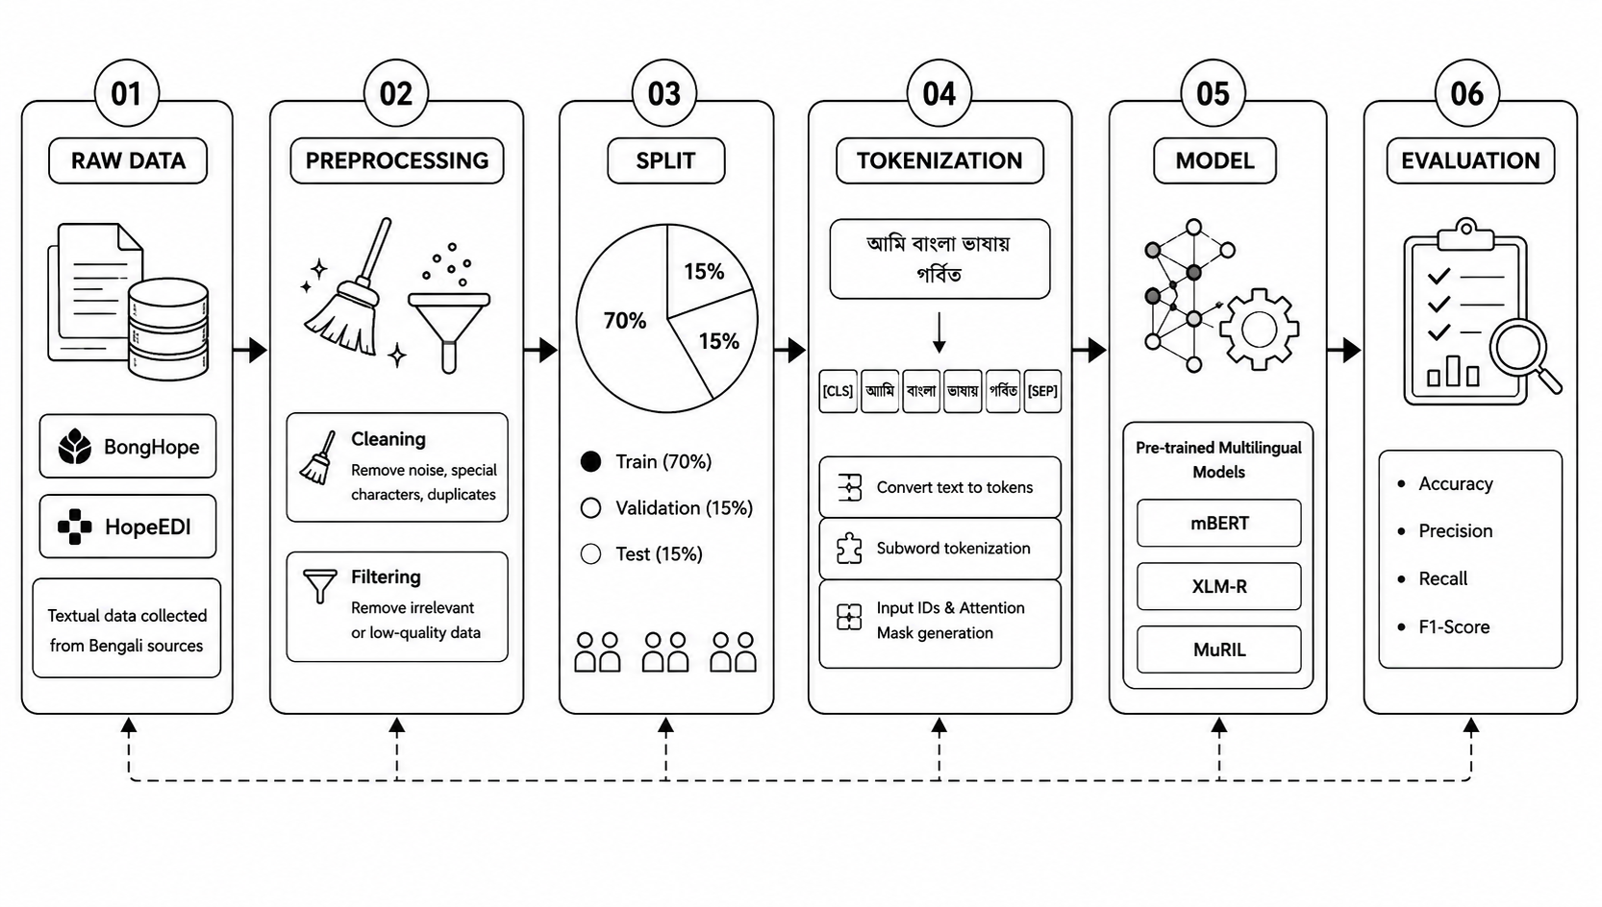

Figure 3.1: Research Framework

3.2 Dataset Description

3.2.1 Dataset Overview
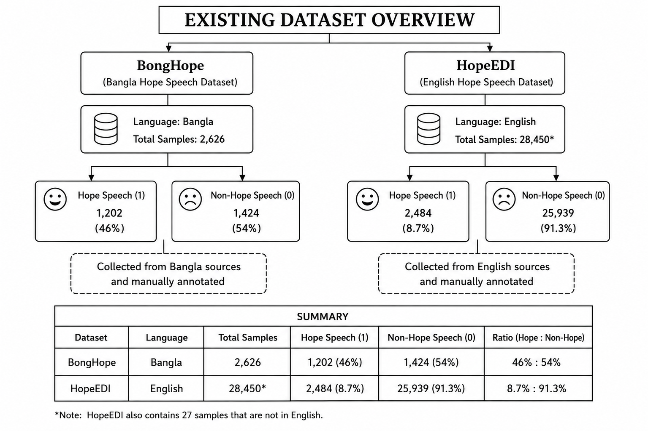

Figure 3.2.1: Existing Dataset Overview

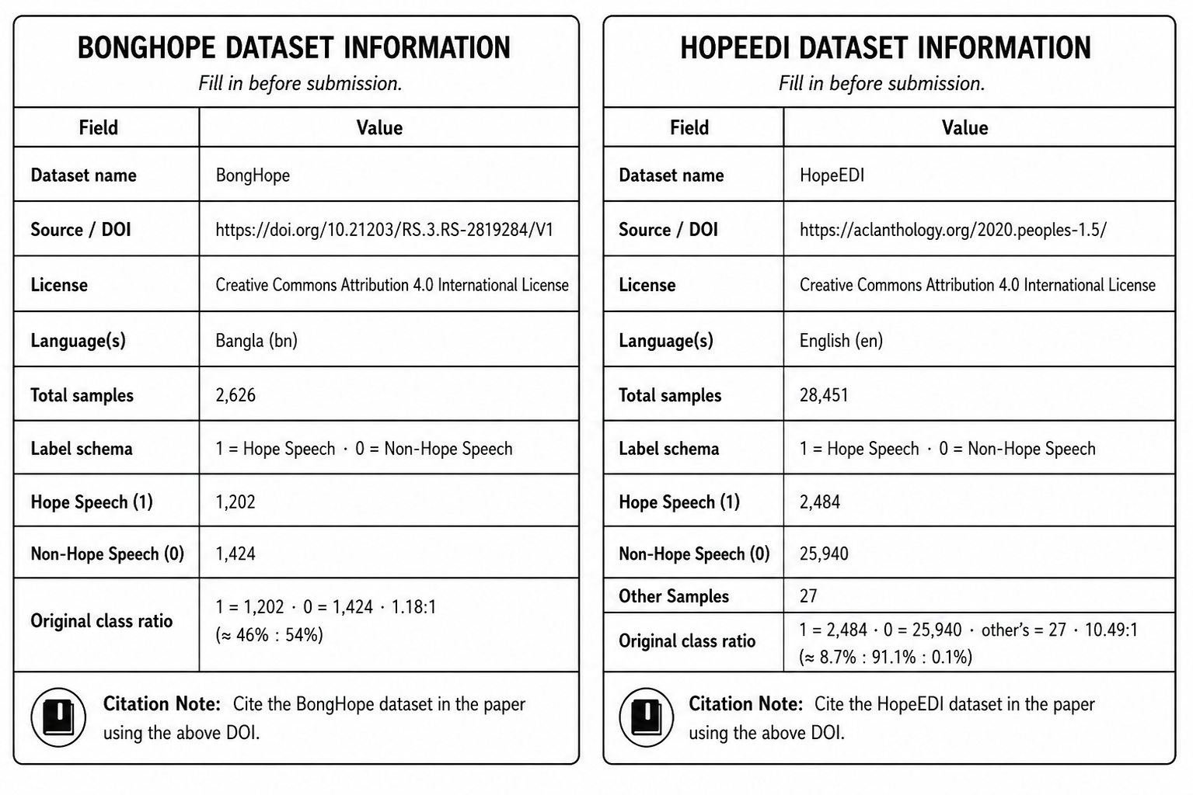
Figure 3.2.1: Dataset Information

After; Data Annotation and Labeling, It contains a total of 4,247 curated Bangla tweets and YouTube comments. This dataset is highly balanced. It contains 1,608 ‘hope speech (1)’ and 2,649 ‘non-hope speech (0)’ items, with a ratio of approximately 37.8%:62.2%. Three local native-Bangla-speaking computer science graduate students labeled the data. Their inter-rater agreement, measured on Fleiss's Kappa scale, was 0.8119, indicating “Almost Perfect Agreement”.

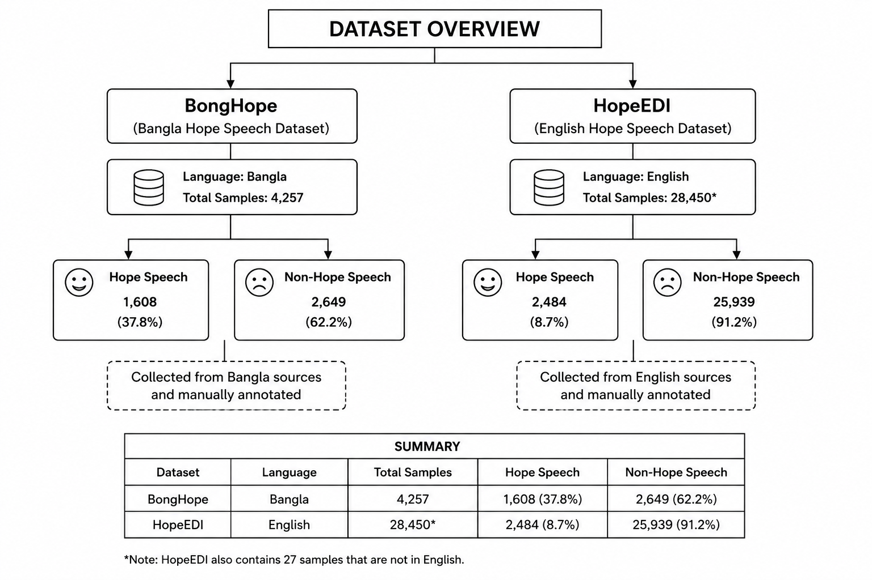
Figure 3.2.1: Datasets Overview

3.2.2 Bangla Dataset

This is the world's first high-quality, curated dataset for hope speech detection in the Bengali language. The data in this dataset was collected from Twitter (X). The data collection period was from January 2021 to September 2022. It contains a total of 2,626 curated Bangla tweets and YouTube comments. This dataset is highly balanced. It contains 1,202 ‘hope speech (1)’ and 1,424 ‘non-hope speech (0)’ items, with a ratio of approximately 46%:54%. Three local native-Bangla-speaking computer science graduate students labeled the data. Their inter-rater agreement, measured on Fleiss's Kappa scale, was 0.8119, indicating “Almost Perfect Agreement”.

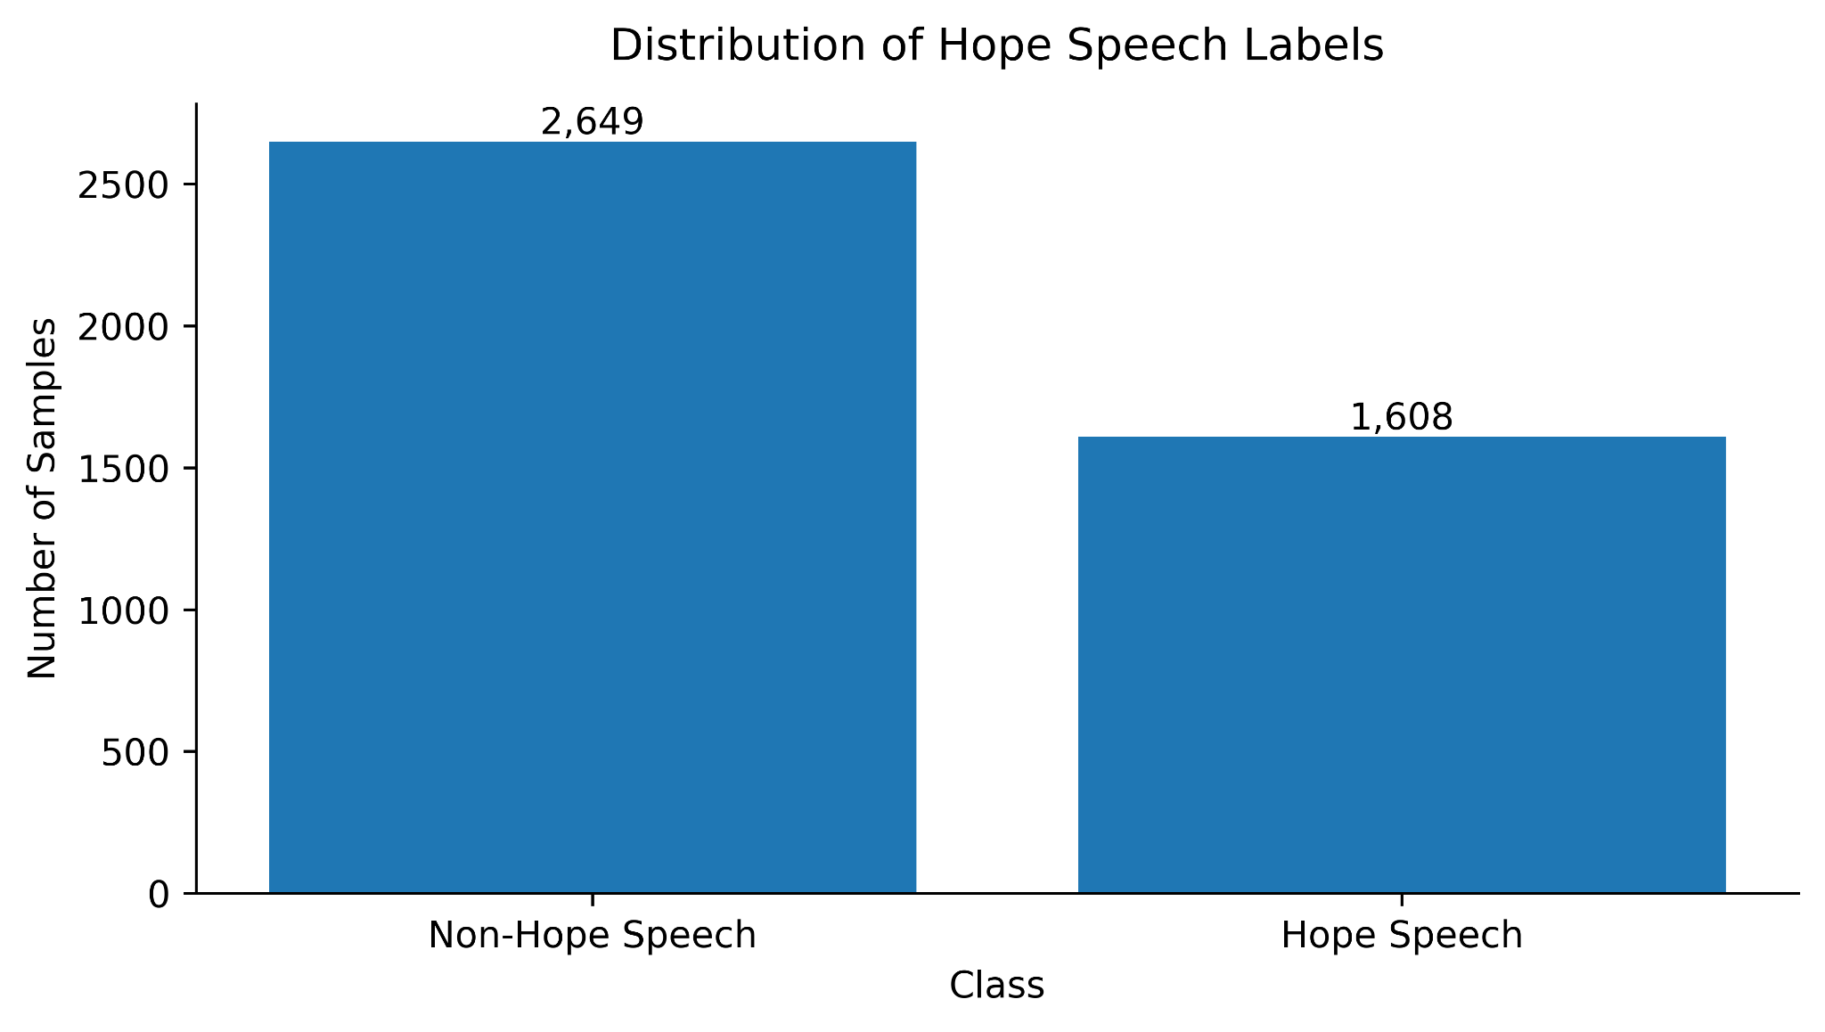
Figure 3.2.2: BongHope Dataset Overview

3.2.3 English Dataset

This is a large multilingual dataset based on topics related to Equality, Diversity, and Inclusion (EDI). This information was primarily collected from YouTube comments. The data collection period was from November 2019 to June 2020. The English subset contains a total of 28,451 YouTube comments. The dataset was primarily created to highlight women in issues, the Black Lives Matter movement, and international geopolitical issues. This dataset is extremely unbalanced. For example, its test set contained 4,784 “non-hope” messages versus only 21 “hope speech” messages. Krippendorff's Alpha was used to measure its reliability, where the standard for English was 0.63.

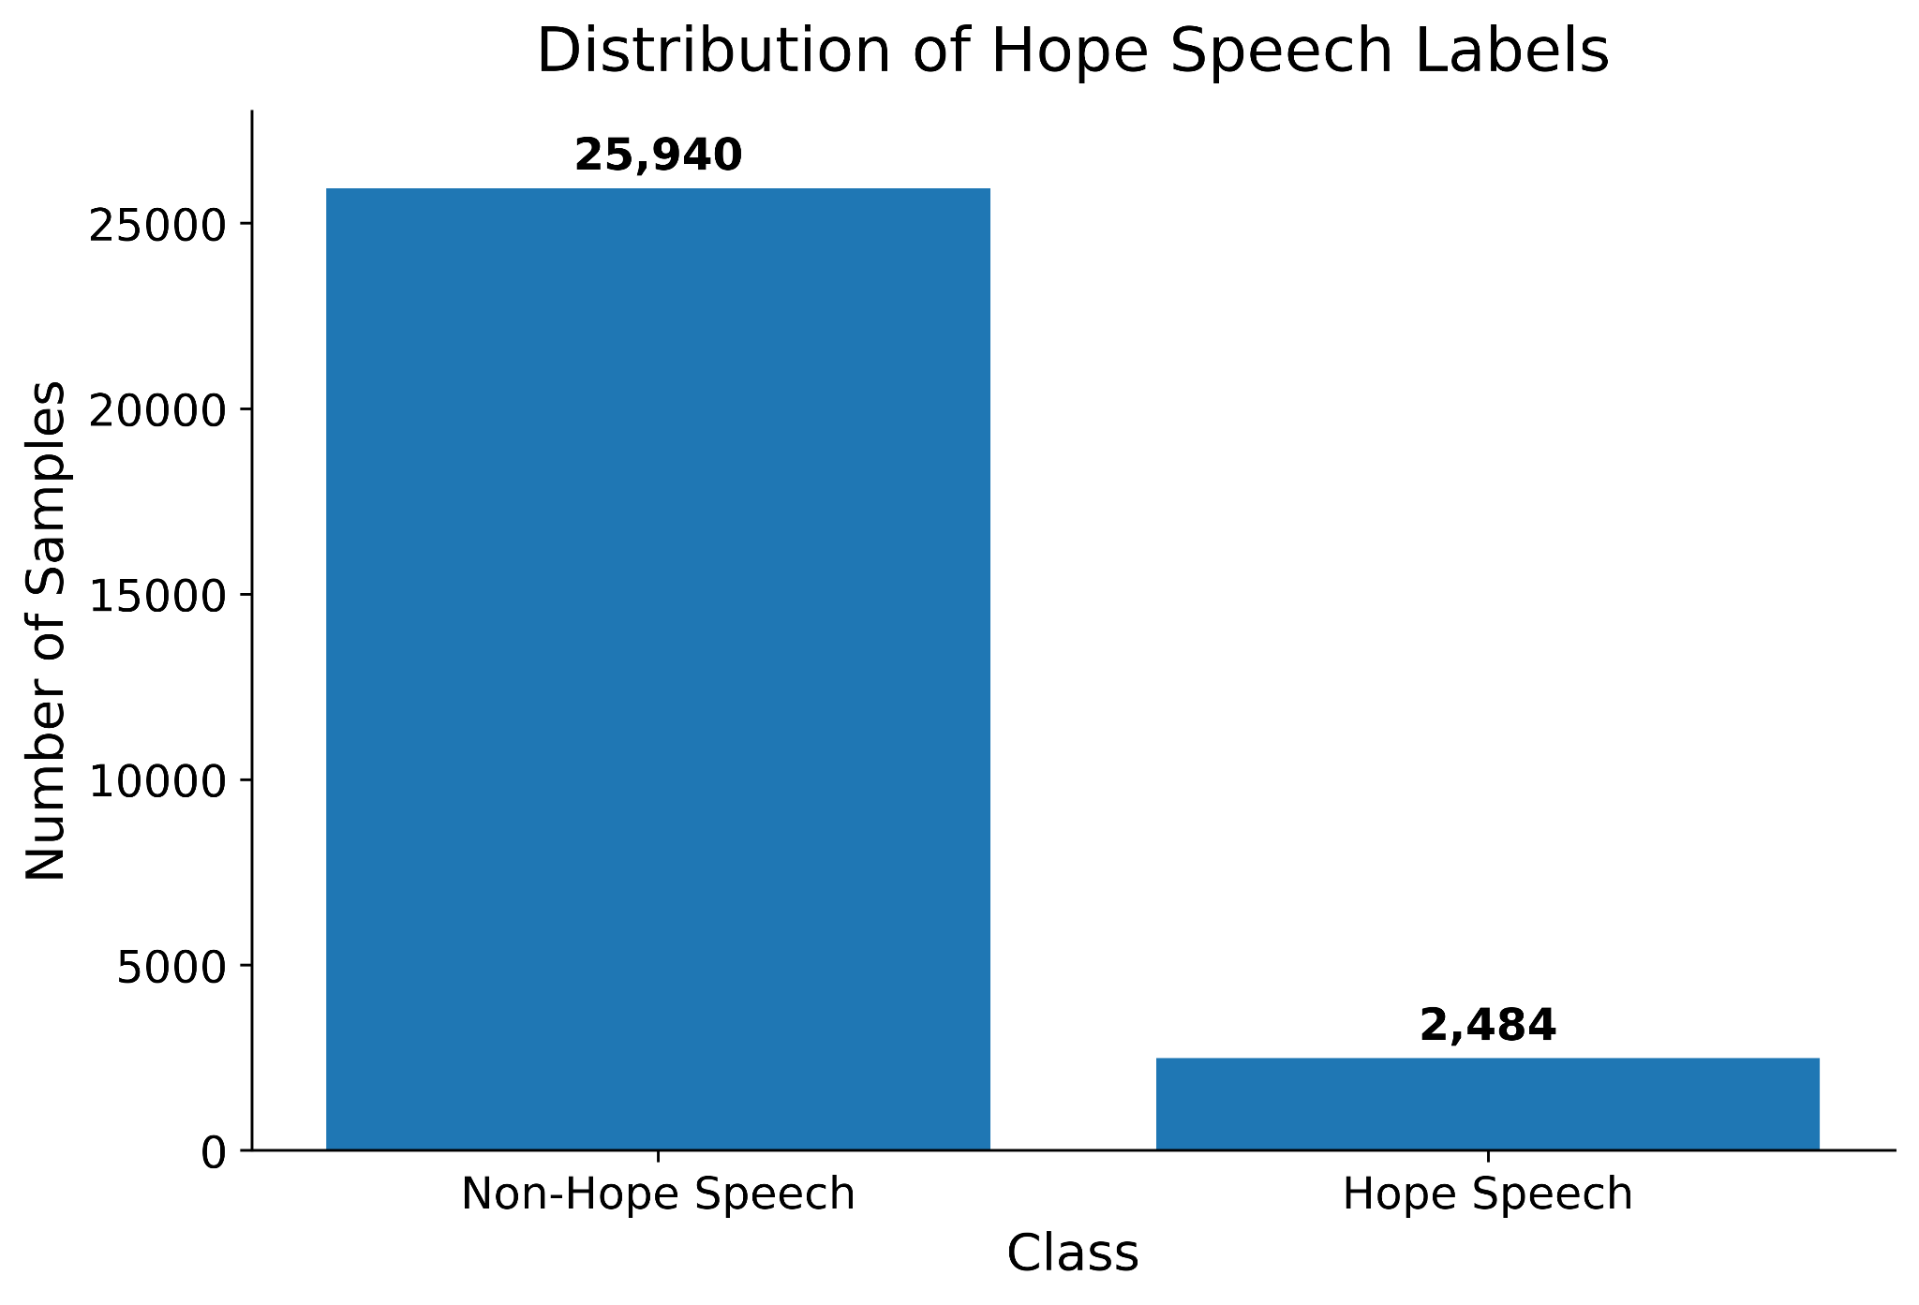

Figure 3.2.3: HopeEDI Dataset Overview

3.2.4 Bangla + English Dataset

This third version has been created by combining the Bengali and English datasets to improve research efficiency. To address the severe shortage of Hope speech in the English HopeEDI dataset, the balanced features of BongHope have been used as a supplement. Through this joint approach, the model's recall and accuracy increase. Additionally, it creates an opportunity for cross-lingual transfer of knowledge acquired from a high-resource language (English) to a low-resource language (Bangla).

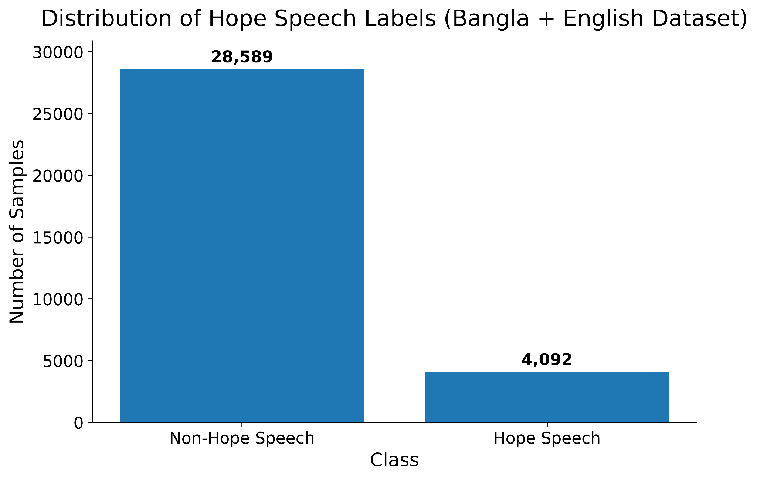

Figure 3.2.4: Bangla + English Combain Dataset

3.3 Data Annotation and Labeling

3.3.1 Hope Speech (1)

Texts or comments that help maintain peace in society and foster positive attitudes among people are identified as ‘hope speech’. Support, reassurance, or encouragement given to others during illness, stress, loneliness, or times of crisis. which promotes peace and expresses confidence in a beautiful and peaceful future. Compassionate and inspirational words that encourage people in times of hardship. Support for Equality, Diversity, and Inclusion, and positive comments toward minority communities (e.g., women, LGBTQ+, ethnic minorities). Expressing gratitude to others, praising someone's work, or conveying a message of forgiveness and tolerance.

3.3.2 Non Hope Speech (0)

Comments that do not fall within the positive or optimistic criteria of hope speech are labeled as “non-hope speech”. Messages that do not reflect any kind of support or hope. Spreading superstition, unjust or discriminatory statements, and hatred toward society or specific individuals. Aggressive or malicious remarks made with the intent to belittle someone. Sarcasm or irony that hurts another person's feelings. which causes fear or despair in people's minds. Non-hope speech does not always mean hate speech; ordinary neutral remarks or negative but non-malicious comments can also fall into this category.

A high-quality and reliable dataset for research has been created through this specific labeling method.

3.4 Data Preprocessing

3.4.1 Cleaning

Preprocessing function defined here. Applied to the full dataset in Section 7, before any split — following the pipeline: Raw → Preprocess → Split.

The main goal of this step is to remove from the text all parts that do not play a meaningful role in the model's learning process but instead may cause confusion.

Cleaning steps (inside preprocess_text):

1. Decode HTML entities (&amp; -> &, <br> -> space, etc.)

2. Strip residual HTML/XML tags.

3. NFC Unicode normalisation -- unifies Bangla characters that have

multiple valid byte-level encodings into a single canonical form.

4. Remove URLs (http:// and https://).

5. Remove @-mention tokens.

6. Clean hashtags: #hope_speech -> hope speech.

7. Collapse repeated punctuation runs (e.g., !!! -> !).

8. Remove invisible Unicode characters (ZWJ, ZWNJ, soft-hyphen, BOM).

These cause the same Bangla word to receive different tokenizer

representations and must be stripped before vocabulary is built.

9. Elongation normalisation -- collapse 3+ repeated characters to 2

(e.g., "পারবোওওও" -> "পারবোও", "yesssss" -> "yess").

Preserves intentional doubles while reducing vocabulary noise.

10. Emoji removal -- all Unicode emoji replaced with a space so they

do not become stray tokens or invisible garbage downstream.

11. Final whitespace normalisation and strip.

3.4.2 Filtering

If the collected data contains text in a language other than the specified one, it is removed. For example, during the creation of the BongHope dataset, tweets written in Assamese were identified and manually removed. Similarly, in the HopeEDI dataset, comments in irrelevant languages were deleted using the Langdetect tool.

Filtering steps (inside apply_preprocessing):

1. Drop NaN values in 'text' or 'label' columns.

2. Drop rows whose label is not in {0, 1}.

3. Apply preprocess_text to the 'text' column.

4. Drop rows whose text is empty after cleaning.

5. Drop rows with fewer than min_words whitespace-delimited tokens.

6. Drop rows shorter than min_chars characters.

7. Drop rows longer than max_chars characters (likely spam / data errors).

8. Script validation: drop rows that do not meet the expected script

ratio (Bangla Unicode block >= script_threshold fraction).

9. Drop exact duplicates (identical text AND label pair).

10. Detect and remove annotation conflicts (same text, different labels).

The Clean step removes unnecessary noise from the text, and the Filter step retains only the high-quality and relevant information for research.

3.5 Data Split

Split: 70% train | 15% val | 15% test — ALL done AFTER preprocessing.

Pipeline: Raw → Preprocess → Split.

df_test -- 15 % stratified hold-out; frozen, never modified.

df_val -- 15 % real data; early stopping + threshold calibration.

df_train_raw -- 70 % training pool.

3.5.1 Test & Val Data

The remaining 15% of the data is reserved to evaluate the model's final performance and accuracy. This data is completely new or unknown to the model. After training is complete, metrics such as Precision, Recall, and F1-score are calculated based on how successfully the model can identify hope speech on this unknown 15% of the data.

During training, 15% of the total data is set aside as a validation set to monitor the model's progress. Its main purpose is to tune the model's hyperparameters (such as the learning rate, batch size) , optimize the model's hyperparameters (such as learning rate, batch size) and prevent overfitting. This ensures that the model is not just memorizing the data, but is actually understanding the underlying patterns.

3.5.2 Train Data

The largest portion of the dataset, i.e., 70% of the data, is used for training the model. The model learns the linguistic features, semantic depth of words, and context of the various ‘hope’ and ‘non-hope’ messages in this portion. Using this vast amount of data, the model establishes its own mathematical weights (Weights) are determined so that the model can subsequently identify the category of any new text it encounters.

3.6 Model Selection

3.6.1 mBERT (Multilingual BERT)

mBERT, or Multilingual BERT (Bidirectional Encoder Representations from Transformers), is a powerful transformer model developed by Google. It is pre-trained on a massive text corpus of 104 world languages, including Bengali. It is capable of understanding deep semantic relationships among different languages, which makes it highly effective in multilingual research. On the BongHope (Bangla) dataset, it achieved an F1 score of 0.808. It also outperformed traditional machine learning models on the English dataset.

3.6.2 XLM-R (XLM-RoBERTa)

XLM-R is a multilingual version of the RoBERTa model. It was trained on 2.5 terabytes (TB) of CommonCrawl data in 100 languages. It is particularly effective for advanced cross-lingual generalization (applying knowledge from one language to another) and for handling unstructured or code-mixed (mixed-language) social media texts. In the BongHope study, it achieved the second-best performance, with an F1-score of 0.827. Additionally, in the LT-EDI 2021 competition for English hope speech detection, it achieved an F1-score of up to 0.93.

3.6.3 MuRIL (Multilingual Representations for Indian Languages)

MuRIL is a transformer model developed in 2020 by Google's Indian Research Unit specifically for Indian languages. It is based on the BERT architecture and has been intensively trained on 17 Indian languages, including Bengali. Compared to general multilingual models, MuRIL can much better understand the linguistic features, writing systems, and cultural contexts of Indian languages. According to the sources you provided, MuRIL achieved the best results in Bangla hope speech recognition, with a Macro F1-score of 0.8498 (approximately 0.85).

The primary reasons for selecting these research models are their high accuracy and multilingual capabilities. In particular, MuRIL has excelled in speech recognition for Bengali, and XLM-R has achieved superiority in international contexts.

3.7 Experimental Setup

Experiment Setup: Bangla → Bangla / English → English (Monolingual);

English to English → Bangla (Cross-Lingual / Zero-Short); Bangla + English → Bangla (Multilingual)

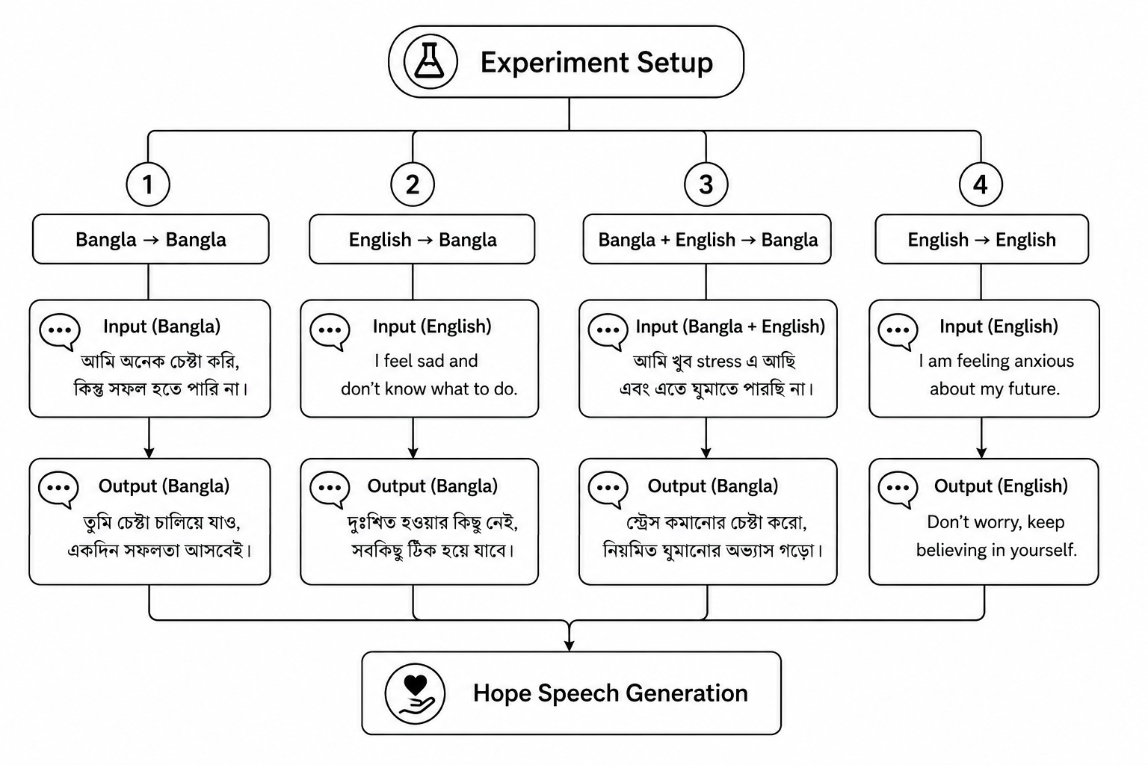

Figure 3.7: Experiment Setup

Experiment Flowchart: Raw Data → Clean → Filter → Split → Tokenize → Train → Prediction → Evaluation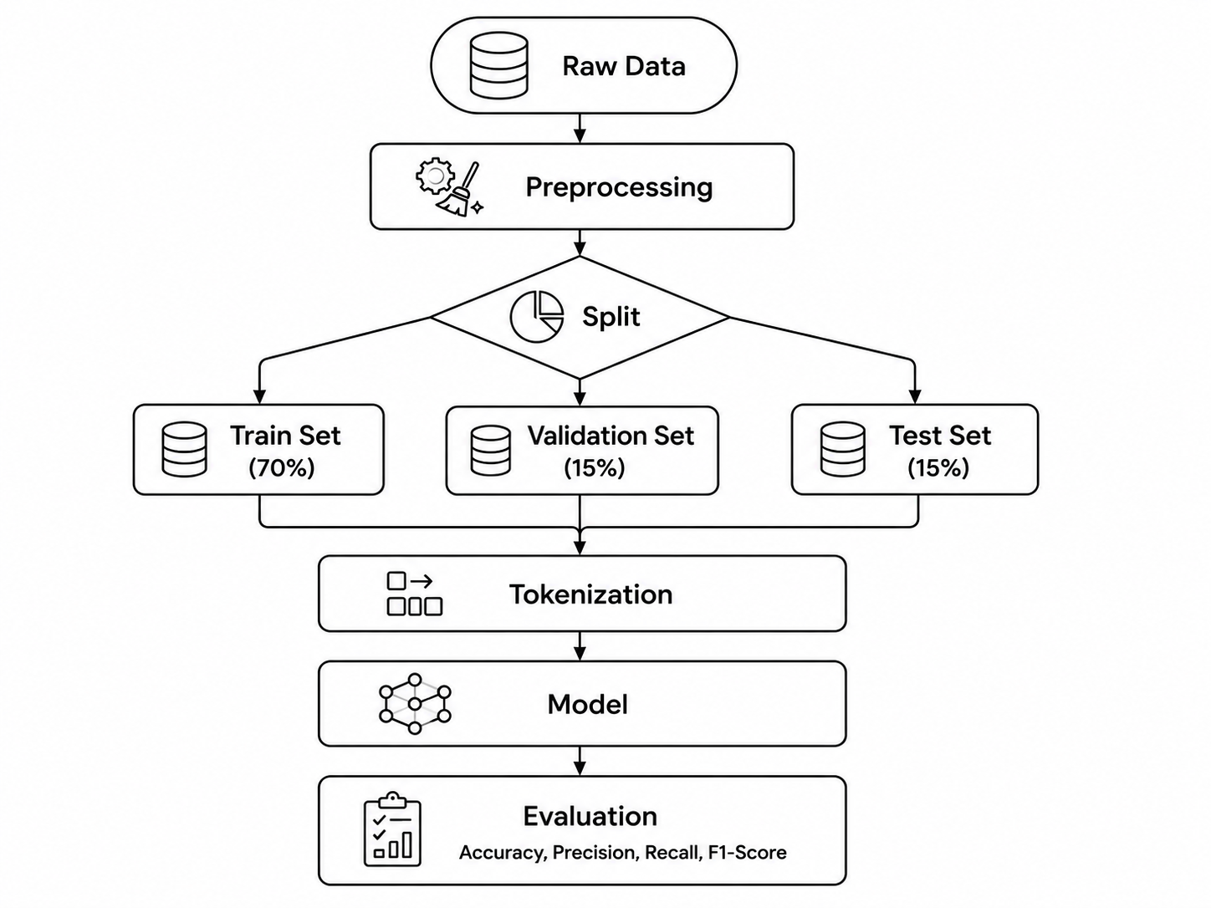

Figure 3.7: Experiment Flowchart

3.7.1 Monolingual (Bangla → Bangla) / (English → English)

In this method, the model is trained on a specific language and its performance is tested on information in that same language.

Bangla → Bangla: Here, the model is trained only using the Bangla tweets from the BongHope dataset and tested solely on Bangla.

English → English: Similarly, the model is trained on the English subset of the HopeEDI dataset to validate its ability to detect English Hope speech.

The main goal of this setup is to establish a baseline performance or benchmark for each language.

3.7.2 Cross-lingual (English → Bangla)

In this approach, knowledge acquired from one language is transferred to another language (Knowledge Transfer).

English → Bangla: Knowledge derived from the vast social and linguistic diversity of English, a high-resource language (HopeEDI), is applied to the low-resource language Bengali (BongHope) [1, 2]. It examines how helpful a language's “semantic” or semantic features are in detecting hope speech in another language. In particular, evidence shows that the F1-score increases by about 7% when transferring from English to Spanish.

3.7.3 Multilingual (Bangla + English → Bangla)

In this setup, datasets from multiple languages are combined to create a joint classifier. The model is trained by combining Bengali and English data. To address the severe class imbalance in the English HopeEDI dataset, the balanced features of BongHope are used as complements. This approach increases the model's recall and accuracy and enables it to handle mixed forms (code-mixing) of different languages.

In all three setups, experiments were primarily conducted using powerful transformer models such as MuRIL, XLM-RoBERTa, and mBERT. Through these methods, researchers have developed a robust framework for hop speech detection in both Bengali and English.

3.8 Baseline Configuration

Term Frequency–Inverse Document Frequency (TF-IDF) was used as the primary feature extraction technique. The extracted TF-IDF features were subsequently utilized by several traditional machine learning classifiers.

TF-IDF(t,d) = TF(t,d) × IDF(t) (3.8)

3.8.1 TF-IDF + Logistic Regression

Logistic Regression (LR) is a linear classification algorithm that estimates the probability of an instance belonging to a particular class.

P(y=1|X)=1/(1+e^-(β₀+β₁x₁+...+β_{n}x_{n})) (3.8.1)

3.8.2 TF-IDF + Linear SVM

Support Vector Machine (SVM) constructs an optimal hyperplane for separating classes.
f(x)=wᵀx+b (3.8.2)

3.8.3 TF-IDF + Naive Bayes

Naive Bayes (NB) is a probabilistic classifier based on Bayes' theorem.

P(C|X)=(P(X|C)×P(C))/P(X) (3.8.3)

3.8.4 TF-IDF + Random Forest

Random Forest (RF) is an ensemble learning method that combines multiple decision trees through majority voting.

ŷ = mode(T₁(x),T₂(x),...,T_{n}(x)) (3.8.4)

3.8.5 TF-IDF + XGBoost

Extreme Gradient Boosting (XGBoost) is a boosting-based ensemble learning algorithm.
ŷ = Σf_{k}(x) (3.8.5)

3.9 Evaluation Metrics

To evaluate the performance of the proposed models, Accuracy, Precision, Recall, and F1-Score were employed. Since the datasets are imbalanced, particular emphasis was placed on metrics that effectively capture minority-class performance.

3.9.1 Accuracy

Accuracy measures the proportion of correctly classified instances.

Accuracy=(TP+TN)/(TP+TN+FP+FN) (3.9.1)

3.9.2 Precision

Precision measures the proportion of predicted Hope Speech instances that are actually Hope Speech.

Precision=TP/(TP+FP) (3.9.2)

3.9.3 Recall

Recall measures the proportion of actual Hope Speech instances correctly identified by the model.

Recall=TP/(TP+FN) (3.9.3)

3.9.4 F1-Score

F1-Score is the harmonic mean of Precision and Recall and is particularly suitable for imbalanced datasets.

F1-Score=2×(Precision×Recall)/(Precision+Recall) (3.9.4)

Chapter 4 Experimental Results and Discussion

4.1 Experimental Environment

Hardware Specifications

Transformer-based models (e.g., BERT, MuRIL, XLM-R) require high-performance hardware for training. The research has typically used the following hardware. NVIDIA T4 GPU was used for model training. Sufficient RAM and video memory (VRAM) were ensured to process large models quickly.

Software and Libraries

The research work was primarily carried out in the Python programming language, and various open-source libraries were used. PyTorch and the Hugging Face Transformers library were used for model building and training. The Scikit-learn (sklearn) library was used to build traditional models and baselines.

Data Splitting

Preprocessing is applied to both full datasets before any split. Pipeline: Raw → Preprocess → Split.

For, Monolingual

df_test — 15 % stratified hold-out; frozen for final evaluation.

df_val — 15 % stratified hold-out from the remaining data; never modified; used for both early stopping during training and threshold calibration after training.

df_train_raw — the remaining 70 % used as the training pool.

For, Cross-lingual

Bangla (df_bn):

df_test — 15 % stratified hold-out; frozen for final evaluation.

df_val_bn — 15 % stratified hold-out; real data; contributes to the combined early-stopping val set.

df_bn_trainval — remaining 70 %; used as the training pool.

English (df_en):

df_en_val — 15 % stratified hold-out; real data; contributes to the combined early-stopping val set.

df_en_train — remaining 85 %; used as the training pool.

The combined early-stopping val set is df_val = df_val_bn + df_en_val (real data only).

Training Hyperparameters / Configarations

MAX_LEN = 128

BATCH_SIZE = 16

NUM_EPOCHS = 4

LEARNING_RATE = 1e-5

WARMUP_RATIO = 0.1

WEIGHT_DECAY = 0.01

TEST_SIZE = 0.15

VAL_SIZE = 0.15

NUM_LABELS = 2

4.2 Experimental Data Overview

4.2.1 Monolingual (Bangla → Bangla / English → English)

mBERT (Bangla → Bangla), Dataset overview (after preprocessing, before split):

Total samples : 4030

Non-Hope (0) : 2531 (62.8 %)

Hope (1) : 1499 (37.2 %)

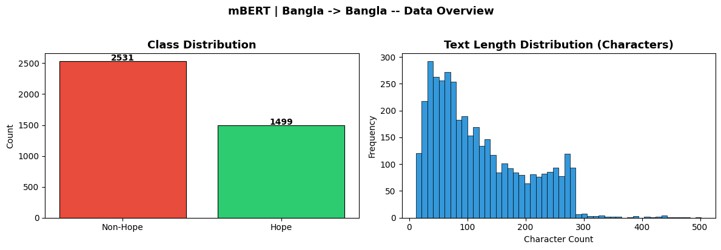
Figure 4.2.1: mBERT BAN → BAN Data Overview

mBERT (English → English), Dataset overview (after preprocessing, before split):

Total samples : 26266

Non-Hope (0) : 24042 (91.5 %)

Hope (1) : 2224 (8.5 %)

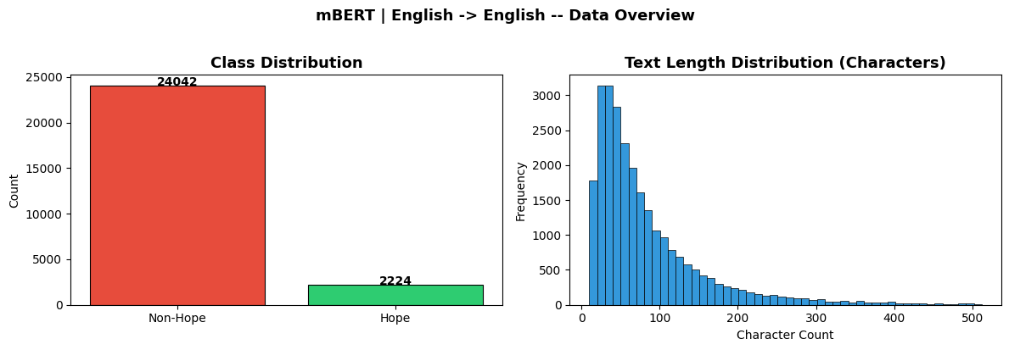
Figure 4.2.1: mBERT ENG → ENG Data Overview

XLM-R (Bangla → Bangla), Dataset overview (after preprocessing, before split):

Total samples : 4030

Non-Hope (0) : 2531 (62.8 %)

Hope (1) : 1499 (37.2 %)

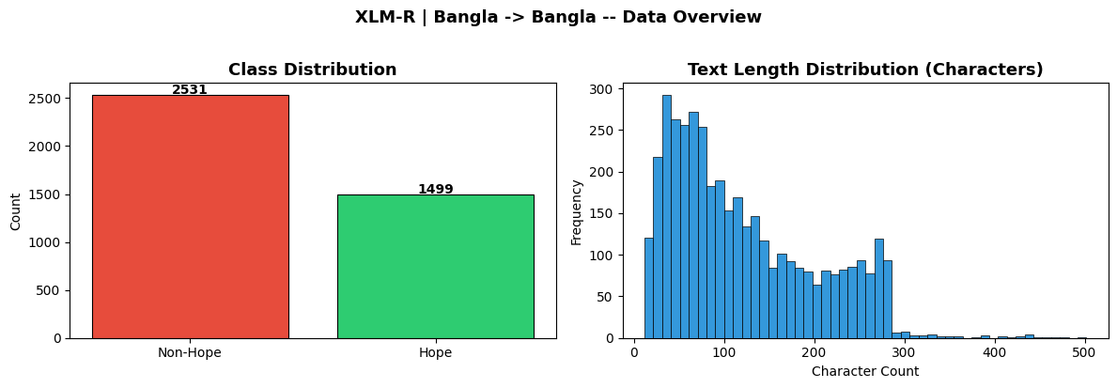
Figure 4.2.1: XLM-R BAN → BAN Data Overview

XLM-R (English → English), Dataset overview (after preprocessing, before split):

Total samples : 26266

Non-Hope (0) : 24042 (91.5 %)

Hope (1) : 2224 (8.5 %)

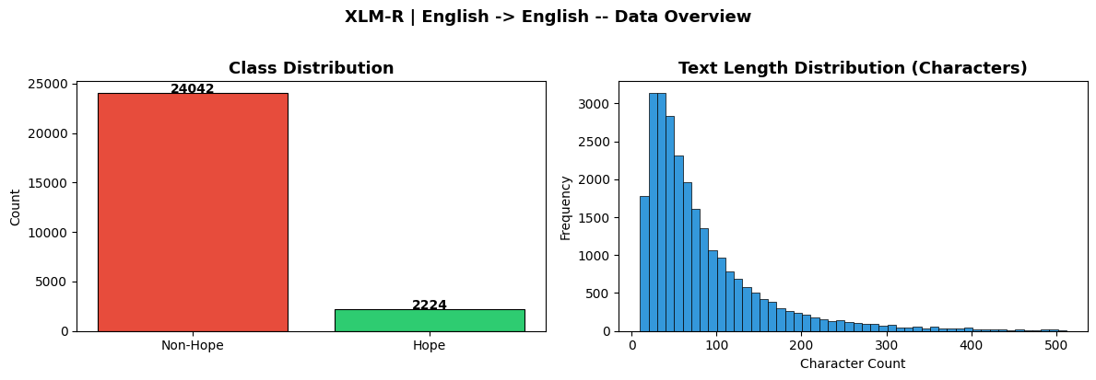
Figure 4.2.1: XLM-R ENG → ENG Data Overview

MuRIL (Bangla → Bangla), Dataset overview (after preprocessing, before split):

Total samples : 4030

Non-Hope (0) : 2531 (62.8 %)

Hope (1) : 1499 (37.2 %)

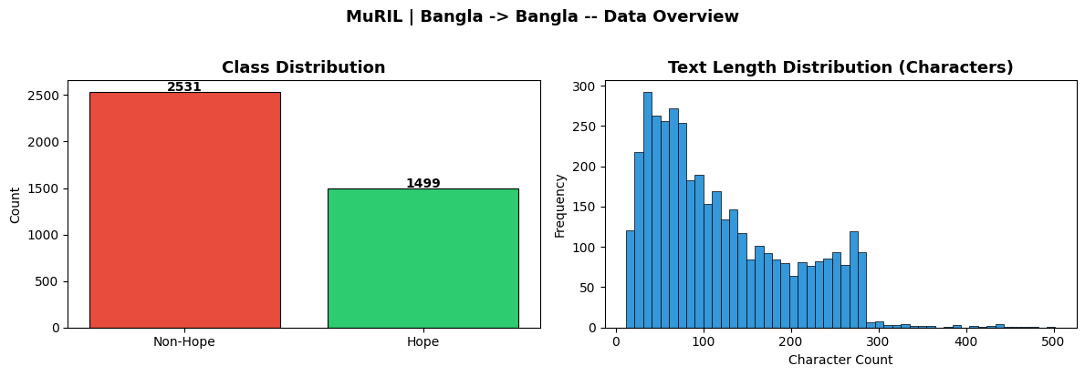
Figure 4.2.1: MuRIL BAN → BAN Data Overview

MuRIL (English → English), Dataset overview (after preprocessing, before split):

Total samples : 26266

Non-Hope (0) : 24042 (91.5 %)

Hope (1) : 2224 (8.5 %)

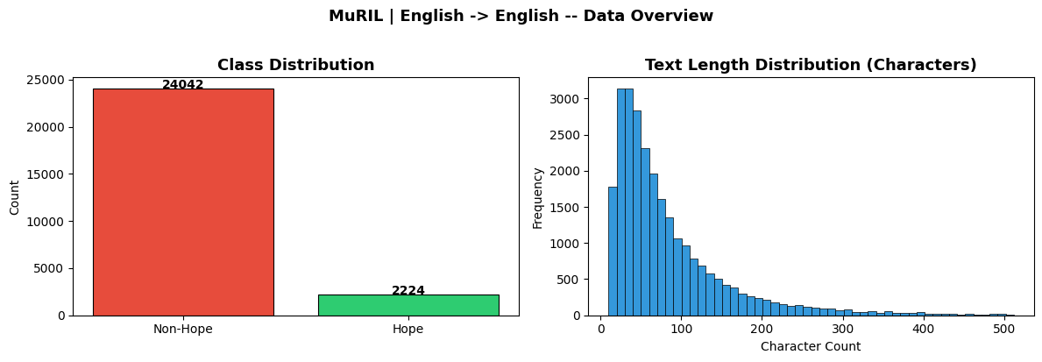
Figure 4.2.1: MuRIL ENG → ENG Data Overview

4.2.2 Cross-lingual (English → Bangla)

mBERT (English → Bangla), Dataset overview (after preprocessing & split):

English total : 26263 samples

English train pool : 22323 (~85.0 %)

English val (early stop) : 3940 (~15.0 %) ← real data, held-out

Bangla (test, zero-shot) : 4030 samples ← frozen

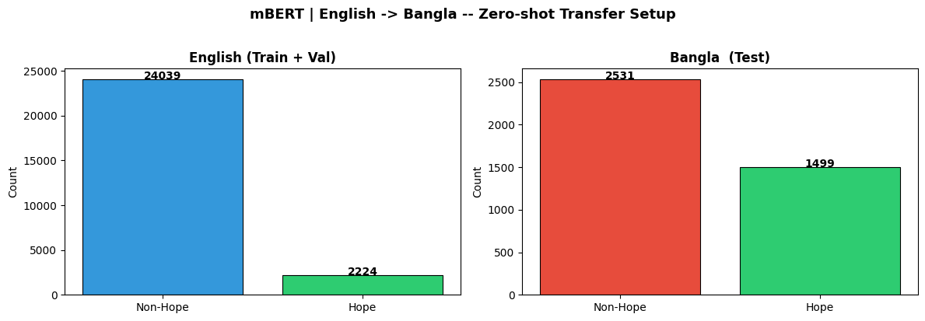
Figure 4.2.2: mBERT ENG → BAN Data Overview

XLM-R (English → Bangla), Dataset overview (after preprocessing & split):

English total : 26263 samples

English train pool : 22323 (~85.0 %)

English val (early stop) : 3940 (~15.0 %) ← real data, held-out

Bangla (test, zero-shot) : 4030 samples ← frozen

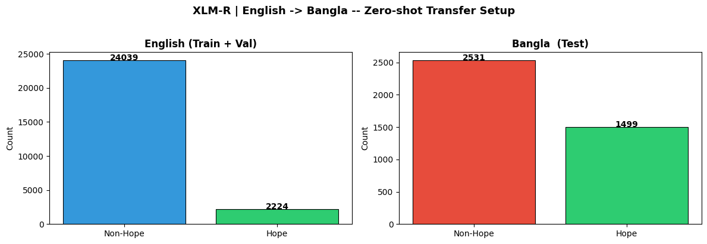
Figure 4.2.2: XLM-R ENG → BAN Data Overview

MuRIL (English → Bangla), Dataset overview (after preprocessing & split):

English total : 26263 samples

English train pool : 22323 (~85.0 %)

English val (early stop) : 3940 (~15.0 %) ← real data, held-out

Bangla (test, zero-shot) : 4030 samples ← frozen

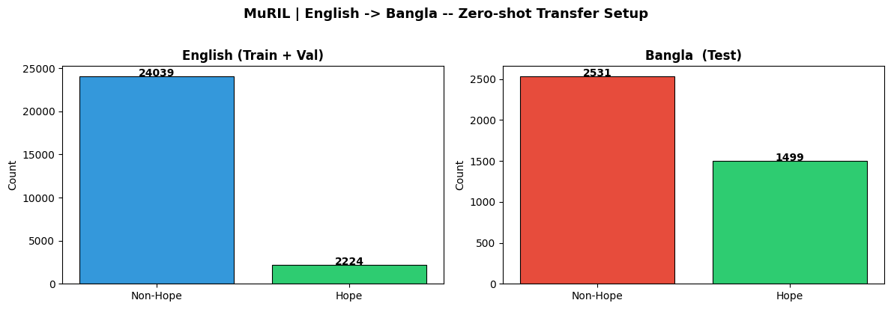
Figure 4.2.2: MuRIL ENG → BAN Data Overview

4.2.3 Multilingual (Bangla + English → Bangla)

mBERT (Bangla + English → Bangla), Dataset overview (after preprocessing & split):

Bangla total : 4030

Bangla train pool : 2820 (~70.0 %)

Bangla val (early stop) : 605 (~15.0 %) ← real data

Bangla test (frozen) : 605 (~15.0 %)

English total : 26266

English train : 22326 (~85.0 %)

English val (early stop) : 3940 (~15.0 %) ← real data

Combined train pool : 25146 (Bangla train + English train)

Combined val : 4545 (Bangla val + English val, real data only)

Training pool : 25146 (Bangla train + English train)

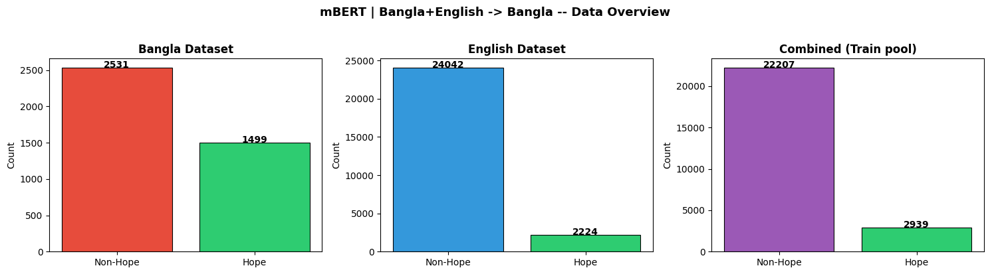
Figure 4.2.3: mBERT BAN + ENG → BAN Data Overview

XLM-R (Bangla + English → Bangla), Dataset overview (after preprocessing & split):

Bangla total : 4030

Bangla train pool : 2820 (~70.0 %)

Bangla val (early stop) : 605 (~15.0 %) ← real data

Bangla test (frozen) : 605 (~15.0 %)

English total : 26266

English train : 22326 (~85.0 %)

English val (early stop) : 3940 (~15.0 %) ← real data

Combined train pool : 25146 (Bangla train + English train)

Combined val : 4545 (Bangla val + English val, real data only)

Training pool : 25146 (Bangla train + English train)

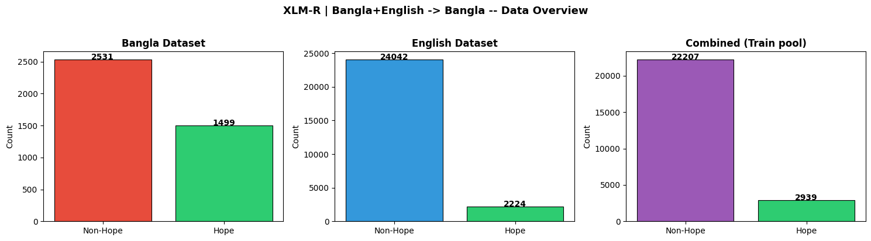
Figure 4.2.3: XLM-R BAN + ENG → BAN Data Overview

MuRIL (Bangla + English → Bangla), Dataset overview (after preprocessing & split):

Bangla total : 4030

Bangla train pool : 2820 (~70.0 %)

Bangla val (early stop) : 605 (~15.0 %) ← real data

Bangla test (frozen) : 605 (~15.0 %)

English total : 26266

English train : 22326 (~85.0 %)

English val (early stop) : 3940 (~15.0 %) ← real data

Combined train pool : 25146 (Bangla train + English train)

Combined val : 4545 (Bangla val + English val, real data only)

Training pool : 25146 (Bangla train + English train)

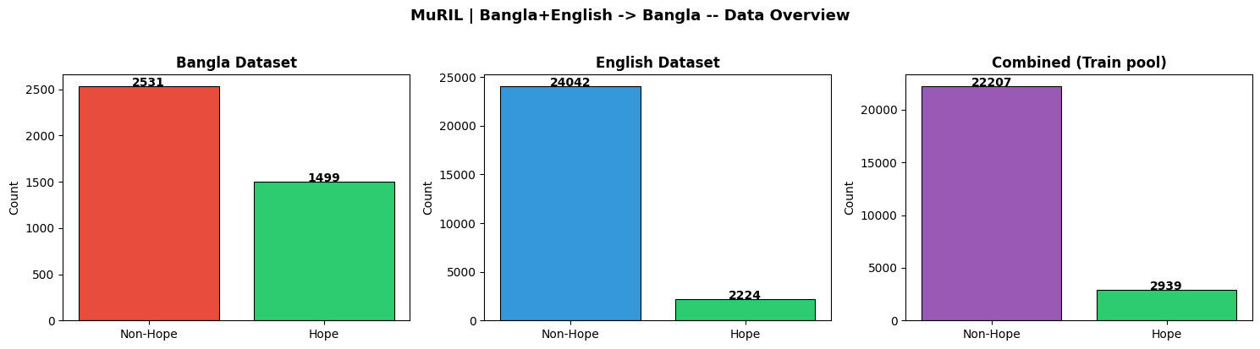
Figure 4.2.3: MuRIL BAN + ENG → BAN Data Overview

4.3 Training & Validation Analysis

4.3.1 Monolingual (Bangla → Bangla / English → English)

mBERT (Bangla → Bangla), Total dataset : 4030 samples

Train pool : 2820 samples (~70.0 %), Val : 605 samples (~15.0 %) ← real data,

held-out, Test : 605 samples (~15.0 %) ← frozen

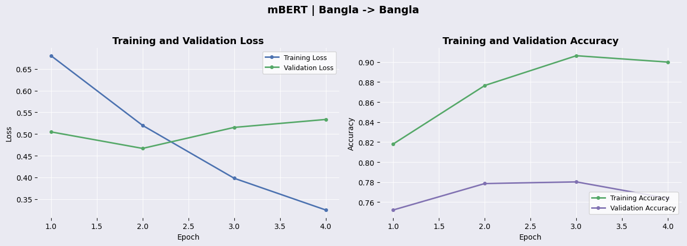

Figure 4.3.1: mBERT BAN → BAN Training Curves

mBERT ( English → English), Total dataset : 26266 samples

Train pool : 18386 samples (~70.0 %)

Val : 3940 samples (~15.0 %) ← real data, held-out

Test : 3940 samples (~15.0 %) ← frozen

Figure 4.3.1: mBERT ENG → ENG Training Curves

XLM-R (Bangla → Bangla), Total dataset : 4030 samples

Train pool : 2820 samples (~70.0 %), Val : 605 samples (~15.0 %) ← real data,

held-out, Test : 605 samples (~15.0 %) ← frozen

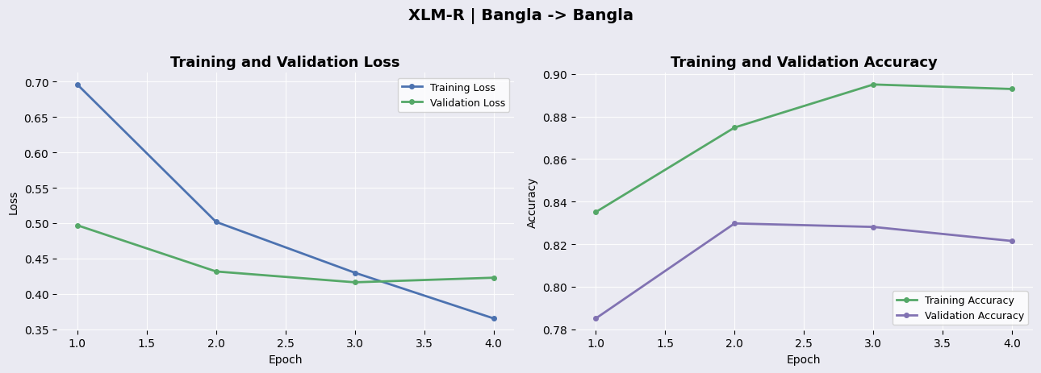

Figure 4.3.1: XLM-R BAN → BAN Training Curves

XLM-R (English → English), Total dataset : 26266 samples

Train pool : 18386 samples (~70.0 %)

Val : 3940 samples (~15.0 %) ← real data, held-out

Test : 3940 samples (~15.0 %) ← frozen

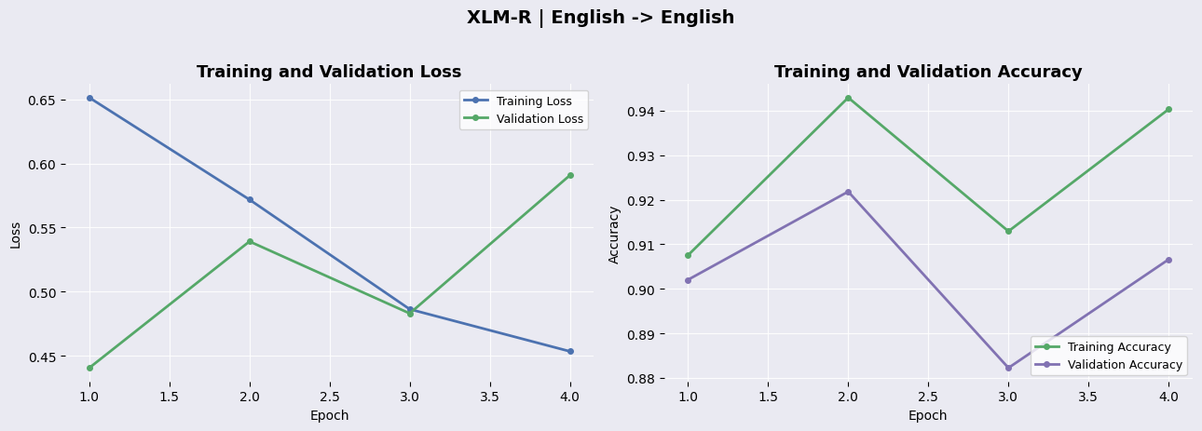

Figure 4.3.1: XLM-R ENG → ENG Training Curves

MuRIL (Bangla → Bangla), Total dataset : 4030 samples

Train pool : 2820 samples (~70.0 %), Val : 605 samples (~15.0 %) ← real data,

held-out, Test : 605 samples (~15.0 %) ← frozen

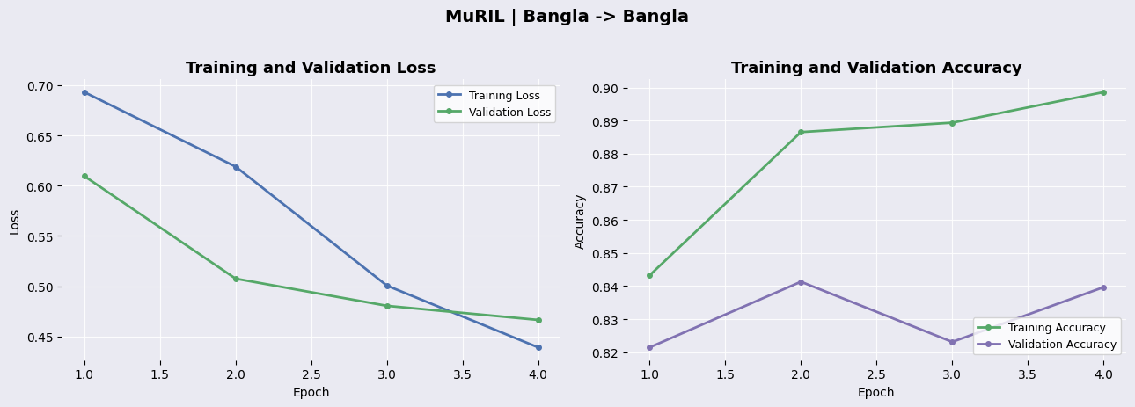

Figure 4.3.1: MuRIL BAN → BAN Training Curves

MuRIL (English → English), Total dataset : 26266 samples

Train pool : 18386 samples (~70.0 %)

Val : 3940 samples (~15.0 %) ← real data, held-out

Test : 3940 samples (~15.0 %) ← frozen

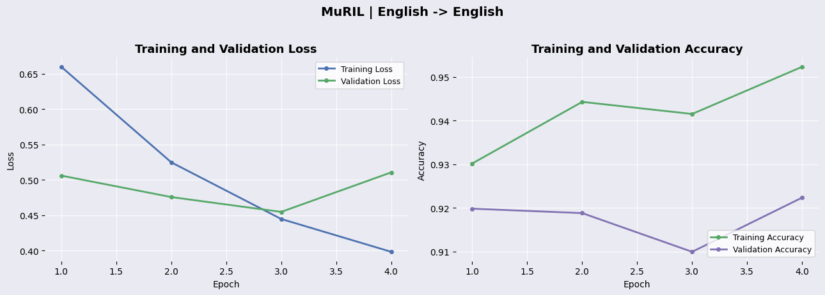

Figure 4.3.1: MuRIL ENG → ENG Training Curves

4.3.2 Cross-lingual (English → Bangla)

mBERT (English → Bangla), Dataset sizes | Train: 22323 | Val: 3940 | Test: 4030

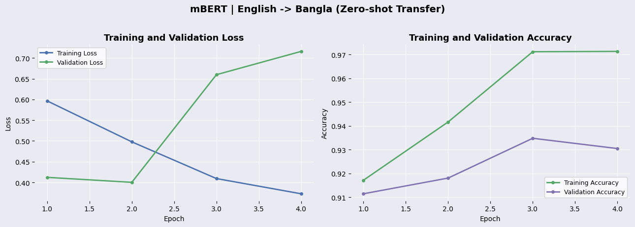

Figure 4.3.2: mBERT ENG → BAN Training Curves

XLM-R (English → Bangla), Dataset sizes | Train: 22323 | Val: 3940 | Test: 4030

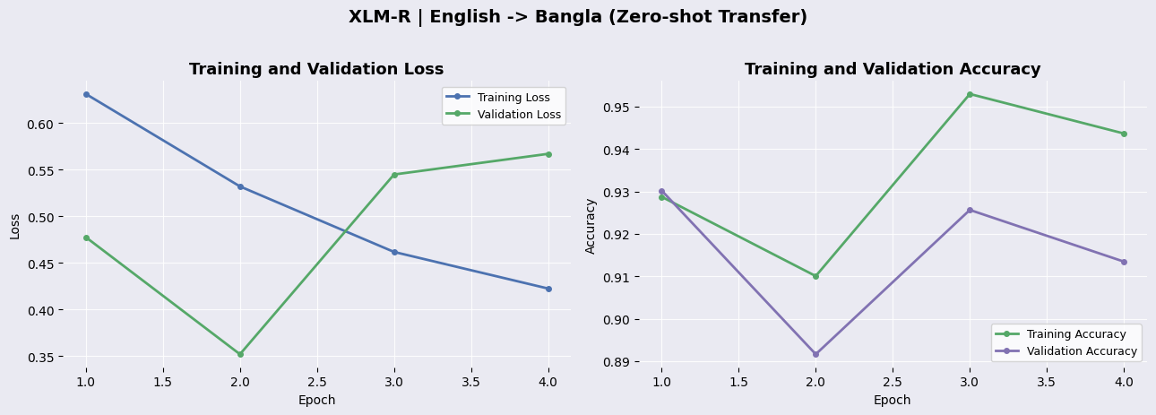

Figure 4.3.2: XLM-R ENG → BAN Training Curves

MuRIL (English → Bangla), Dataset sizes | Train: 22323 | Val: 3940 | Test: 4030

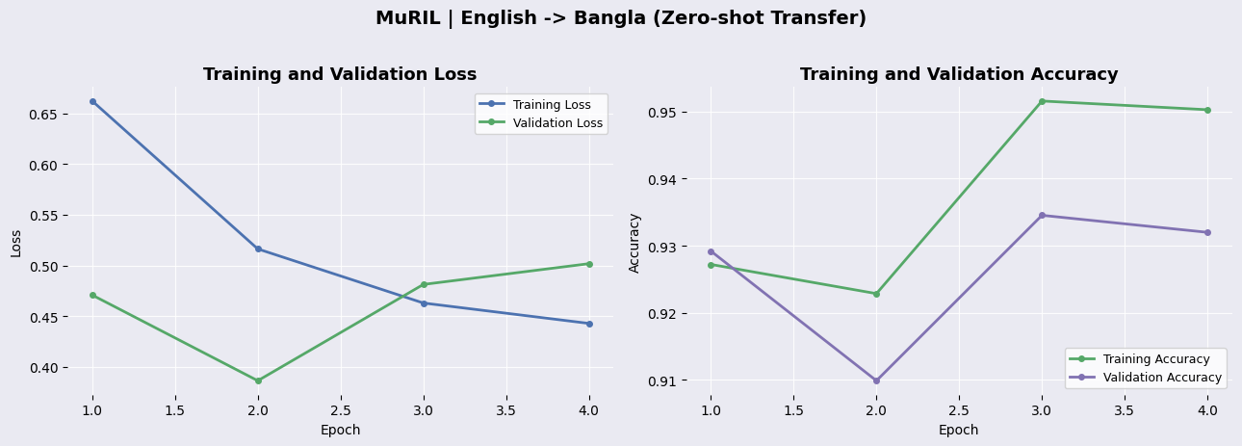

Figure 4.3.2: MuRIL ENG → BAN Training Curves

4.3.3 Multilingual (Bangla + English → Bangla)

mBERT (Bangla + English → Bangla), Dataset sizes | Train: 25146 | Val: 4545 | Test: 605

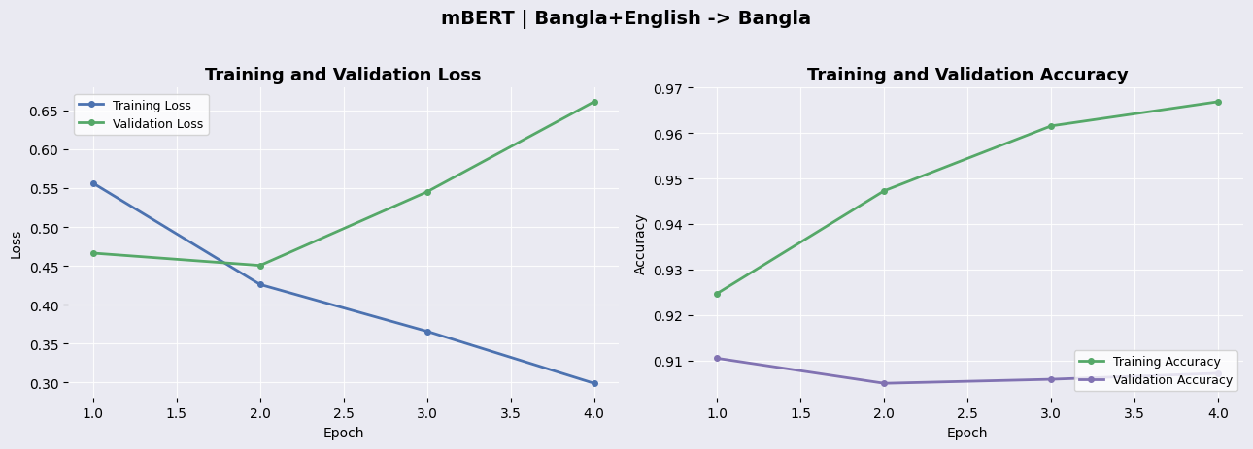

Figure 4.3.3: mBERT BAN + ENG → BAN Training Curves

XML-R (Bangla + English → Bangla), Dataset sizes | Train: 25146 | Val: 4545 | Test: 605

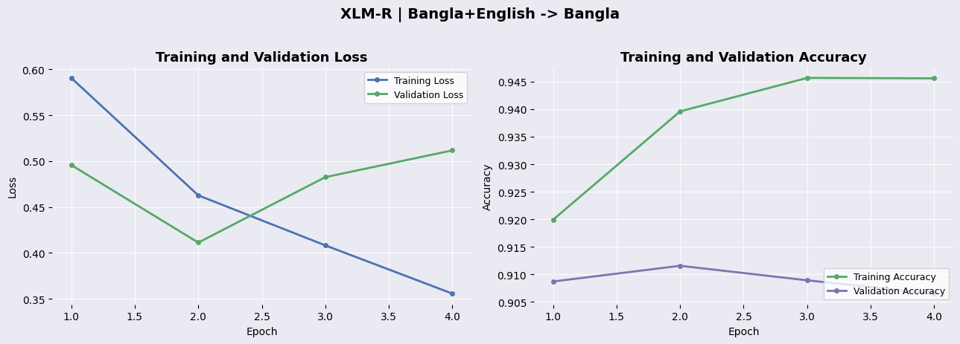

Figure 4.3.3: XLM-R BAN + ENG → BAN Training Curves

MuRIL (Bangla + English → Bangla), Dataset sizes | Train: 25146 | Val: 4545 | Test: 605

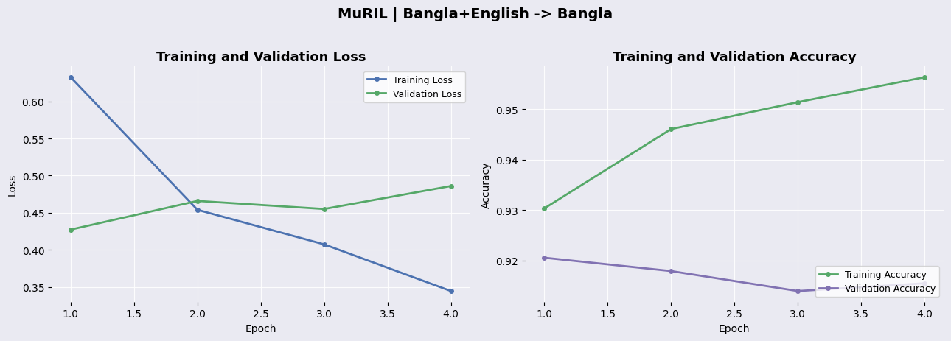

Figure 4.3.3: MuRIL BAN + ENG → BAN , Training Curves

4.4 Confusion Matrix & Roc Analysis

4.4.1 Monolingual (Bangla → Bangla / English → English)

mBERT (Bangla → Bangla)
Total test samples : 605
Correctly classified : 470 (77.7 %)
False Positives (FP) : 53 (8.8 %)
False Negatives (FN) : 82 (13.6 %)
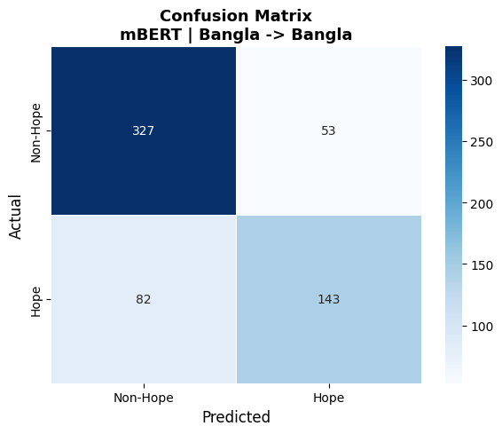
Figure 4.4.1: mBERT BAN → BAN Confusion Matrix

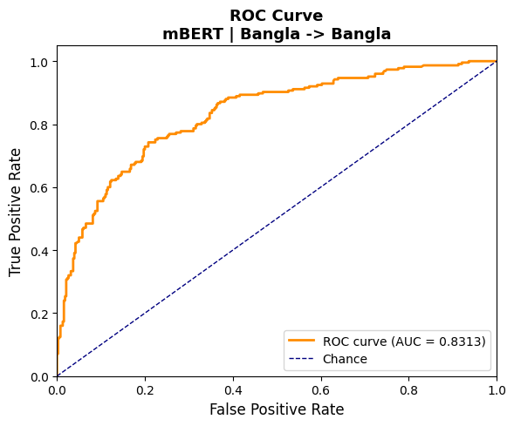
Figure 4.4.1: mBERT BAN → BAN ROC Curve

mBERT (English → English)
Total test samples : 3940
Correctly classified : 3661 (92.9 %)
False Positives (FP) : 153 (3.9 %)
False Negatives (FN) : 126 (3.2 %)

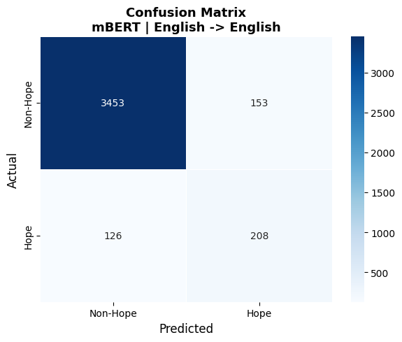
Figure 4.4.1: mBERT ENG → ENG Confusion Matrix

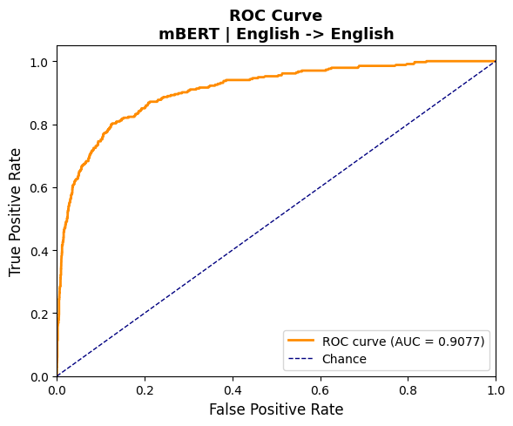
Figure 4.4.1: mBERT ENG → ENG ROC Curve
XLM-R (Bangla → Bangla)
Total test samples : 605
Correctly classified : 499 (82.5 %)
False Positives (FP) : 50 (8.3 %)
False Negatives (FN) : 56 (9.3 %)
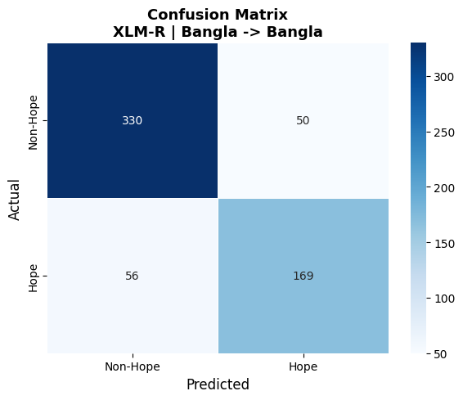
Figure 4.4.1: XLM-R BAN → BAN Confusion Matrix

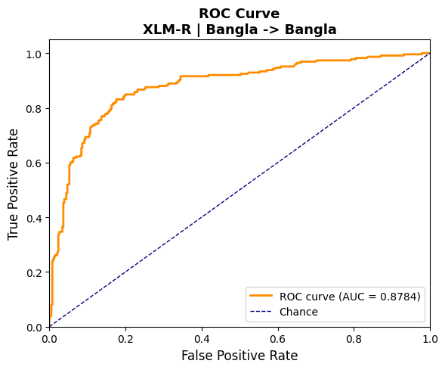
Figure 4.4.1: XLM-R BAN → BAN ROC Curve

XLM-R (English → English)
Total test samples : 3940
Correctly classified : 3661 (92.9 %)
False Positives (FP) : 153 (3.9 %)
False Negatives (FN) : 126 (3.2 %)

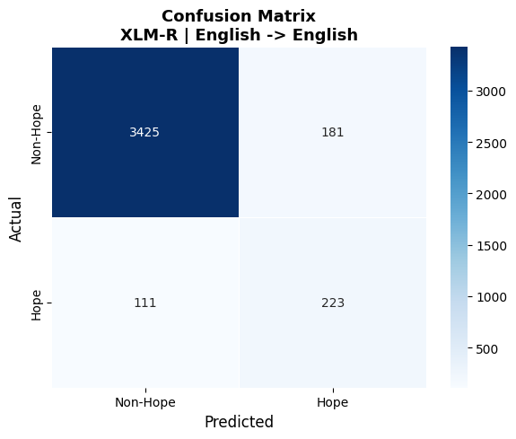
Figure 4.4.1: XLM-R ENG → ENG Confusion Matrix

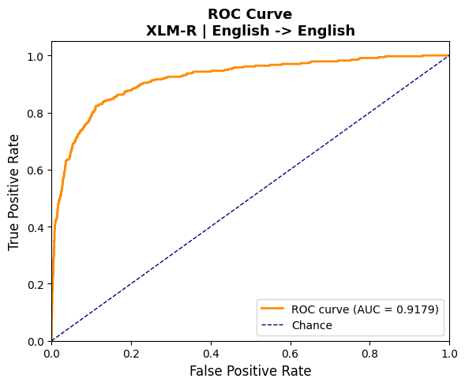
Figure 4.4.1: XLM-R ENG → ENG ROC Curve
MuRIL (Bangla → Bangla)
Total test samples : 605
Correctly classified : 507 (83.8 %)
False Positives (FP) : 46 (7.6 %)
False Negatives (FN) : 52 (8.6 %)
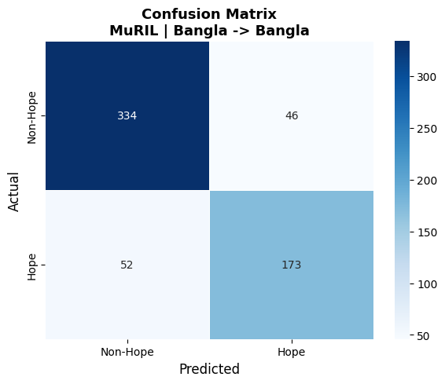
Figure 4.4.1: MuRIL BAN → BAN Confusion Matrix

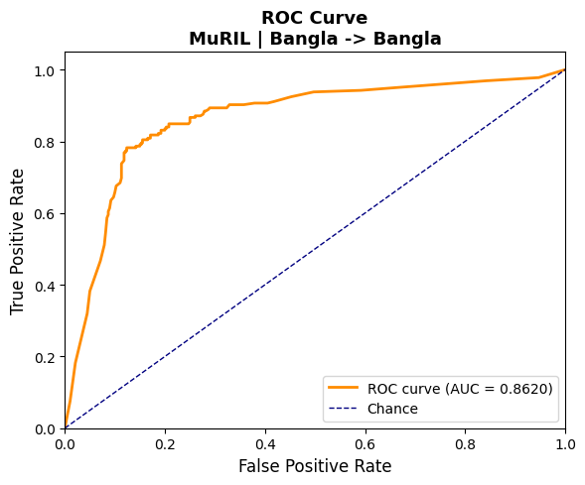
Figure 4.4.1: MuRIL BAN → BAN ROC Curve

MuRIL (English → English)
Total test samples : 3940
Correctly classified : 3645 (92.5 %)
False Positives (FP) : 180 (4.6 %)
False Negatives (FN) : 115 (2.9 %)
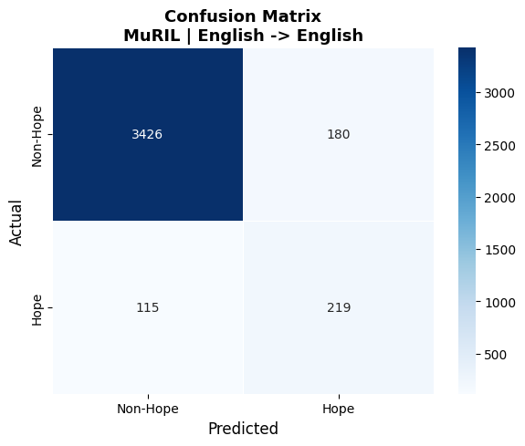
Figure 4.4.1: MuRIL ENG → ENG Confusion Matrix

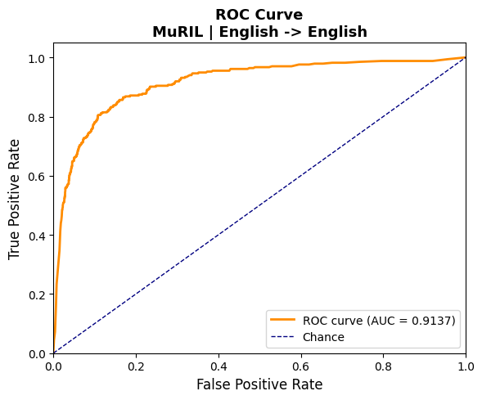
Figure 4.4.1: MuRIL ENG → ENG ROC Curve

4.4.2 Cross-lingual (English → Bangla)

mBERT (English → Bangla)
Total test samples : 4030
Correctly classified : 2541 (63.1 %)
False Positives (FP) : 3 (0.1 %)
False Negatives (FN) : 1486 (36.9 %)

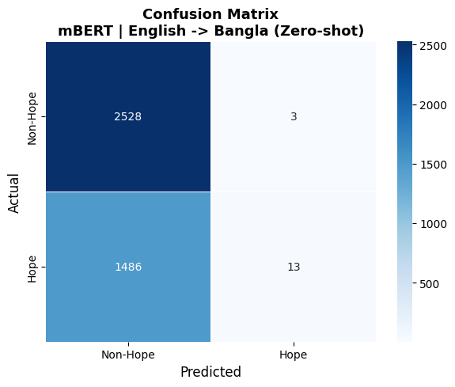
Figure 4.4.2: mBERT ENG → BAN Confusion Matrix

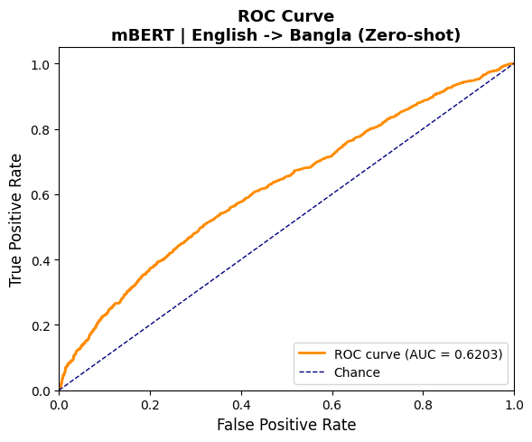
Figure 4.4.2: mBERT ENG → BAN ROC Curve

XLM-R (English → Bangla)

Total test samples : 4030
Correctly classified : 2605 (64.6 %)
False Positives (FP) : 9 (0.2 %)
False Negatives (FN) : 1416 (35.1 %)

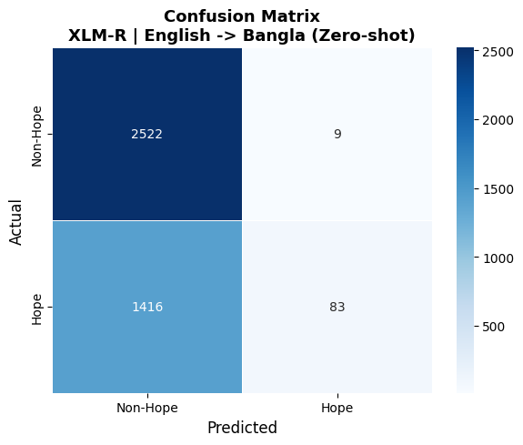
Figure 4.4.2: XLM-R ENG → BAN Confusion Matrix

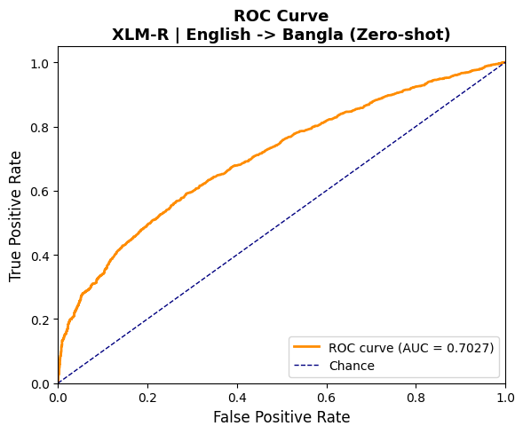
Figure 4.4.2: XLM-R ENG → BAN ROC Curve
MuRIL (English → Bangla)
Total test samples : 4030
Correctly classified : 2755 (68.4 %)
False Positives (FP) : 51 (1.3 %)
False Negatives (FN) : 1224 (30.4 %)

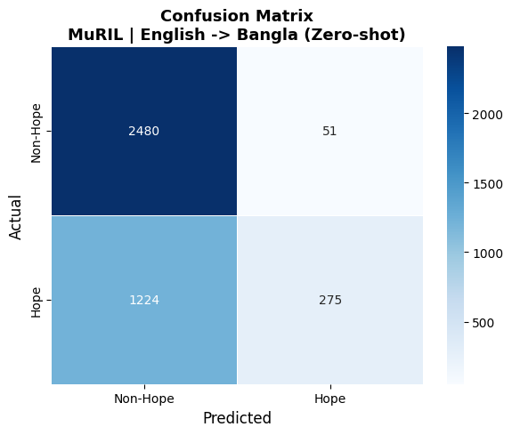
Figure 4.4.2:MuRIL ENG → BAN Confusion Matrix

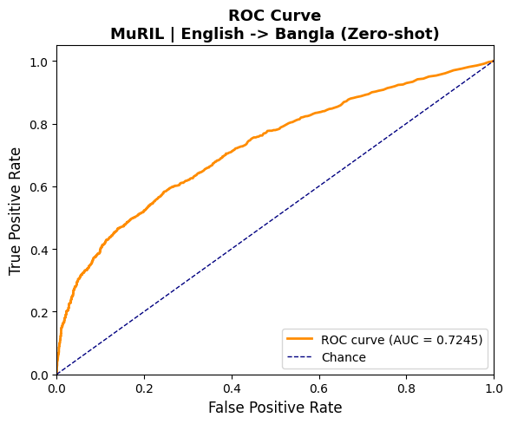
Figure 4.4.2: MuRIL ENG → BAN ROC Curve

4.4.3 Multilingual (Bangla + English → Bangla)

mBERT (English + Bangla → Bangla)
Total test samples : 605
Correctly classified : 478 (79.0 %)
False Positives (FP) : 80 (13.2 %)
False Negatives (FN) : 47 (7.8 %)

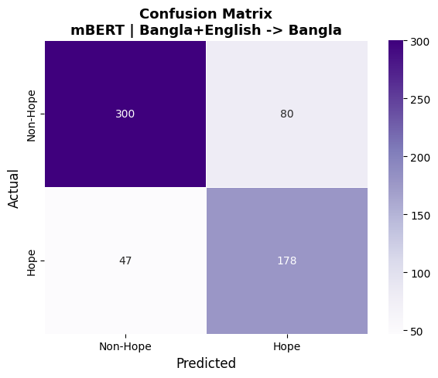
Figure 4.4.3: mBERT BAN + ENG → BAN Confusion Matrix

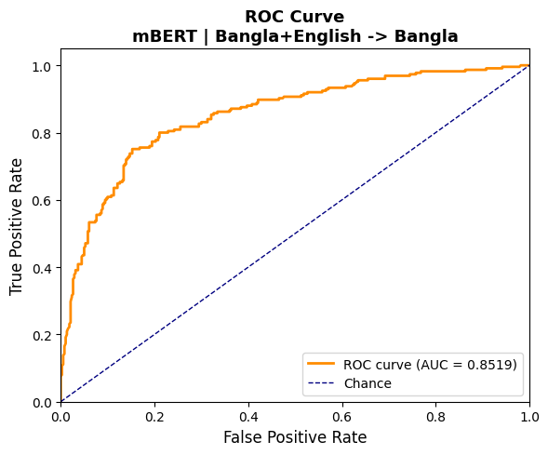
Figure 4.4.3: mBERT BAN + ENG → BAN ROC Curve

XLM-R (English + Bangla → Bangla)

Total test samples : 605
Correctly classified : 493 (81.5 %)
False Positives (FP) : 81 (13.4 %)
False Negatives (FN) : 31 (5.1 %)
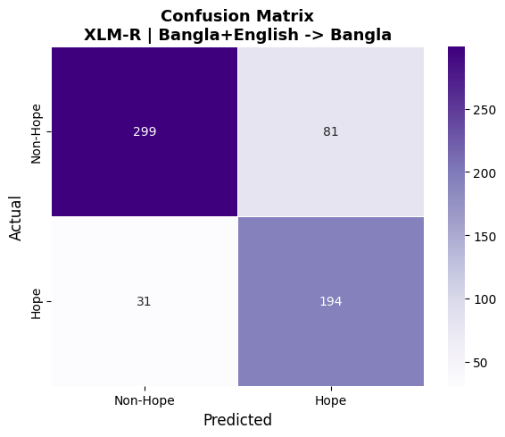
Figure 4.4.3: XLM-R BAN + ENG → BAN Confusion Matrix

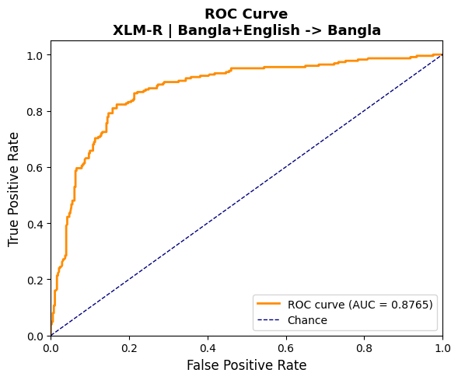
Figure 4.4.3: XLM-R BAN + ENG → BAN ROC Curve

MuRIL (English + Bangla → Bangla)
Total test samples : 605
Correctly classified : 488 (80.7 %)
False Positives (FP) : 89 (14.7 %)
False Negatives (FN) : 28 (4.6 %)

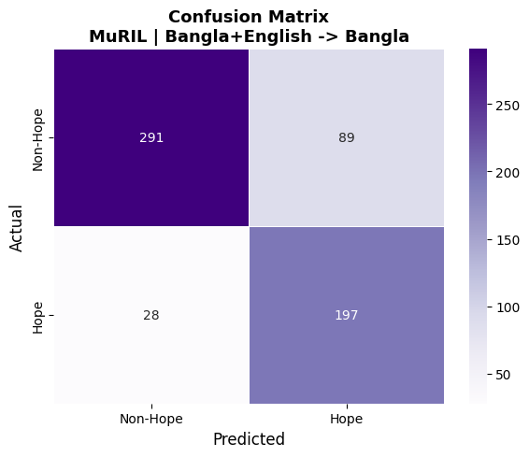
Figure 4.4.3: MuRIL BAN + ENG → BAN Confusion Matrix

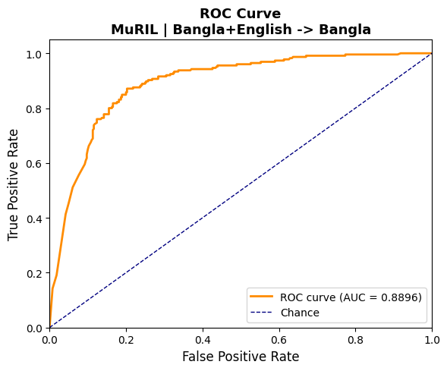
Figure 4.4.3: MuRIL BAN + ENG → BAN ROC Curve
4.5 Error Analysis

4.5.1 Monolingual (Bangla → Bangla / English → English)

mBERT (Bangla → Bangla)
Mean predicted probability:
FP mean prob = 0.875 (std 0.068)
FN mean prob = 0.279 (std 0.218)
Errors on very short texts (<=5 words): 12 (8.9 % of all errors)
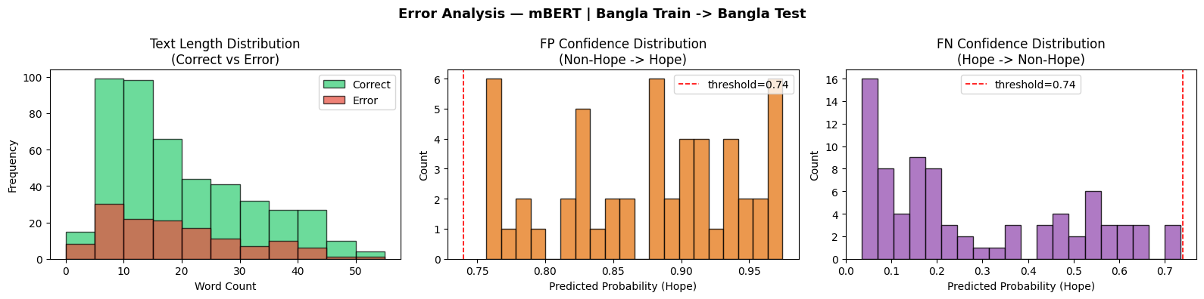
Figure 4.5.1: mBERT BAN → BAN Error Analysis

mBERT (English → English)
Mean predicted probability:
FP mean prob = 0.958 (std 0.067)
FN mean prob = 0.078 (std 0.148)
Errors on very short texts (<=5 words): 16 (5.7 % of all errors)
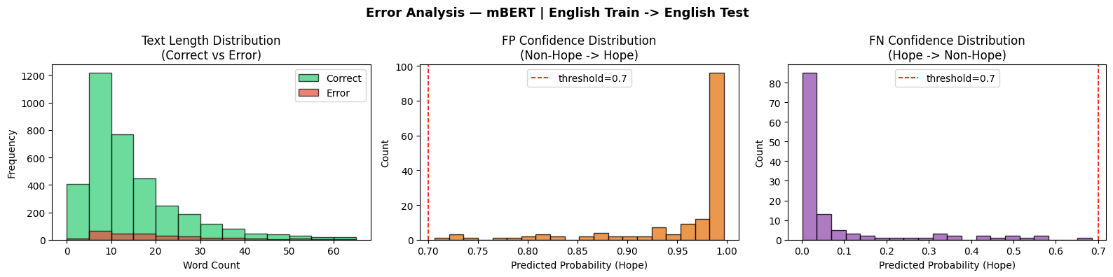
Figure 4.5.1: mBERT ENG → ENG Error Analysis
XLM-R (Bangla → Bangla)
Mean predicted probability:
FP mean prob = 0.856 (std 0.106)
FN mean prob = 0.296 (std 0.121)
Errors on very short texts (<=5 words): 10 (9.4 % of all errors)
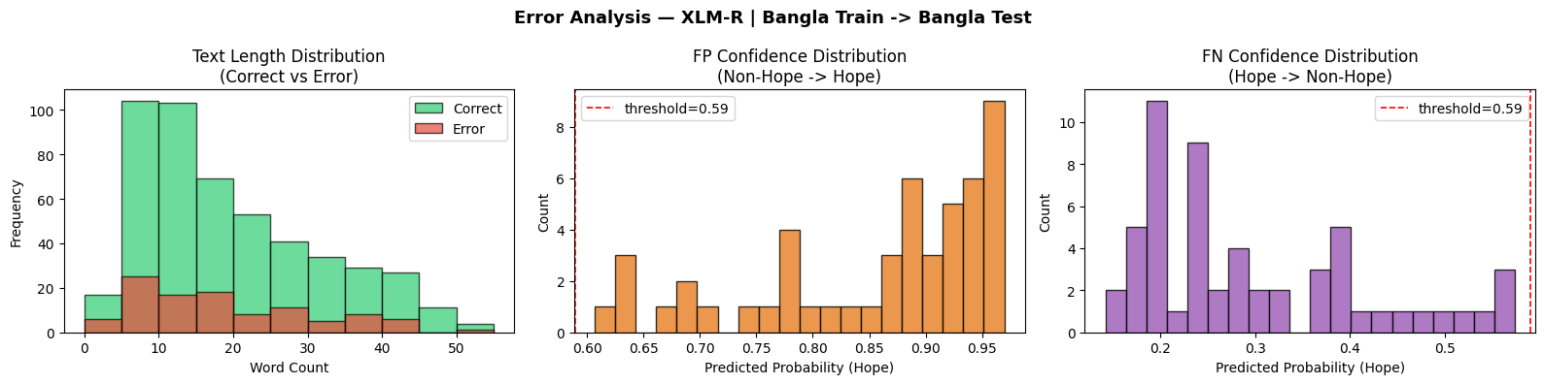
Figure 4.5.1: XLM-R BAN → BAN Error Analysis

XLM-R (English → English)
Mean predicted probability:
FP mean prob = 0.833 (std 0.166)
FN mean prob = 0.121 (std 0.131)
Errors on very short texts (<=5 words): 13 (4.5 % of all errors)

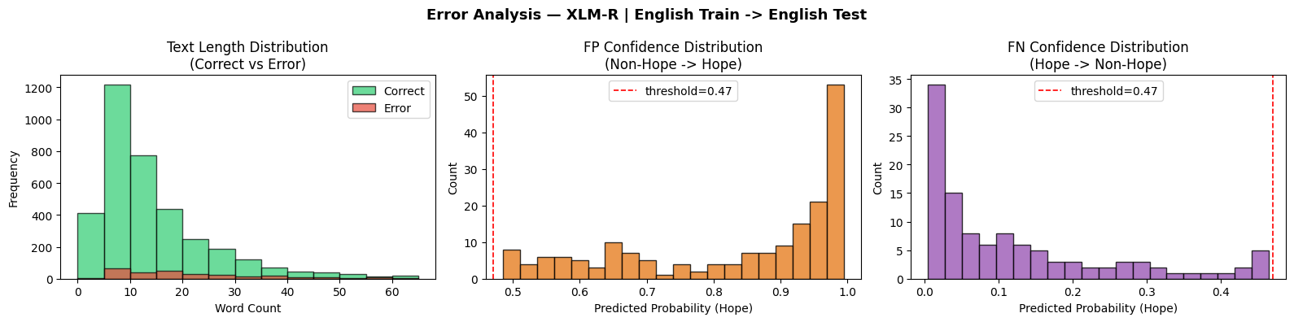
Figure 4.5.1: XLM-R ENG → ENG Error Analysis
MuRIL (Bangla → Bangla)
Mean predicted probability:
FP mean prob = 0.745 (std 0.001)
FN mean prob = 0.317 (std 0.142)
Errors on very short texts (<=5 words): 6 (6.1 % of all errors)
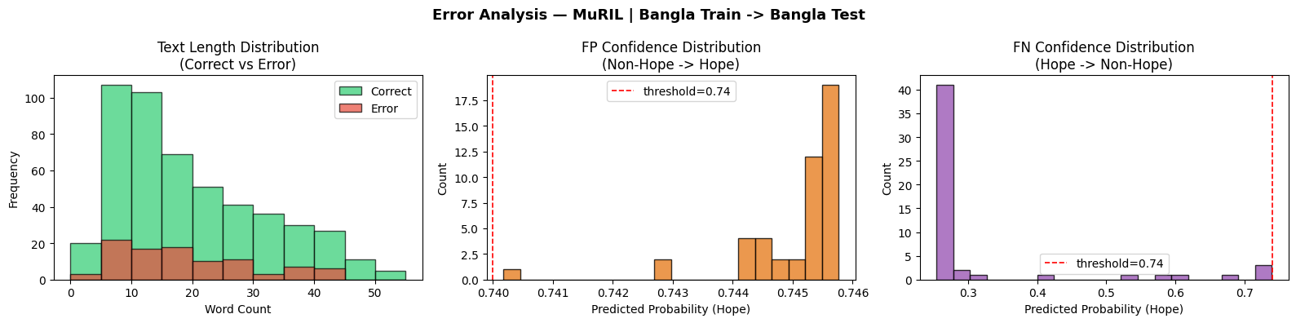
Figure 4.5.1: MuRIL BAN → BAN Error Analysis

MuRIL (English → English)
Mean predicted probability:
FP mean prob = 0.934 (std 0.047)
FN mean prob = 0.107 (std 0.132)
Errors on very short texts (<=5 words): 19 (6.4 % of all errors)

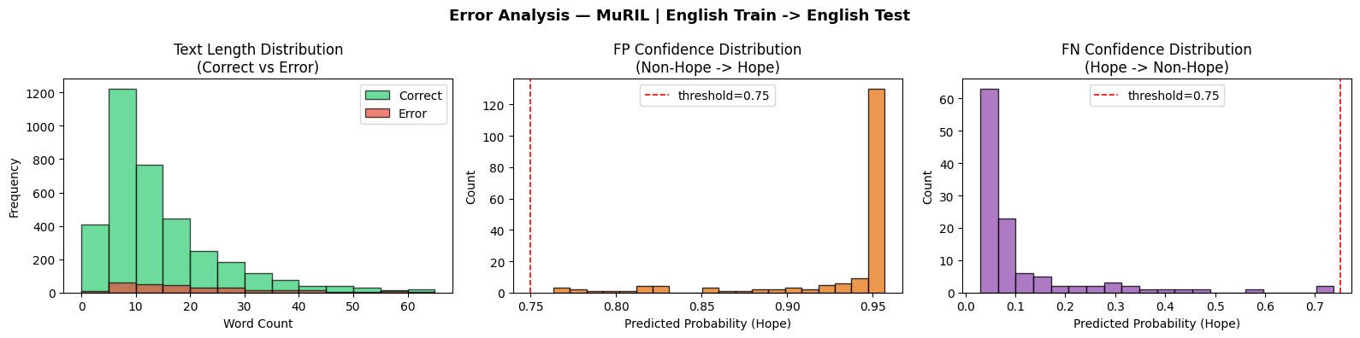
Figure 4.5.1: MuRIL ENG → ENG Error Analysis

4.5.2 Cross-lingual (English → Bangla)

mBERT (English → Bangla)
Mean predicted probability:
FP mean prob = 0.666 (std 0.162)
FN mean prob = 0.031 (std 0.056)
Errors on very short texts (<=5 words): 117 (7.9 % of all errors)
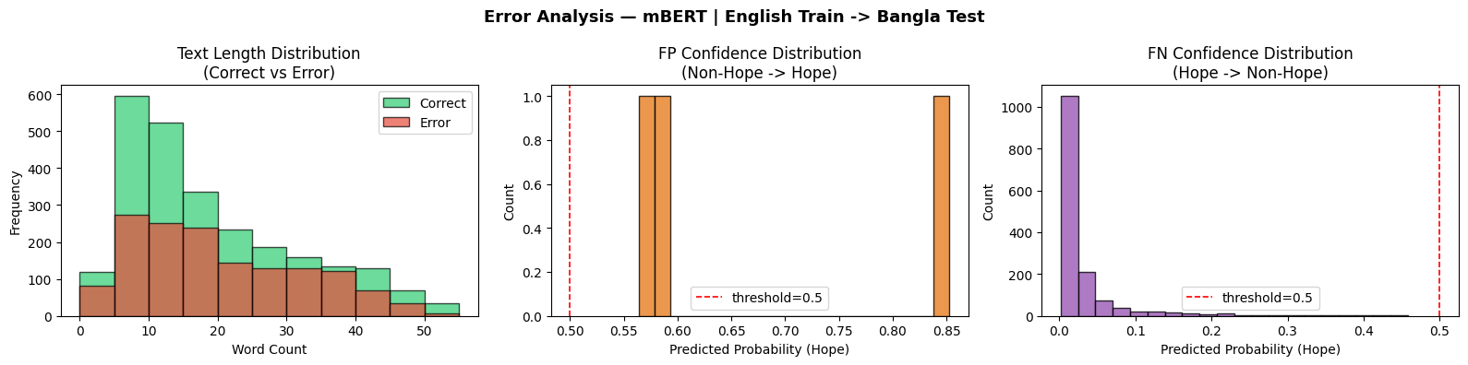
Figure 4.5.2: mBERT ENG → BAN Error Analysis

XLM-R (English → Bangla)
Mean predicted probability:
FP mean prob = 0.824 (std 0.163)
FN mean prob = 0.028 (std 0.066)
Errors on very short texts (<=5 words): 116 (8.1 % of all errors)
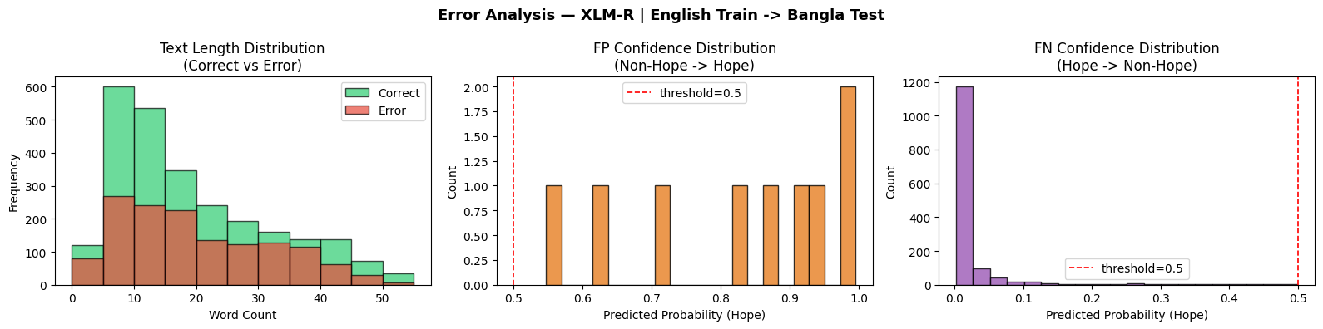
Figure 4.5.2: XLM-R ENG → BAN Error Analysis
MuRIL (English → Bangla)
Mean predicted probability:
FP mean prob = 0.862 (std 0.128)
FN mean prob = 0.071 (std 0.074)
Errors on very short texts (<=5 words): 114 (8.9 % of all errors)
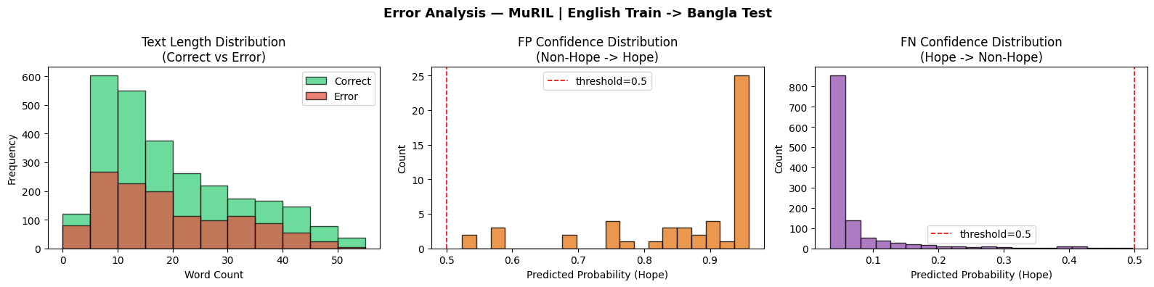
Figure 4.5.2: MuRIL ENG → BAN Error Analysis

4.5.3 Multilingual (Bangla + English → Bangla)

mBERT (Bangla + English → Bangla)
Mean predicted probability:
FP mean prob = 0.946 (std 0.082)
FN mean prob = 0.080 (std 0.131)
Errors on very short texts (<=5 words): 6 (4.7 % of all errors)
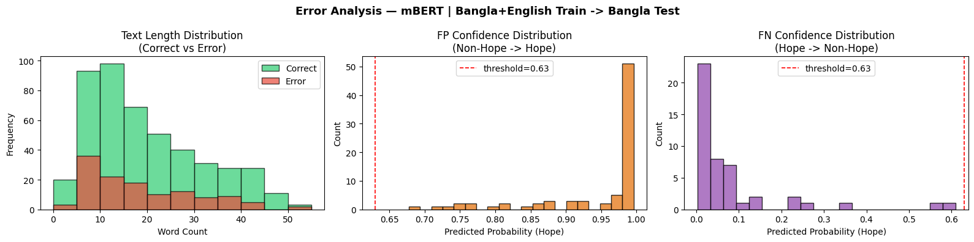
Figure 4.5.3: mBERT BAN + ENG → BAN Error Analysis

XLM-R (Bangla + English → Bangla)
Mean predicted probability:
FP mean prob = 0.981 (std 0.025)
FN mean prob = 0.120 (std 0.163)
Errors on very short texts (<=5 words): 9 (8.0 % of all errors)
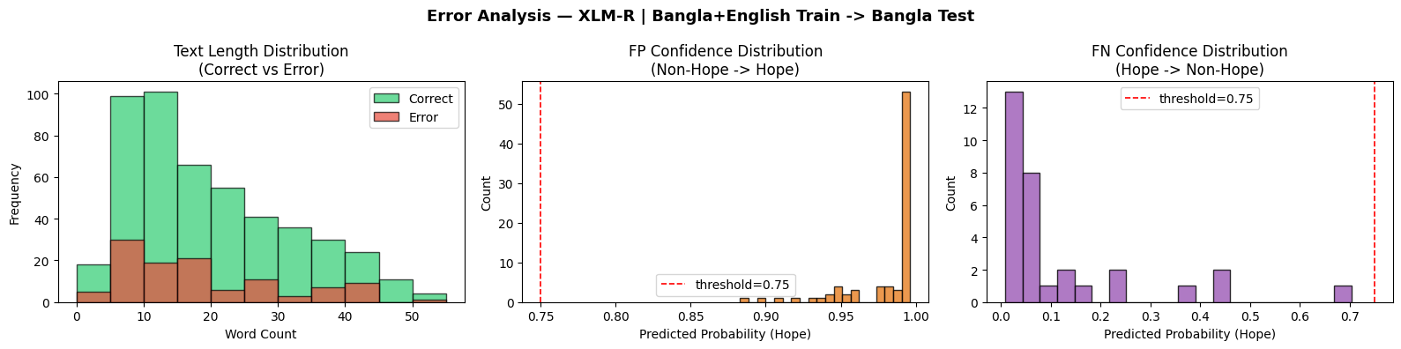
Figure 4.5.3: XLM-R BAN + ENG → BAN Error Analysis

MuRIL (Bangla + English → Bangla)
Mean predicted probability:
FP mean prob = 0.939 (std 0.098)
FN mean prob = 0.098 (std 0.112)
Errors on very short texts (<=5 words): 8 (6.8 % of all errors)
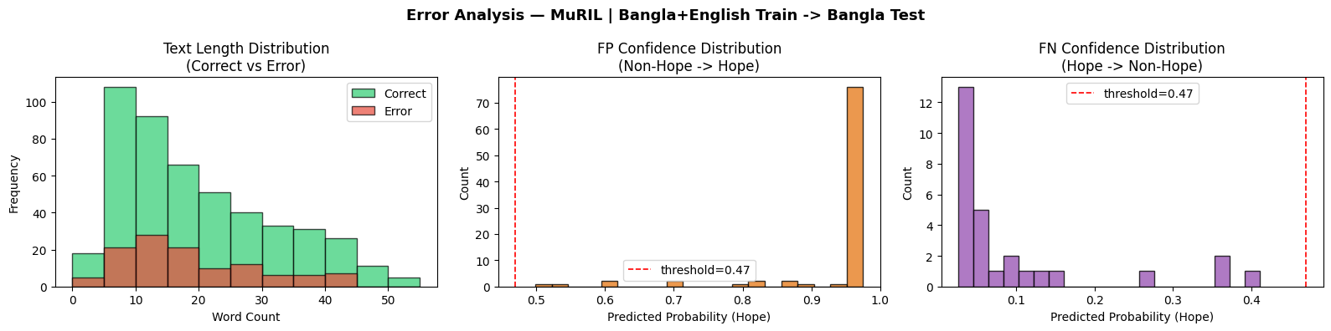
Figure 4.5.3: MuRIL BAN + ENG → BAN Error Analysis

4.6 Models with Baseline Comparison

4.6.1 Monolingual (Bangla → Bangla / English → English)

mBERT (Bangla → Bangla)
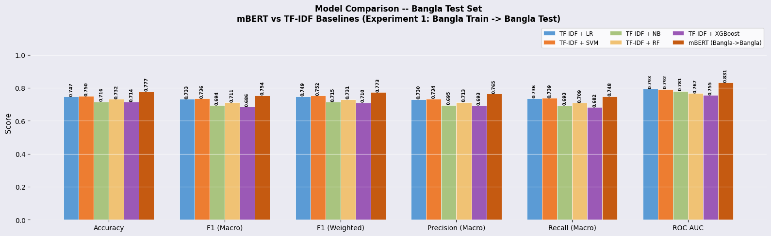
Figure 4.6.1: mBERT BAN → BAN Model Comparison

mBERT (English → English)
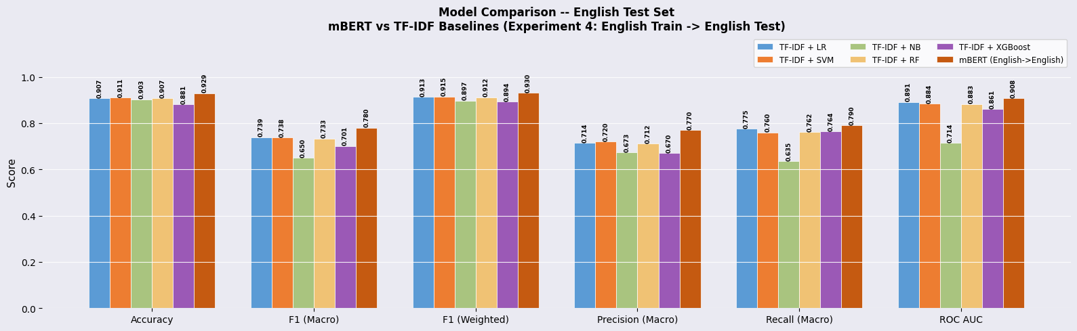
Figure 4.6.1: mBERT ENG → ENG Model Comparison

XLM-R (Bangla → Bangla)
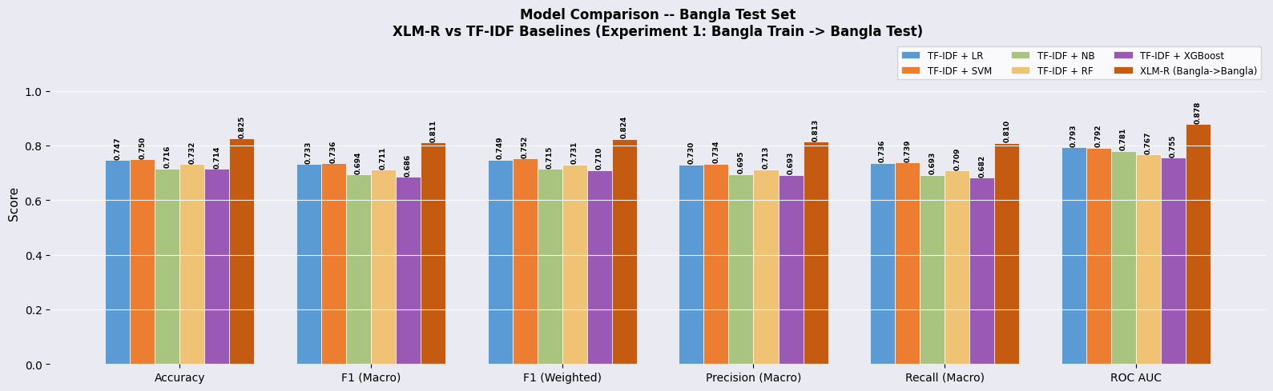
Figure 4.6.1: XLM-R BAN → BAN Model Comparison
XLM-R (English → English)
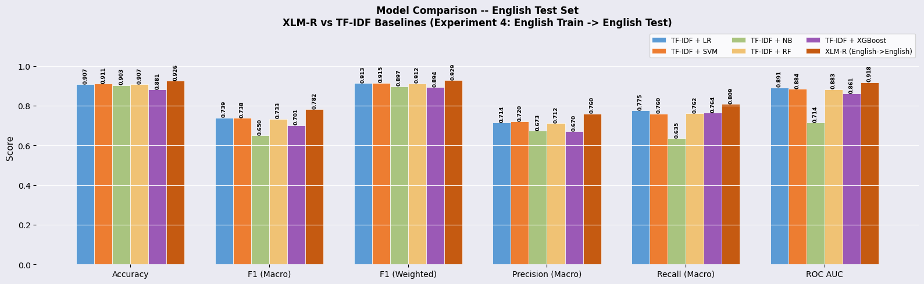
Figure 4.6.1: XLM-R ENG → ENG Model Comparison

MuRIL (Bangla → Bangla)
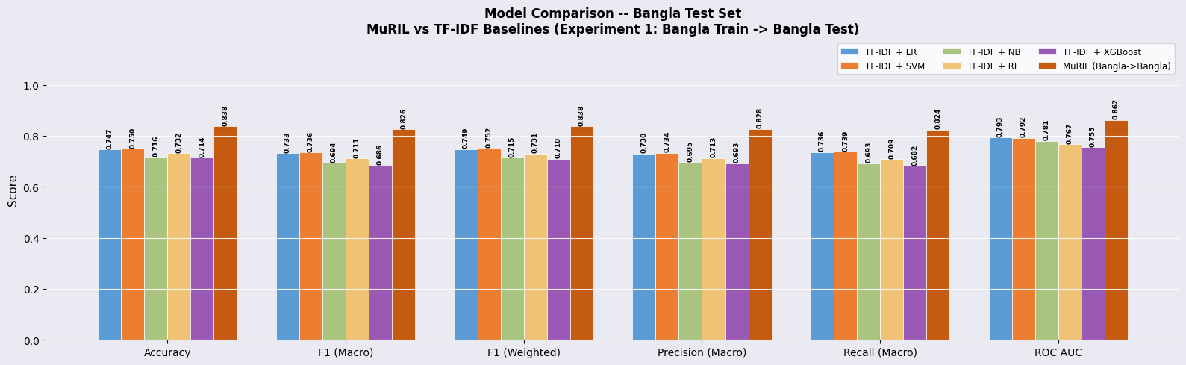
Figure 4.6.1: MuRIL BAN → BAN Model Comparison

MuRIL (English → English
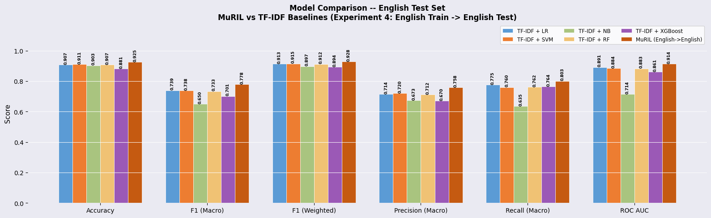
Figure 4.6.1: MuRIL ENG → ENG Model Comparison

4.6.2 Cross-lingual (English → Bangla)

mBERT (English → Bangla)
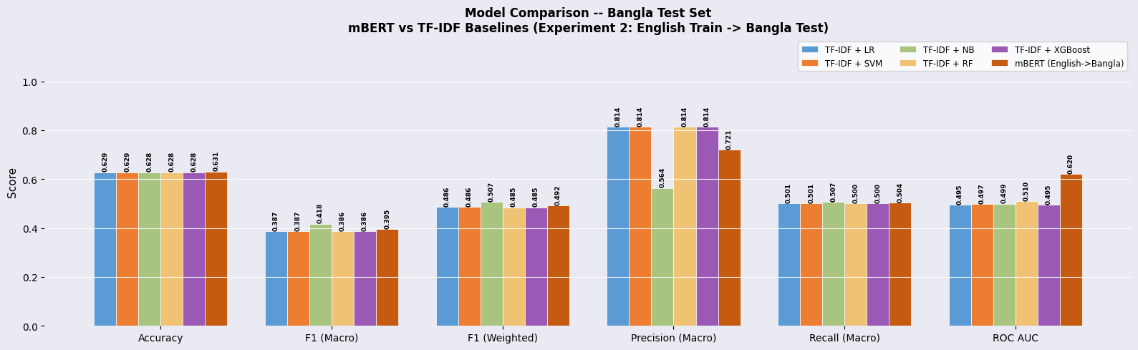
Figure 4.6.2: mBERT ENG → BAN Model Comparison

XLM-R (English → Bangla)
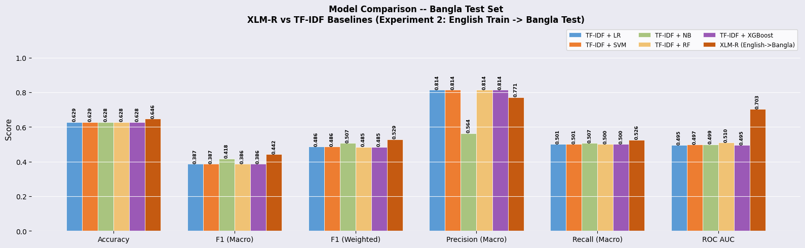
Figure 4.6.2: XLM-R ENG → BAN Model Comparison

MuRIL (English → Bangla)
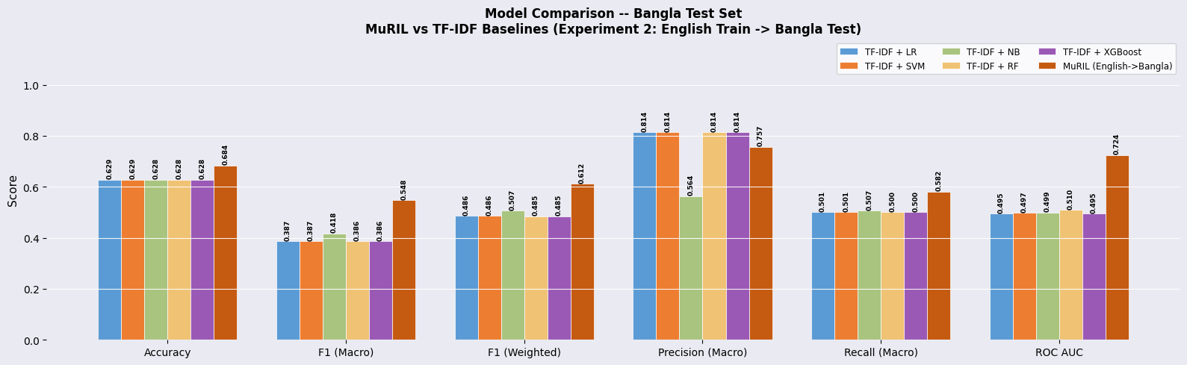
Figure 4.6.2: MuRIL ENG → BAN Model Comparison

4.6.3 Multilingual (Bangla + English → Bangla)

mBERT (Bangla + English → Bangla)
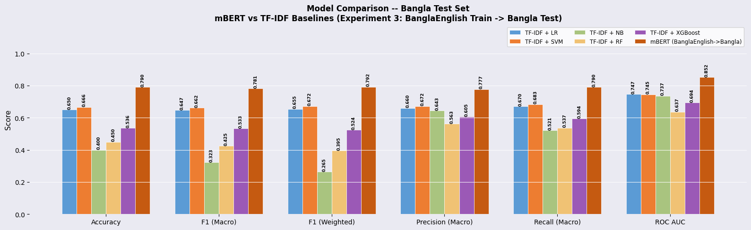
Figure 4.6.3: mBERT BAN + ENG → BAN Model Comparison

XLM-R (Bangla + English → Bangla)
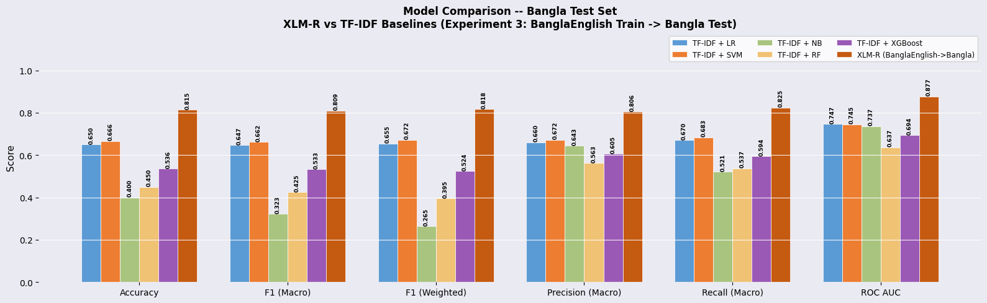
Figure 4.6.3: XLM-R BAN + ENG → BAN Model Comparison

MuRIL (Bangla + English → Bangla)
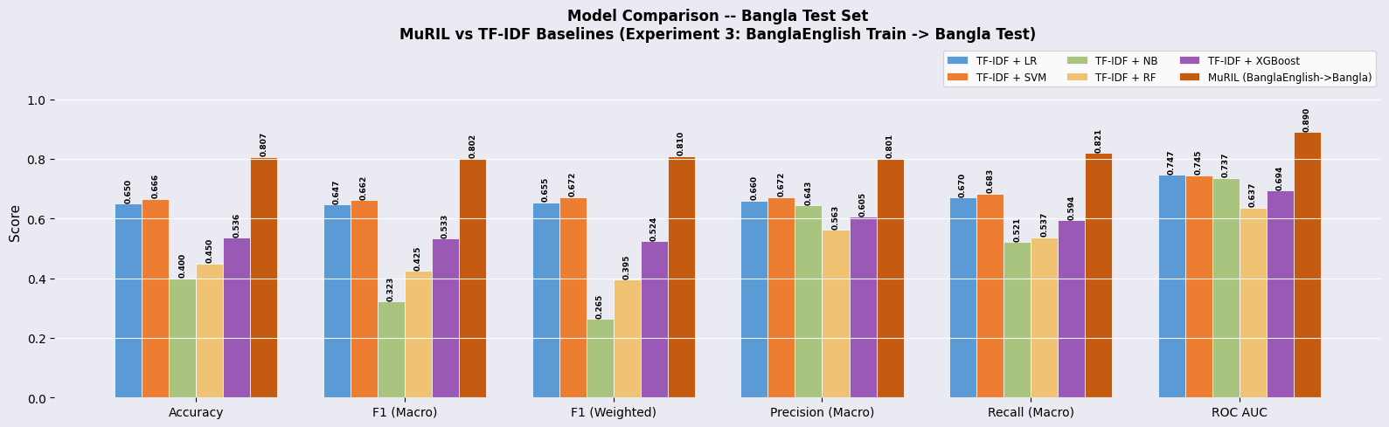
Figure 4.6.3: MuRIL BAN + ENG → BAN Model Comparison
4.7 ROC Curve Comparison

4.7.1 Monolingual (Bangla → Bangla / English → English)

mBERT (Bangla → Bangla)
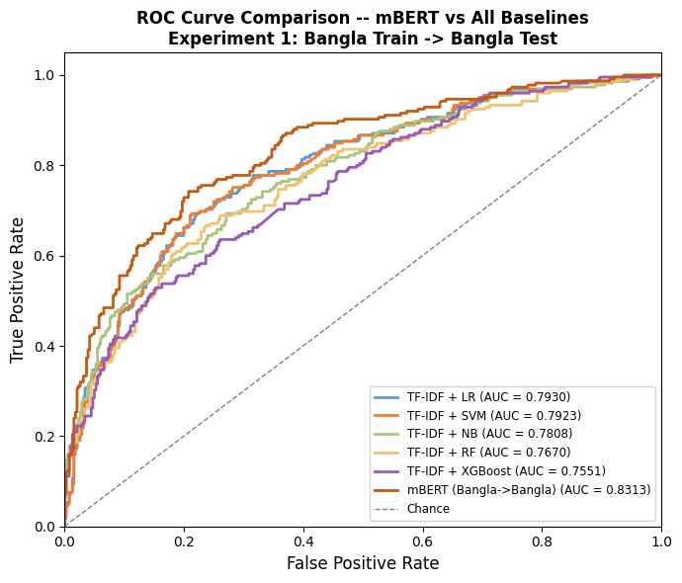
Figure 4.7.1: mBERT BAN → BAN ROC Curve Comparison

mBERT (English → English)
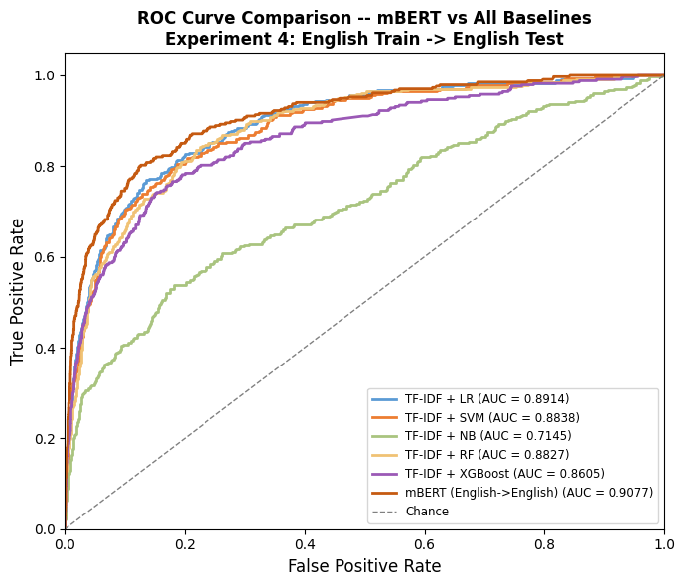
Figure 4.7.1: mBERT ENG → ENG ROC Curve Comparison
XLM-R (Bangla → Bangla)
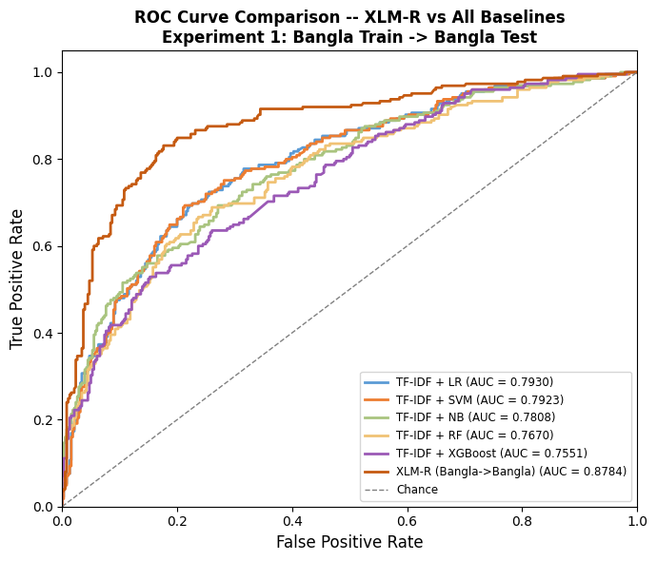
Figure 4.7.1: XLM-R BAN → BAN ROC Curve Comparison

XLM-R (English → English)
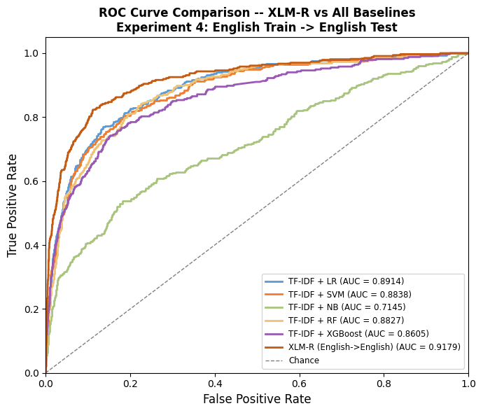
Figure 4.7.1: XLM-R ENG → ENG Curve Comparison

MuRIL (Bangla → Bangla)

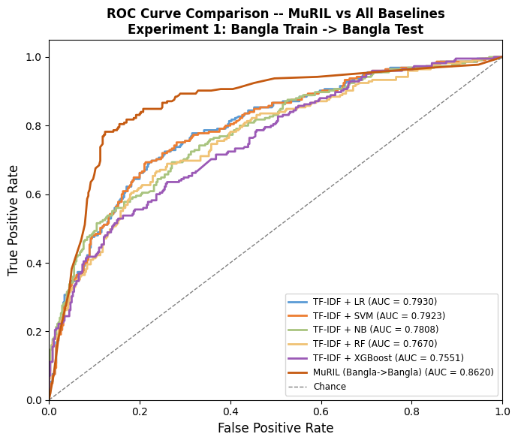
Figure 4.7.1: MuRIL BAN → BAN ROC Curve Comparison

MuRIL (English → English)
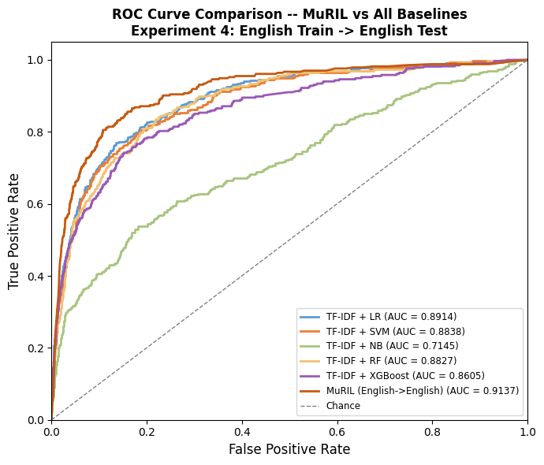
Figure 4.7.1: MuRIL ENG → ENG ROC Curve Comparison

4.7.2 Cross-lingual (English → Bangla)

mBERT (English → Bangla)
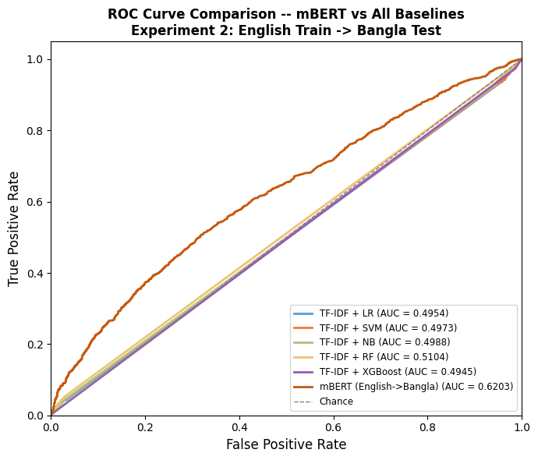
Figure 4.7.2: mBERT ENG → BAN ROC Curve Comparison

XLM-R (English → Bangla)
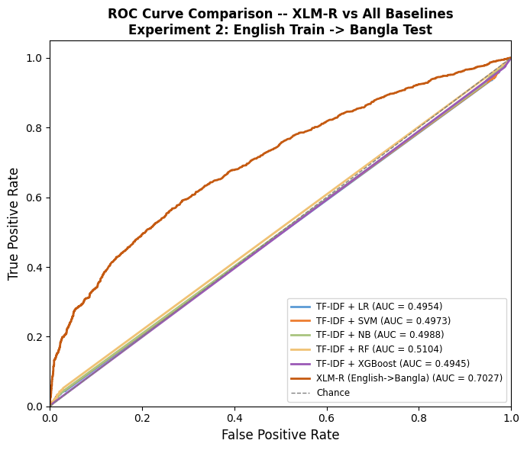
Figure 4.7.2: XLM-R ENG → BAN ROC Curve Comparison
MuRIL (English → Bangla)
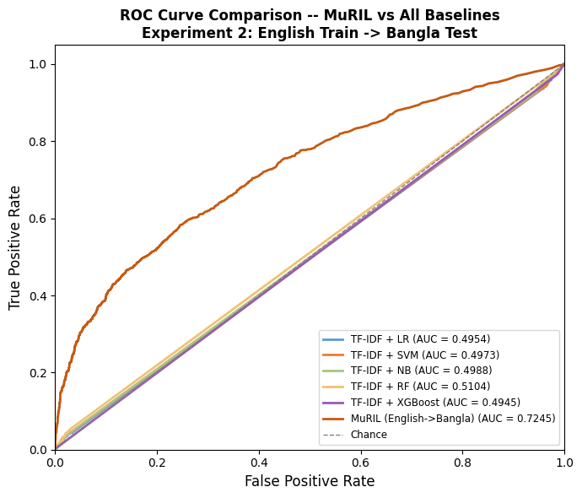
Figure 4.7.2: MuRIL ENG → BAN ROC Curve Comparison

4.7.3 Multilingual (Bangla + English → Bangla)

mBERT (Bangla + English → Bangla)
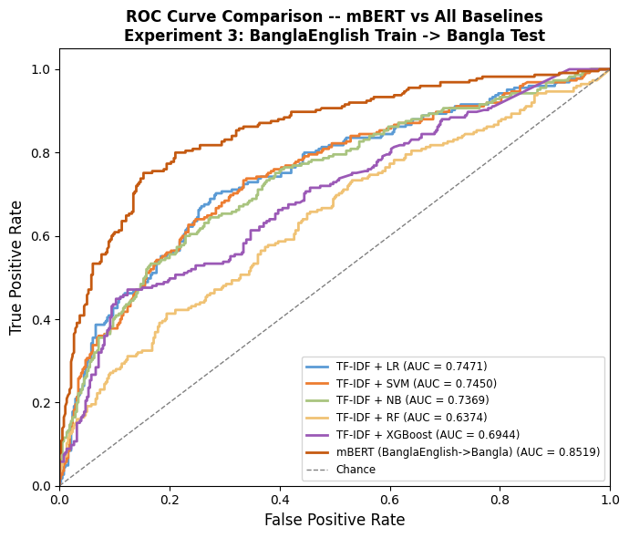
Figure 4.7.3: mBERT BAN + ENG → BAN ROC Curve Comparison

XLM-R (Bangla + English → Bangla)
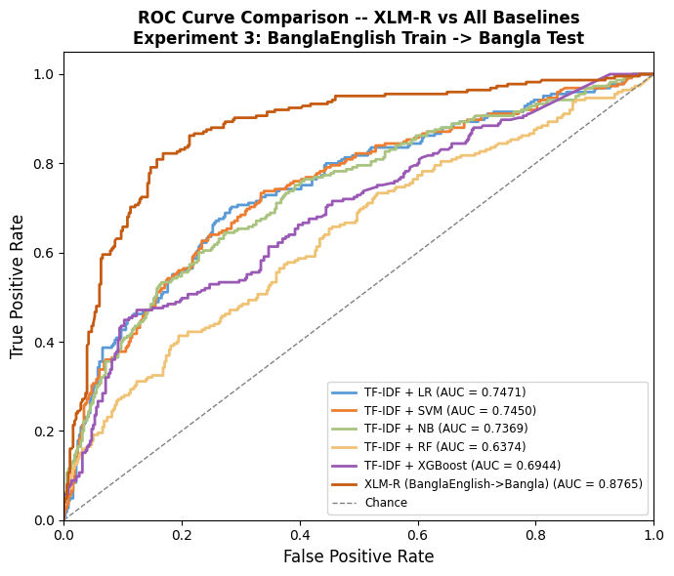
Figure 4.7.3: XLM-R BAN + ENG → BAN ROC Curve Comparison

MuRIL (Bangla + English → Bangla)

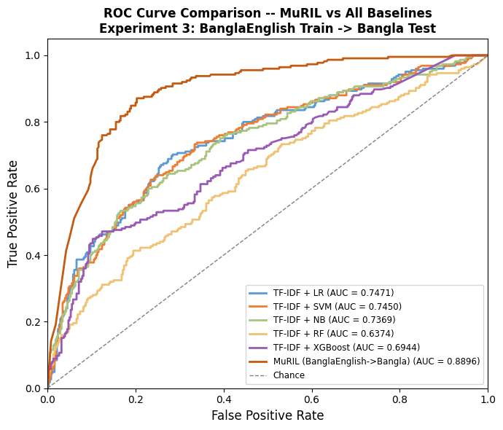
Figure 4.7.3: MuRIL BAN + ENG → BAN ROC Curve Comparison

4.8 Experimental Comparison

4.8.1 Monolingual (Bangla → Bangla / English → English)

TABLE III
MONOLINGUAL (BANGLA → BANGLA / ENGLISH → ENGLISH) COMPARISON
Monolingual (Bangla → Bangla / English → English)
Best Model | Experiment Setup | Accuracy | F1 (Macro) | F1 (Weighted) | Precision (Macro) | Recall (Macro)
1. mBERT | ENG → ENG | 0.9292 | 0.7799 | 0.9304 | 0.7705 | 0.7902
1. mBERT | BAN → BAN | 0.7769 | 0.7541 | 0.7733 | 0.7646 | 0.748
2. XLM-R | ENG → ENG | 0.9259 | 0.7817 | 0.929 | 0.7603 | 0.8087
2. XLM-R | BAN → BAN | 0.8248 | 0.8114 | 0.8243 | 0.8133 | 0.8098
3. MuRIL | ENG → ENG | 0.9251 | 0.7781 | 0.9281 | 0.7582 | 0.8029
3. MuRIL | BAN → BAN | 0.838 | 0.8257 | 0.8376 | 0.8276 | 0.8239

4.8.2 Cross-lingual (English → Bangla)

TABLE IV
CROSS-LINGUAL (BANGLA → ENGLISH) COMPARISON
Cross-lingual (English → Bangla)
Best Model | Experiment Setup | Accuracy | F1 (Macro) | F1 (Weighted) | Precision (Macro) | Recall (Macro)
1. mBERT | ENG → BAN | 0.6305 | 0.3948 | 0.4915 | 0.7211 | 0.5037
2. XLM-R | ENG → BAN | 0.6464 | 0.442 | 0.5285 | 0.7713 | 0.5259
3. MuRIL | ENG → BAN | 0.6836 | 0.5484 | 0.6117 | 0.7566 | 0.5817

4.8.3 Multilingual (Bangla + English → Bangla)

TABLE V
MULTILINGUAL (BANGLA + ENGLISH → ENGLISH) COMPARISON
Multilingual (Bangla + English → Bangla)
Best Model | Experiment Setup | Accuracy | F1 (Macro) | F1 (Weighted) | Precision (Macro) | Recall (Macro)
1. mBERT | BAN + ENG → BAN | 0.7901 | 0.7812 | 0.7925 | 0.7772 | 0.7903
2. XLM-R | BAN + ENG → BAN | 0.8149 | 0.8099 | 0.8176 | 0.8058 | 0.8245
3. MuRIL | BAN + ENG → BAN | 0.8066 | 0.8098 | 0.8097 | 0.8005 | 0.8207

4.9 Performance Comparison

The performance of the proposed joint multilingual framework is evaluated across three experimental setups: Monolingual, Cross-lingual (Zero-shot), and Multilingual, using state-of-the-art transformer models compared against traditional baselines.

I. Monolingual Performance

In the monolingual setup, models were trained and tested on the same language to establish a performance benchmark.

Bengali (BongHope): Google’s MuRIL model, specifically optimized for Indian languages, achieved the highest performance with a Macro F1-score of 0.8257 and an accuracy of 0.8380. XLM-RoBERTa (XLM-R) followed closely with a Macro F1-score of 0.8114.

English (HopeEDI): All three transformer models demonstrated high accuracy (>92%), though the Macro F1-scores were lower due to the extreme class imbalance in the English dataset. XLM-R achieved the highest Macro F1-score of 0.7817 in the English monolingual task.

II. Cross-lingual (Zero-shot) Performance

This experiment tested the models' ability to transfer knowledge from high-resource English to low-resource Bengali without any Bengali training data.

MuRIL demonstrated superior cross-lingual capability, achieving a Macro F1-score of 0.5484, significantly outperforming mBERT (0.3948) and XLM-R (0.4420). The results indicate that while zero-shot transfer is challenging, the models can capture some universal semantic features of hope speech across languages.

III. Joint Multilingual Performance

The joint setup combined Bengali and English datasets to create a Universal Classifier, leveraging the balanced nature of BongHope to address the scarcity of hope speech in English. XLM-R emerged as the top performer in this setup, reaching a Macro F1-score of 0.8099 and an accuracy of 0.8149. MuRIL showed nearly identical performance with a Macro F1-score of 0.8098.

Impact on Recall: This joint approach effectively increased model recall, particularly for the rare hope speech instances in English, by using the balanced Bengali data as a training supplement.

IV. Comparison with Traditional Baselines

Transformer-based models significantly outperformed traditional machine learning baselines (Logistic Regression, SVM, Random Forest, XGBoost) using TF-IDF features. While traditional models like Logistic Regression achieved an F1-score of 0.79 on English comments, they struggled to capture the deep semantic context required for complex or code-mixed social media text.

MuRIL and XLM-R provided a substantial performance boost (F1-scores > 0.80) over conventional deep learning models like CNN or LSTM, which only achieved F1-scores between 0.46 and 0.48 in similar Bengali tasks.

TABLE VI
A JOINT MULTILINGUAL FRAMEWORK COMPARISON
Performance Comparison
Best Model | Experiment Setup | Accuracy | F1 (Macro) | F1 (Weighted) | Precision (Macro) | Recall (Macro)
1. mBERT | ENG → ENG | 0.9292 | 0.7799 | 0.9304 | 0.7705 | 0.7902
1. mBERT | BAN → BAN | 0.7769 | 0.7541 | 0.7733 | 0.7646 | 0.748
1. mBERT | ENG → BAN | 0.6305 | 0.3948 | 0.4915 | 0.7211 | 0.5037
1. mBERT | BAN + ENG → BAN | 0.7901 | 0.7812 | 0.7925 | 0.7772 | 0.7903
2. XLM-R | ENG → ENG | 0.9259 | 0.7817 | 0.929 | 0.7603 | 0.8087
2. XLM-R | BAN → BAN | 0.8248 | 0.8114 | 0.8243 | 0.8133 | 0.8098
2. XLM-R | ENG → BAN | 0.6464 | 0.442 | 0.5285 | 0.7713 | 0.5259
2. XLM-R | BAN + ENG → BAN | 0.8149 | 0.8099 | 0.8176 | 0.8058 | 0.8245
3. MuRIL | ENG → ENG | 0.9251 | 0.7781 | 0.9281 | 0.7582 | 0.8029
3. MuRIL | BAN → BAN | 0.838 | 0.8257 | 0.8376 | 0.8276 | 0.8239
3. MuRIL | ENG → BAN | 0.6836 | 0.5484 | 0.6117 | 0.7566 | 0.5817
3. MuRIL | BAN + ENG → BAN | 0.8066 | 0.8098 | 0.8097 | 0.8005 | 0.8207

TABLE VII
PERFORMANCE SUMMARY OF TOP-PERFORMING MODELS
Experiment Setup | Best Model | Accuracy | Macro F1-Score
Monolingual (Bangla) | MuRIL | 0.8380 | 0.8257
Monolingual (English) | XLM-R | 0.9259 | 0.7817
Cross-lingual (EN → BN) | MuRIL | 0.6836 | 0.5484
Multilingual (BN+EN → BN) | XLM-R | 0.8149 | 0.8099

4.10 Performance Analysis

The following performance analysis evaluates the efficacy of the proposed joint multilingual framework across various experimental dimensions, focusing on the comparative results of transformer-based models and the impact of the joint training approach on data imbalance.

I. Monolingual Baseline Analysis

The monolingual experiments established the performance ceiling for each language. For the Bengali (BongHope) dataset, MuRIL emerged as the superior model, achieving a Macro F1-score of 0.8257 and an accuracy of 0.8380. This demonstrates MuRIL's specialized capability in understanding the linguistic nuances and cultural contexts of Indian languages compared to general multilingual models like mBERT, which scored 0.7541 in the same category. For the English (HopeEDI) dataset, all models showed exceptionally high accuracy—peaking at 92.92% for mBERT—but significantly lower Macro F1-scores (~0.78). This discrepancy highlights a critical finding in the performance analysis: the high accuracy is largely driven by the extreme class imbalance (91.5% non-hope), where models can achieve high scores simply by predicting the majority class.

II. Cross-lingual Transfer Effectiveness

The cross-lingual (zero-shot) setup tested the models' ability to transfer "semantic" knowledge from English to Bengali without prior exposure to Bengali training data. MuRIL again outperformed other models with a Macro F1-score of 0.5484, nearly 10% higher than XLM-R (0.4420) and 15% higher than mBERT (0.3948). These results indicate that while zero-shot transfer is challenging, MuRIL is significantly more robust in identifying universal features of hope speech that transcend language boundaries.

III. Joint Multilingual Framework Performance

The joint multilingual approach (Bangla + English → BNG) demonstrated the framework's core strength. XLM-RoBERTa (XLM-R) achieved the highest performance in this setup with a Macro F1-score of 0.8099 and an accuracy of 0.8149, followed almost identically by MuRIL. The primary technical success of this joint approach was its ability to mitigate class imbalance. By using the balanced BongHope data (approx. 46% hope) to supplement the sparse HopeEDI data (approx. 8.7% hope), the framework effectively increased model recall.

This allowed the "Universal Classifier" to capture rare positive messages in the English dataset that monolingual models typically overlooked.

IV. Comparison with Traditional Baselines

A comparative analysis against traditional machine learning models (Logistic Regression, SVM, NB, RF, XGBoost) confirms the superiority of transformers. Traditional models using TF-IDF features lacked the depth to understand semantic context and sarcasm. While Logistic Regression was effective for small datasets (achieving 0.79 on English comments), it fell short of the 0.80+ F1-scores consistently delivered by the transformer models in Bengali tasks.
TABLE VIII
SUMMARY OF TOP RESULTS
Experiment Setup | Best Model | Accuracy | Macro F1-Score
Monolingual (BN) | MuRIL | 0.8380 | 0.8257
Monolingual (EN) | XLM-R | 0.9259 | 0.7817
Cross-lingual (EN→BN) | MuRIL | 0.6836 | 0.5484
Multilingual (BN+EN→BN) | XLM-R | 0.8149 | 0.8099

Chapter 5

Conclusion and Future Work

5.1 Conclusion

This research successfully developed a robust joint multilingual framework for hope speech detection, specifically addressing the resource gap for Bengali—the world’s fifth most spoken native language—and high-resource English. A cornerstone of this study is the creation of BongHope, the first curated and balanced Bengali hope speech corpus, which serves as a foundational resource for future Natural Language Processing (NLP) research.

The experimental findings demonstrate that transformer-based models, specifically MuRIL, XLM-RoBERTa (XLM-R), and mBERT, significantly outperform traditional machine learning baselines and conventional deep learning models like CNN or LSTM in capturing the subtle semantic features of optimistic text. While MuRIL exhibited the highest performance in monolingual Bengali tasks (F1 ≈ 0.83), the XLM-R model achieved the superior Macro F1-score of approximately 0.81 within the joint multilingual framework.

A critical technical achievement of this framework is its ability to mitigate the extreme class imbalance prevalent in real-world social media content, where hope speech often accounts for less than 1% of total messages. By leveraging the balanced characteristics of the BongHope dataset as a training supplement for the imbalanced English HopeEDI data, the framework significantly increased model recall, ensuring rare positive messages are effectively identified.

Ultimately, this study transcends technical advancement by fostering Equality, Diversity, and Inclusion (EDI) in digital spaces. By prioritizing positive reinforcement over simple censorship, this research establishes a humane foundation for digital moderation that protects freedom of speech while supporting marginalized communities. These results provide a scalable pathway toward building a more inclusive, supportive, and secure global digital environment.

5.2 Contributions of the Research

The primary contributions of this research to the field of Natural Language Processing (NLP) and digital moderation are summarized as follows:

Creation of the BongHope Dataset: The most significant contribution is the development of BongHope, the world’s first high-quality, curated, and highly balanced dataset for Bengali hope speech detection. Comprising 2,626 samples, it addresses a critical resource gap for the world’s fifth most spoken native language.

Introduction of a Joint Multilingual Framework: The study proposes a novel framework that utilizes Bengali and English data simultaneously. This Universal Classifier leverages the linguistic diversity of high-resource English and the balanced characteristics of low-resource Bengali to enhance recognition capabilities across both languages.

Mitigation of Extreme Class Imbalance: The research provides a technical solution for the severe class imbalance found in large-scale datasets like HopeEDI, where hope speech often accounts for less than 1% of content. By using the balanced BongHope data as a supplement, the framework significantly increases model recall and accuracy for rare positive messages in English.

Technical Benchmarking of Transformer Models: This work establishes a performance benchmark by evaluating state-of-the-art models, demonstrating that MuRIL (optimized for Indian languages) and XLM-RoBERTa achieve superior results (F1 ≈ 0.83) compared to traditional machine learning or general deep learning approaches.

Validation of Cross-lingual Knowledge Transfer: The research demonstrates that linguistic knowledge acquired from a high-resource language can be successfully transferred to a low-resource language, allowing models to better understand subtle semantic features and context.

Philosophical Shift Toward Positive Reinforcement: Moving beyond traditional moderation that focuses on censoring hate speech, this study promotes a positive reinforcement approach. This philosophy protects freedom of expression while fostering social cohesion, mental well-being, and an inclusive digital environment for marginalized communities.

Support for Equality, Diversity, and Inclusion (EDI): By utilizing the HopeEDI dataset, the research specifically identifies and promotes supportive discourse regarding women in STEM, the LGBTIQ community, and anti-racism movements, providing a technical foundation for building a more inclusive society.

5.3 Limitations

The following sections outline the primary limitations of this research, categorized by data constraints, linguistic complexities, and technical requirements.

I. Dataset and Generalization Constraints

The BongHope dataset, while curated, contains only 2,626 Bengali samples, which is a relatively small volume for training large-scale language models. Similarly, the Spanish subsets of HopeEDI are limited to 1,650 tweets, further hindering broad generalization. A significant technical hurdle is the severe class imbalance found in high-resource datasets; for instance, the HopeEDI English test set contains only 21 hope speech messages compared to 4,784 non-hope messages. Furthermore, because the data was exclusively sourced from Twitter (X) and YouTube, the models may not fully align with the unique linguistic characteristics of other platforms like Facebook or TikTok.

II. Scope and Linguistic Complexity

The current study is limited to binary classification (Hope vs. Non-Hope) and does not address fine-grained categories such as Generalized, Realistic, or Unrealistic hope. Detecting subtle linguistic nuances remains a major challenge, as sarcasm, irony, metaphors, and idioms can mask negative intent behind positive wording, leading to classification errors. Additionally, social media text often features code-mixing (e.g., mixing Bengali and English in a single sentence) and romanized script, both of which are technically complex to process and often hinder the retrieval of correct meanings.

III. Subjectivity and Annotation Reliability

"Hope" is a highly subjective concept, and the labeling process can be influenced by the personal experiences or cultural backgrounds of the annotators. This subjectivity has occasionally led to annotation inconsistencies; for example, controversial statements like "All Lives Matter" were mislabeled as hope speech in the HopeEDI dataset, which subsequently impacts model accuracy.

IV. Computational and Model Limitations

Training state-of-the-art transformer models like BERT and XLM-R requires high-powered hardware (GPUs) and significant memory, posing a barrier to real-time applications. Furthermore, these deep learning models possess a "black-box" nature, making it difficult to explain the logic behind specific classification decisions. Finally, the models face a risk of "catastrophic forgetting" during cross-lingual learning, where they may lose prior knowledge, thereby impairing overall multilingual performance.

5.4 Future Work

Future research will build upon this multilingual framework by transitioning from binary classification to fine-grained categorization, specifically distinguishing between Realistic, Unrealistic, and Generalized hope. To address current linguistic limitations, advanced architectures will be developed to better decipher complex semantic features, such as sarcasm, metaphors, and idioms that often mask negative intent behind positive wording.

Key areas for future technical development include:

Multimodal Integration: Enhancing detection capabilities by incorporating emojis, images, and other visual signals alongside text, as these are primary drivers of emotion on social media.

Dataset Expansion and Augmentation: Scaling the BongHope corpus beyond its current 2,626 samples and utilizing synthetic data generation to mitigate the severe class imbalance in high-resource datasets like HopeEDI.

Cross-Platform Generalization: Extending model training to capture the unique linguistic characteristics of platforms like Facebook and TikTok.

Advanced Model Evaluation: Investigating the effectiveness of Large Language Models (LLMs) such as GPT-4 and ModernBERT through zero-shot and few-shot learning, as well as developing hybrid models that merge traditional and transformer-based approaches.

Real-time Application: Developing a high-performance Universal Classifier capable of operating in real-time to foster safe online environments by automatically promoting positive discourse.

Explainability and Ethics: Prioritizing model transparency to clarify how specific texts are labeled as "Hope" while refining definitions to respect cultural diversity and data privacy.

Ultimately, these efforts aim to transcend linguistic boundaries, creating a more inclusive and humane digital world through the intersection of social science and advanced technology.

5.5 Final Remarks

This research establishes a robust joint multilingual framework for hope speech detection, fundamentally shifting the computational paradigm from the mere suppression of negativity to the active fostering of positive online discourse. By introducing BongHope, the first curated and balanced Bengali hope speech corpus, this study addresses a critical resource gap for the world’s fifth most spoken native language.

Experimental results underscore the superiority of transformer-based architectures, with MuRIL and XLM-RoBERTa significantly outperforming traditional machine learning baselines in capturing the subtle semantic features of optimistic text. Furthermore, the proposed joint approach successfully mitigates the severe class imbalance inherent in high-resource datasets like HopeEDI. By utilizing balanced Bengali data as a training supplement, the framework effectively enhances model recall for rare positive messages, ensuring they are not overlooked by automated systems.

Ultimately, this study serves as a technical foundation for Equality, Diversity, and Inclusion (EDI). By promoting positive reinforcement over simple censorship, this research offers a humane approach to digital moderation that protects freedom of expression while supporting marginalized communities and enhancing social cohesion. These findings pave the way for a more inclusive, optimistic, and secure global digital environment.

References

[1] | Nath, T., Singh, V. K., & Gupta, V. (2025). BongHope: An annotated corpus for Bengali hope speech detection. International Journal of Information Technology, 17(4), 2523-2531.
[2] | Chakravarthi, B. R. (2020, December). HopeEDI: A multilingual hope speech detection dataset for equality, diversity, and inclusion. In Proceedings of the third workshop on computational modeling of people's opinions, personality, and emotion's in social media (pp. 41-53).
[3] | Abiola, T. O., Abiodun, K. D., Olumide, O. E., Adebanji, O. O., Calvo, O. H., & Sidorov, G. (2025). Multilingual Hope Speech Detection: A Comparative Study of Logistic Regression, mBERT, and XLM-RoBERTa with Active Learning. arXiv preprint arXiv:2509.20315.
[4] | Jiménez-Zafra, S. M., Garcia-Cumbreras, M. Á., García-Baena, D., Garcia-Díaz, J. A., Chakravarthi, B. R., Valencia-García, R., & Ureña-López, L. A. (2023). Overview of hope at iberlef 2023: Multilingual hope speech detection. Procesamiento del lenguaje natural, 71, 371-381.
[5] | Butt, S., Balouchzahi, F., Amjad, A. I., Amjad, M., Ceballos, H. G., & Jimenez-Zafra, S. M. (2025). Optimism, expectation, or sarcasm? multi-class hope speech detection in spanish and english. arXiv preprint arXiv:2504.17974.
[6] | Abdullah, A., Mahmood, H., & Fatima, S. (2025, December). GHaLIB: A Multilingual Framework for Hope Speech Detection in Low-Resource Languages. In 2025 26th International Arab Conference on Information Technology (ACIT) (pp. 547-553). IEEE.
[7] | Rodríguez-García, M. Á., Riaño-Martínez, A., & Montalvo-Herranz, S. (2023). URJC-Team at HOPE2023@ IberLEF: Multilingual Hope Speech Detection Using Transformers Architecture. In IberLEF@ SEPLN.
[8] | Balaji, V., Kannan, A., Balaji, A., & Singh, B. B. (2023). NLP_SSN_CSE at HOPE2023@ IberLEF: Multilingual Hope Speech Detection using Machine Learning Algorithms. In IberLEF@ SEPLN.
[9] | Ullah, F., Zamir, M. T., Ahmad, M., Sidorov, G., & Gelbukh, A. F. (2024, September). HOPE: A Multilingual Approach to Identifying Positive Communication in Social Media. In IberLEF@ SEPLN.
[10] | Abiola, T. O., Abiodun, K. D., Olumide, O. E., Adebanji, O. O., Calvo, O. H., & Sidorov, G. (2025). Multilingual Hope Speech Detection: A Comparative Study of Logistic Regression, mBERT, and XLM-RoBERTa with Active Learning. arXiv preprint arXiv:2509.20315.
[11] | Ahmad, M., Ameer, I., Sharif, W., Usman, S., Muzamil, M., Hamza, A., ... & Sidorov, G. (2025). Multilingual hope speech detection from tweets using transfer learning models. Scientific reports, 15(1), 9005.
[12] | Thanh, N. P., Tuan, C. N. H. T., & Chinh, N. T. (2025). SupaChoke at IberLEF2025 PolyHope: Custom BGE Models For Multilingual Hope Speech Detection.
[13] | Hegde, A., Kavya, G., Coelho, S., & Shashirekha, H. L. (2023, September). MUCS@ LT-EDI2023: Learning Approaches for Hope Speech Detection in Social Media Text. In Proceedings of the Third Workshop on Language Technology for Equality, Diversity and Inclusion (pp. 279-286).
[14] | Rehman, M. Z. U., Raghuvanshi, D., Pachar, H., Raghaw, C. S., & Kumar, N. (2025). Hierarchical attention-enhanced contextual capsulenet for multilingual hope speech detection. Expert Systems with Applications, 268, 126285.
[15] | Ullah, F., Zamir, M. T., Ahmad, M., Sidorov, G., & Gelbukh, A. F. (2024, September). HOPE: A Multilingual Approach to Identifying Positive Communication in Social Media. In IberLEF@ SEPLN.

Appendix A.

This section of the appendix includes detailed information on the hardware and software used in the research, the keywords for data collection, and the hyperparameters for model training.
- Detailed Hardware & Software Specifications
The technical setup used for training the transformer models (e.g., mBERT, MuRIL, XLM-R) used in the research is as follows:
(i) Hardware: NVIDIA T4 GPUs were used to train the models. During training, sufficient RAM and video memory (VRAM) were ensured to process the large language models quickly.
(ii) Software & Libraries: The research was coded in the Python programming language. The following libraries were primarily used:
- PyTorch & Hugging Face Transformers: for building and fine-tuning transformer models.
- Scikit-learn (sklearn): for traditional machine learning models (SVM, Logistic Regression, Naive Bayes, Random Forest, XGBoost) and performance evaluation.
- Data Collection Keywords & Filters
Certain keywords have been used to collect Bengali and English hope speech data that elicit positive or negative reactions in people's minds.
- Positive keyword (Hope): ‘Congratulations’ (অভিনন্দন), ‘Thank you’ (ধন্যবাদ), ‘Brave’ (সাহসী), ‘Hope’ (আশা), ‘Support’ (সমর্থন) ইত্যাদি।
- Negative (Non-hope) keyword: ‘Lose’ (হারানো), ‘Ignorance’ (অজ্ঞতা), ‘End’ (শেষ), ‘Sorrow’ (দুঃখ), ‘War’ (যুদ্ধ) ইত্যাদি ।
- Social issues: Various types of comments were collected using keywords such as ‘Hindu’, ‘Muslim’, ‘Coronavirus’, ‘Vaccine’, ‘Transgender’, ‘Equality’, etc..
- Summary of Experimental Hyperparameters
The models have been trained with the following hyper-parameter settings for optimal results:
MAX_LEN = 128 # covers > 95 % of texts in the Bangla dataset
BATCH_SIZE = 16
NUM_EPOCHS = 4
LEARNING_RATE = 1e-5
WARMUP_RATIO = 0.1
WEIGHT_DECAY = 0.01
TEST_SIZE = 0.15 # 15 % stratified hold-out for testing
VAL_SIZE = 0.15 # 15 % of the post-split training pool for validation
NUM_LABELS = 2

- Summary of Experimental Hyperparameters
Text Content | English Translation | Final Label
প্রতি রাতে ঘুমানোর আগে সবাইকে ক্ষমা করে দিন। | Forgive everyone before sleep. | Hope Speech
এটি ভালোবাসা টাকার কাছে বিক্রি হওয়ার নিদর্শন। | Love is being sold for money. | Non-Hope Speech
আপনি একজন পতিতা, তাই আপনি এমন ভাবেন। | You are a ..., that's why you think so. | Non-Hope Speech

